Our Savior’s, Crookston and First English, Eldred

PO Box 477 • 217 S. Broadway, Crookston, MN 56716
Steven Bohler Pastor
Carol Weber Organist
Laurain Jurchen Director of Music
Katie Brockpahler Business Manager
Sandra Trittin School Principal
Church: 218-281-1239 • www.oursaviorslutheranchurchcrookston.org
School: 218-281-5191 • www.oursaviorslutheranschool.org

Our Savior’s Lutheran Day School Mission Statement:
Our Savior’s School effectively educates, trains and equips students
of our church and community to achieve their God-given potential
by providing a Christ – centered education.
April 28, 2024
5th Sunday of Easter/Gideon’s
Our Savior’s Order For Worship: First English Order For Worship:
Hymns: 468, 487, 458, 477 Hymns: 196, 204, 189
Liturgy: Page 184 Liturgy: Page 15

Weekly Calendar: April 28th-May 4th

Sunday: 8:00 am Worship Service at Our Savior’s
9:30 am Adult Bible Study or Sunday School
9:30 Worship Service at First English
11 am Worship Service at Our Savior’s
Monday:
Tuesday: 8:00 am Bible Breakfast
1-6 pm Sewing
Wednesday: 8:30 am Day School Chapel
Thursday:
Friday:
Saturday:
Next Sunday: 8:00 am Worship Service at Our Savior’s
9:30 am Worship Service at First English
9:30 am Sunday School and Adult Bible Study
11 am Worship Service at Our Savior’s

Welcome to our service this morning. We pray that the Lord blesses you as you hear His Word proclaimed today. If you are a visitor, please sign our guestbook in the narthex & introduce yourself to the Pastor.

Communion Policy
In joyful obedience to the teaching of Scripture, we have promised to practice close communion. Guests who desire to commune are asked to speak with the pastor before the service. During the Distribution of Holy Communion remember that we will all drink the cup when the Pastor speaks the words “Take & Drink” showing the unity of the church.

Prayer List
-Lori Hoerner
-Susan Vilven
-Pam Blair, mother of Matt Blair
-Claudette Bruley
-Scott Oliver
-Elderly
-Sunday School and Confirmation Students

Announcements

- Ivan Luckow is our acolyte for the early service, and Elsie Volker is the acolyte for the late service.

- Our School Online Silent Auction will be held the first week in May! Right now, we are looking for basket donations and larger items to put into the Auction.

If you have any connections to businesses in town, we would be grateful to have you reach out and ask about a donation to the auction. This is our school’s biggest fundraiser of the year! Any donations can be brought to the school or church office.

- Lutheran Island Camp Scholarship applications are now available in the back of the Narthex for this summer! Please turn these into the office by May 5, 2024.

- COMING SOON: The crumbled brick sidewalk out front of the main entry will be replaced sometime this spring. The tree that is growing out of the brick will also be removed at that time.

- Congratulations to Jordan and Tobie DeBoer! Jordan has been called to serve as Pastor of First English Church in Park Rapids, MN!

- If you would like to donate towards the new dishwasher or new carpet in the 1st/2nd grade classroom, please make a note on your check or envelope!

  - The dishwasher costs $5.700; we’ve raised $5,075 (89%). We still need $625
to pay for the appliance in full.
  - Our carpet goal is to raise $10,000. We’ve raised $7,960 (80%). We still need $2,040 to meet our goal.
  - Thank you for all that donated towards these projects already!!

- The Christian Corner Store has confirmation cards, graduation cards and Mother’s Day cards, along with a wide variety of other cards. Please stop in and shop for cards with a scripture verse in them. Thanks.

- All congregations in the Minnesota North District are invited to collect new socks and undies for men, women and children. The greatest need is for items that could go to children age 3 through 12. These items can be dropped off at church, and Pastor Bohler will bring them to the MN State Pastor’s Conference on May 13-15th for the Orphan Grain Train.

These items will be sent to help meet the needs of children in Texas and other countries. Children are not allowed to go to school without socks and shoes.

Members celebrating birthdays this week:

-Charles Perry (4/28) -Delton Roelofs (4/30)
-Julianne Reitmeier (4/28) -Jennifer Del Vecchio (5/2)
-Sara Beattie (4/29) -Eugene Hanson (5/2)
-Dawn Resendiz (4/29) -Shane Briggs (5/3)
-Waylon Yarbro (4/29) -Blake Brockpahler (5/3)
-Ronald Dale (4/30) -Justin Erdman (5/3)
-James Laughery (4/30)

Mission Opportunities

- See the bins we have for collecting our mission donations. We always collect crafts for REM Group Home residents, candles & wax, soap, eye glasses, & box tops for the school.

- Missions of the Month: Purses with a Purposes
Purses filled with various items will go to people dealing with domestic violence. Donations of purses for men, women, and children will be collected. You can fill your donated purses with any of the following items: hygiene items, shaving supplies, feminine products, stuffed toys, etc.

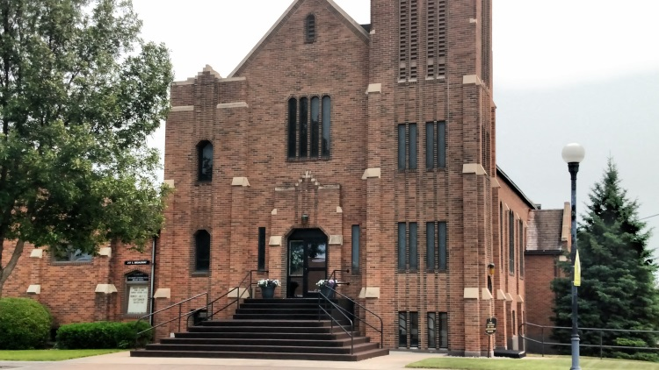
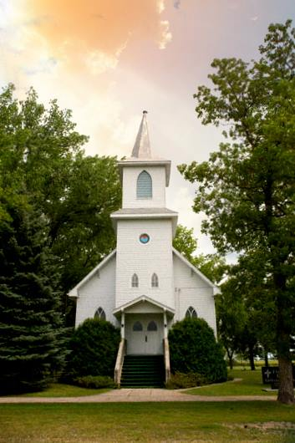
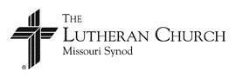
Our Savior’s Lutheran Church
Crookston, MN
First English Lutheran Church
Eldred, MN
April 28, 2024

