2024 Confirmation

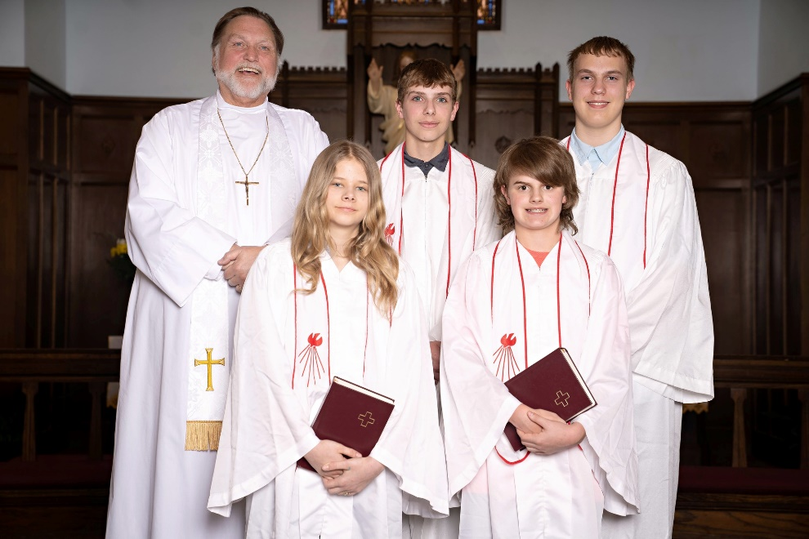
Back row (left to right): Pastor Bohler, Ivan Luckow, Evan Wagner
Fron trow (left to right): Elsie Volker and Caden Perry
Not pictured: Abbegayle Lundmark

Help us to celebrate and pray for our confirmands this morning. We are very proud of you, Ivan, Abbegayle, Cade, Elsie, and Evan!

May God continue to bless you and guide you in your life.

Confirmation Verses

Ivan Allen Luckow
“Whoever believes and is baptized shall be saved.”
Mark 16:16

Abbegayle Lundmark
“Fear not, for I have redeemed you, I have called you by name: you are mine.”
Isaiah 43:1

Caden James Perry
“He that believes in the Son has everlasting life.”
John 3:36

Elsie Kay Volker
“We love Him because He first loved us.”
1 John 4:19

Evan David Wagner
(Jesus says) “I am the Way, the Truth, and the Life. No one comes to the Father but through Me.”
John 14:6

