Our Savior’s, Crookston and First English, Eldred

PO Box 477 • 217 S. Broadway, Crookston, MN 56716
Steven Bohler Pastor
Carol Weber Organist
Laurain Jurchen Director of Music
Katie Brockpahler Business Manager
Sandra Trittin School Principal
Church: 218-281-1239 • www.oursaviorslutheranchurchcrookston.org
School: 218-281-5191 • www.oursaviorslutheranschool.org

Our Savior’s Lutheran Day School Mission Statement:
Our Savior’s School effectively educates, trains and equips students
of our church and community to achieve their God-given potential
by providing a Christ – centered education.
April 14, 2024
3rd Sunday of Easter
Our Savior’s Order For Worship: First English Order For Worship:
Hymns: 464, 480, 470, 475 Hymns: 143, 138, 129
Liturgy: Page 184 Liturgy: Page 158

Weekly Calendar: April 14-20th

Sunday: 8:00 am Worship Service at Our Savior’s
9:30 am Adult Bible Study or Sunday School
9:30 Worship Service at First English
11 am Worship Service at Our Savior’s
Monday:
Tuesday: 8:00 am Bible Breakfast
1-6 pm Sewing
Wednesday: 8:30 am Day School Chapel
4 pm Confirmation Prep for 8th grade only
Thursday: 1:30 pm Women’s Bible Study
Friday:
Saturday:
Next Sunday: 8:00 am Worship Service at Our Savior’s
9:30 am Worship Service at First English
9:30 am Sunday School and Adult Bible Study
9:30 am Confirmation Reception
11 am Worship Service at Our Savior’s
11 am Rite of Confirmation

Welcome to our service this morning. We pray that the Lord blesses you as you hear His Word proclaimed today. If you are a visitor, please sign our guestbook in the narthex & introduce yourself to the Pastor.

Communion Policy
In joyful obedience to the teaching of Scripture, we have promised to practice close communion. Guests who desire to commune are asked to speak with the pastor before the service. During the Distribution of Holy Communion remember that we will all drink the cup when the Pastor speaks the words “Take & Drink” showing the unity of the church.

Prayer List
-Lori Hoerner
-Susan Vilven
-Jean Thomforde
-Pam Blair, mother of Matt Blair
-Claudette Bruley
-Scott Oliver
-Jaeger Jay, newborn son of Jared and Stacy Olson
-Shut-ins and homebound members
-College students

Announcements
- Ivan Luckow is our acolyte for the early service, and Elsie Volker is the acolyte for the late service.

- 14 of our 1st-6th grade students attended the MN North Lutheran Schools Knowledge Bowl at St. John Lutheran School in Thief River Falls on Saturday, April 13th.

- Lutheran Island Camp Scholarship applications are now available in the back of the Narthex for this summer! Please turn these into the office by May 5, 2024.

- COMING SOON: The crumbled brick sidewalk out front of the main entry will be replaced sometime this spring. The tree that is growing out of the brick will also be removed at that time.

- Our Savior’s Lutheran School will be holding an open house on Thursday, April 25th from 5:30-6:30 PM. All are welcome to visit our classrooms and learn more about the Christ-centered education provided. Please share this information with others.

- If you would like to donate towards the new dishwasher or new carpet in the 1st/2nd grade classroom, please make a note on your check or envelope!

  - The dishwasher costs $5.700; we’ve raised $2,975 (53%). We still need $2,725 to pay for the appliance in full.
  - Our carpet goal is to raise $10,000. We’ve raised $865 (9%). We still need $9,135 to meet our goal.
  - Thank you for all that donated towards these projects already!!

- Please join us on Monday, April 15th at 6:30pm for a presentation discussing how parents and caregivers can address internet safety in their home and with the young people in their lives. A representative from Safe Harbor Minnesota will go over why we should address online safety and healthy relationships with youth, and provide attendees with tools to begin addressing these topics with youth. Attendees will also learn how to address solicitation of children if it occurs, and tools to help monitor online activity within your homes.

Childcare during the event will be provided by Our Saviors Youth Group.

- Thank you to the Lien family that donated a gently used (almost new!) wheel chair to our church/school! It is located near the elevator under the coat rack should anyone need to use it.

- The Christian Corner Store has confirmation cards, graduation cards and Mother’s Day cards, along with a wide variety of other cards. Please stop in and shop for cards with a scripture verse in them. Thanks.

- Common Ground is hosting their 3rd annual “Spring Thing” event on Wednesday, April 17th from 6:30-8:45pm at CHS. All 7th-12th graders are invited for a night of games and connection! Please bring a canned soup item or a box of cereal for the Care & Share Food Shelf.

Members celebrating birthdays this week:

-Dustin Uttermark (4/14)
-Andrew Fee (4/15)
-Patricia Lien (4/15)
-Ivan Luckow (4/16)
-Ericka Kollin (4/18)

Mission Opportunities

- See the bins we have for collecting our mission donations. We always collect crafts for REM Group Home residents, candles & wax, soap, eye glasses, & box tops for the school.

- Missions of the Month: Purses with a Purposes
Purses filled with various items will go to people dealing with domestic violence. Donations of purses for men, women, and children will be collected. You can fill your donated purses with any of the following items: hygiene items, shaving supplies, feminine products, stuffed toys, etc.

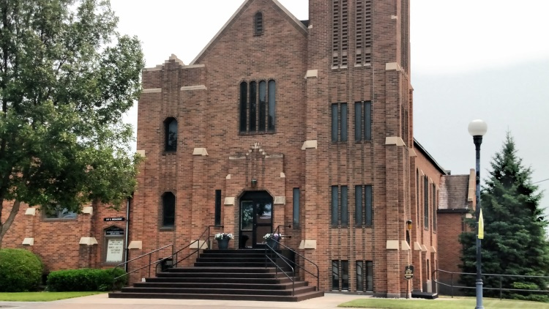
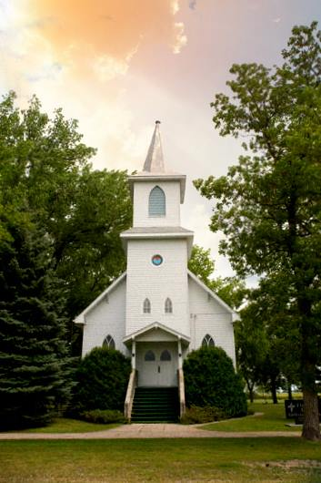
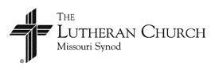
Our Savior’s Lutheran Church
Crookston, MN
First English Lutheran Church
Eldred, MN
April 14, 2024

