Our Savior’s, Crookston and First English, Eldred

PO Box 477 • 217 S. Broadway, Crookston, MN 56716
Steven Bohler Pastor
Carol Weber Organist
Laurain Jurchen Director of Music
Katie Brockpahler Business Manager
Sandra Trittin School Principal
Church: 218-281-1239 • www.oursaviorslutheranchurchcrookston.org
School: 218-281-5191 • www.oursaviorslutheranschool.org

Our Savior’s Lutheran Day School Mission Statement:
Our Savior’s School effectively educates, trains and equips students
of our church and community to achieve their God-given potential
by providing a Christ – centered education.
May 24/28, 2023
6th Grade Graduation/Day of Pentecost
Our Savior’s Order For Worship: First English Order For Worship:
Wed. Hymns: 497, 864, 498, 861 Hymns: 224, 234 (1-3), 234 (4-6)
Wed. Liturgy: Page 260 Liturgy: Page 15
Sun. Hymns: 497, TLH 235 (v.1-4), TLH 235 (v.5-8), 496 Sun. Liturgy: Page 184

Weekly Calendar: May 28th-June 3rd

Sunday: 8:00 am Worship Service at Our Savior’s
9:30 am Worship Service at First English
11:00 am Worship Service at Our Savior’s
Monday: School & Church Offices Closed
Tuesday: 1-6 pm Sewing
Wednesday: NO RBJs Bible Breakfast
Thursday:
Friday:
Saturday:
Next Sunday: 8:00 am Worship Service at Our Savior’s
9:30 am Worship Service at First English
No 11:00 am Worship Service at Our Savior’s for the summer

Welcome to our service this morning. We pray that the Lord blesses you as you hear His Word proclaimed today. If you are a visitor, please sign our guestbook in the narthex & introduce yourself to the Pastor.

Communion Policy
In joyful obedience to the teaching of Scripture, we have promised to practice close communion. Guests who desire to commune are asked to speak with the pastor before the service. During the Distribution of Holy Communion remember that we will all drink the cup when the Pastor speaks the words “Take & Drink” showing the unity of the church.

Prayer List
-Elderly
-Sunday School and Confirmation Students

Announcements

- The radio broadcast this morning is sponsored by Gary Sylvester’s family in loving memory of his birthday on June 1st.

- The altar flowers are given by the Dans family in loving remembrance of Leslie Dans.

- The additional altar flowers are given to honor Sandra Trittin’s 30 years of service to the school. Our school and church community have been so blessed to have you, and grateful for your hard work and faithful service throughout the years.

- The Wednesday evening service and graduation will feature the 5th and 6th grade class playing bells for pre-service. They will play:

- Glory, Glory Hallelujah
- Fairest Lord Jesus
- Jesus Shall Reign

- The Christian Corner Store has all you need for Graduation cards (by the box or singles).

- Please join us for VBS (Sunday, July 23-Wednesday, July 26th) this summer! Contact the church office to register your children (bookkeeper.oslds@midconetwork.com or 218-281-1239) We will resume the Sunday after Labor Day weekend!

- Anyone interested in volunteering for VBS this summer (Sunday, July 23rd-Wednesday, July 26th), let Katie in the office know! Adults and Middle School/High School Students are welcomed and encouraged to attend and help!

- There are surveys in the back on the Narthex about starting different events, family bible studies and small groups within church. Please consider filling out the form. You can leave them in the offering plate or in the dropbox in the entryway of the school. You can also find the survey online:

https://form.jotform.com/231153611360039
- Summer Monday evening services will begin on Monday, June 5th at 6:30 PM.

Members celebrating birthdays this week:
-David Hegge (5/28) -Ryan Nalipinski (6/2)
-Hailey Eidenschink (5/29) -Taylor Perry (6/2)
-Madilyn Abrams (5/30) -Claudette Bruley (6/3)
-Harold Unke (5/31) -Piper Jensrud (6/3)
-Kathryn Perry (6/1) -Paul Reitmeier (6/3)

Mission Opportunities
- See the bins we have for collecting our mission donations. We always collect crafts for REM Group Home residents, candles & wax, soap, eye glasses, & box tops for the school.

- Missions of the Month:

- The Mission Project for April and May will be making Hygiene Kits for the Orphan Grain Train. Each kit should contain: 1 bath towel, 1 wash cloth, 1 bath-sized bar of soap, 1 soap container, 1 toothbrush, 1 sturdy comb, 1 nail clipper, 6 band-aids (1/2 or 3/4 inch), 1 small package of facial tissues, 1 piece of strong cord or ribbon (used to tie up the rolled bath towel-with the other items inside).

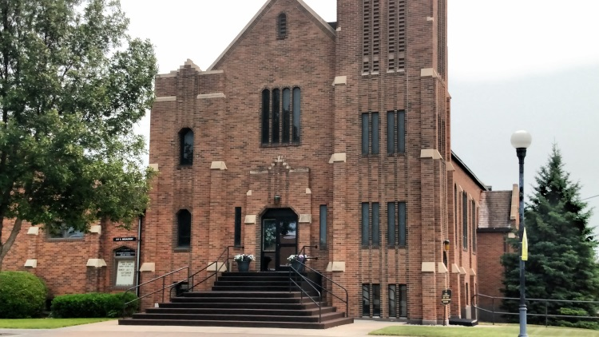
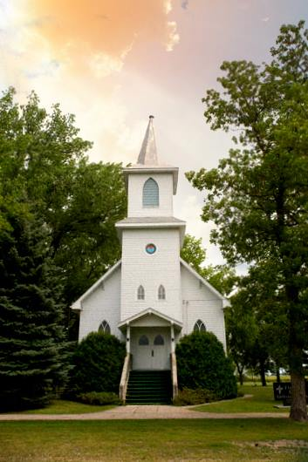
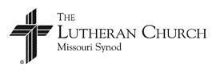
Our Savior’s Lutheran Church
Crookston, MN
First English Lutheran Church
Eldred, MN
May 28, 2023

