Introit Psalm 116:1–4; antiphon: v. 5

Gracious is the Lord, and righteous;
our God is merciful.
I love the Lord, because He has heard
my voice and my pleas for mercy.
Because He inclined His ear to me,
therefore I will call on Him as long as I live.
The snares of death encompassed me; the pangs of Sheol laid hold on me;
I suffered distress and anguish.
Then I called on the name of the Lord:
“O Lord, I pray, deliver my soul!”
Gracious is the Lord, and righteous;
our God is merciful.

March 28, 2024

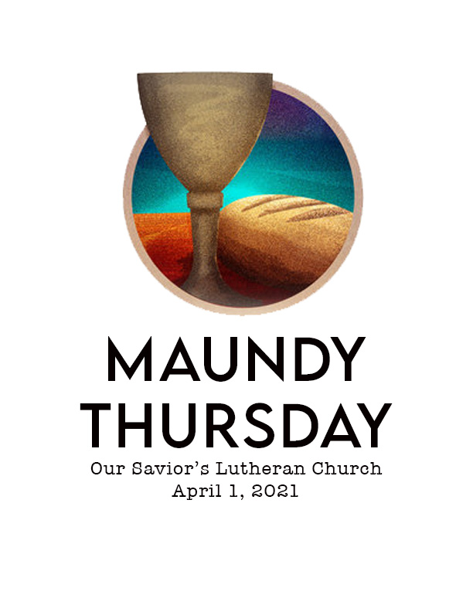

Our Savior’s, Crookston and First English, Eldred

PO Box 477 • 217 S. Broadway, Crookston, MN 56716
Steven Bohler Pastor
Carol Weber Organist
Laurain Jurchen Director of Music
Katie Brockpahler Business Manager
Sandra Trittin School Principal
Church: 218-281-1239 • www.oursaviorslutheranchurchcrookston.org
School: 218-281-5191 • www.oursaviorslutheranschool.org

Our Savior’s Lutheran Day School Mission Statement:
Our Savior’s School effectively educates, trains and equips students
of our church and community to achieve their God-given potential
by providing a Christ – centered education.
March 28, 2024
Maundy Thursday
Our Savior’s Order For Worship: First English Order For Worship:
Hymns: 438, 451, 634, 880 Hymns: N/A
Liturgy: Page 184 Liturgy: N/A

Weekly Calendar: March 24th-30th

Sunday: 8:00 am Worship Service at Our Savior’s
9:30 am Adult Bible Study or Sunday
NO Worship Service at First English
11 am Worship Service at Our Savior’s
Monday: 5:30 pm Choir
Tuesday: 8:00 am Bible Breakfast
1-6 pm Sewing
Wednesday: 8:30 am Day School Chapel
6:30-8 PM Youth Group
Thursday: NO SCHOOL
7 pm Maundy Thursday Service at Our Savior’s
Friday: NO SCHOOL
9:30 am Good Friday Service at First English
7 pm Good Friday Service at Our Savior’s
Saturday:
Next Sunday: 7:00 am Sunrise Easter Worship Service at Our Savior’s
9:30 am Worship Service at First English
9:30 am Sunday School and Adult Bible Study
11 am Worship Service at Our Savior’s

Welcome to our service this morning. We pray that the Lord blesses you as you hear His Word proclaimed today. If you are a visitor, please sign our guestbook in the narthex & introduce yourself to the Pastor.

Communion Policy
In joyful obedience to the teaching of Scripture, we have promised to practice close communion. Guests who desire to commune are asked to speak with the pastor before the service. During the Distribution of Holy Communion remember that we will all drink the cup when the Pastor speaks the words “Take & Drink” showing the unity of the church.

Prayer List
-Lori Hoerner
-Susan Vilven
-Jean Thomforde
-Donna Koval
-Pam Blair, mother of Matt Blair
-Friends and family of Bud Ellingson
-Claudette Bruley
-Daryl Wagner

Announcements
- Eva Gosse is our acolyte for the early service, and Elsie Volker is the acolyte for the late service. Eva Gosse will acolyte for Maundy Thursday and Good Friday.

- There is a sign-up sheet in the back of the narthex for our Easter Lily cross. The cost of each lily this year is $22.50.

- THANK YOU Our Savior’s Church members for supporting our Hope Center Project!! The OSLC Hope Center Core Committee—Kim Dans, Mary Gosse, Sandra Trittin and Helen Phalen.

- Lutheran Island Camp Scholarship applications are now available in the back of the Narthex for this summer! Please turn these into the office by May 5, 2024.

- COMING SOON: The crumbled brick sidewalk out front of the main entry will be replaced sometime this spring. The tree that is growing out of the brick will also be removed at that time.

- Our youth group will be serving Easter Breakfast at 8 AM after the Sunrise service at Our Savior’s. Money raised during Easter Breakfast with go towards the Youth Gathering in New Orleans next summer.

- If you would like to donate towards the new dishwasher or new carpet in the 1st/2nd grade classroom, please make a note on your check or envelope!

