Order of Service — March 28, 2024
(Maundy Thursday)

Welcome/Announcements

Opening Hymn
438 A Lamb Goes Uncomplaining Forth
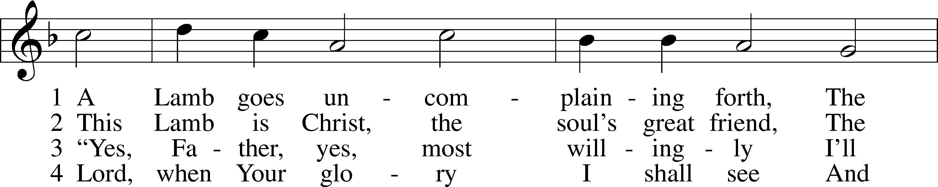
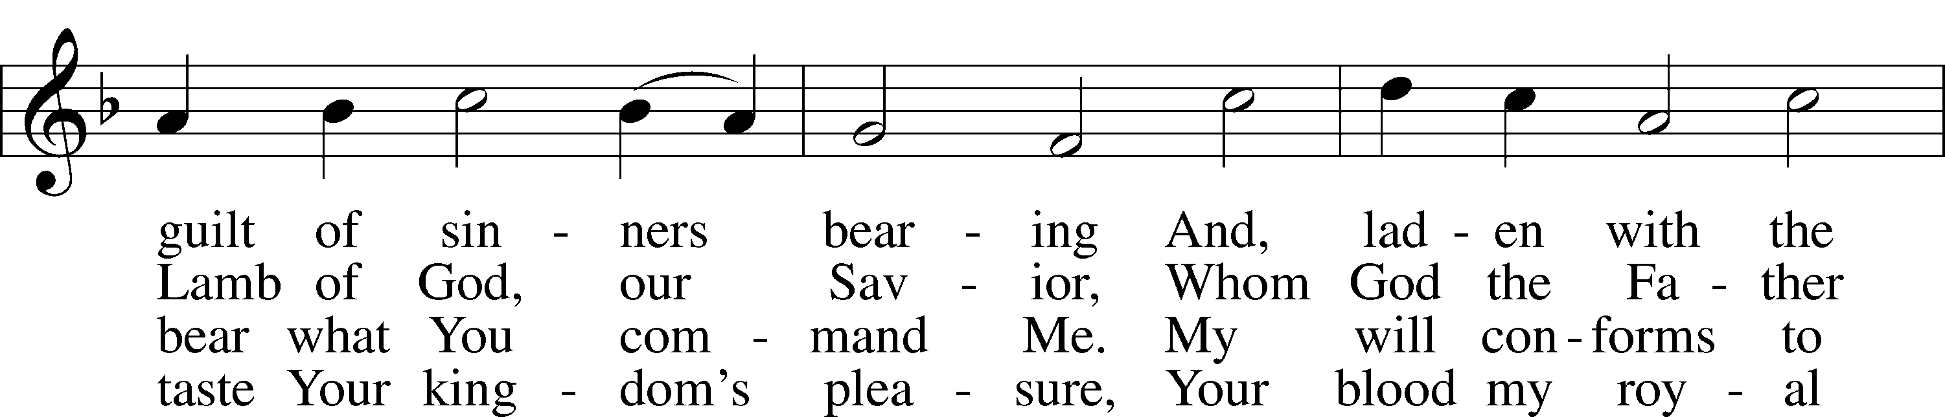
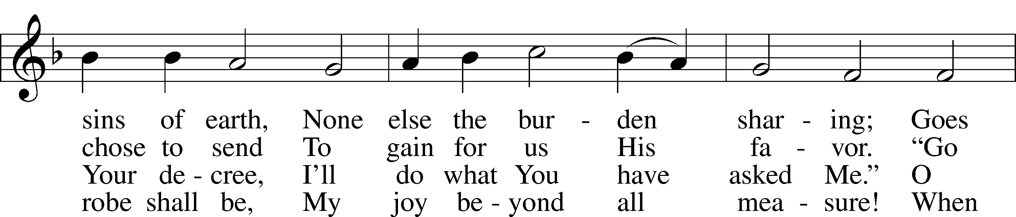
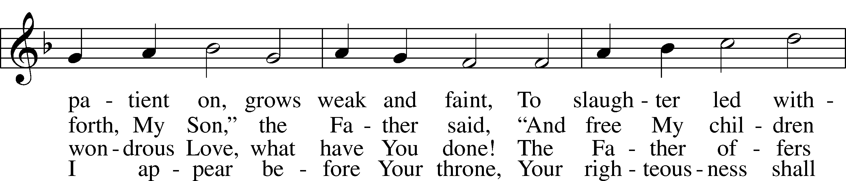
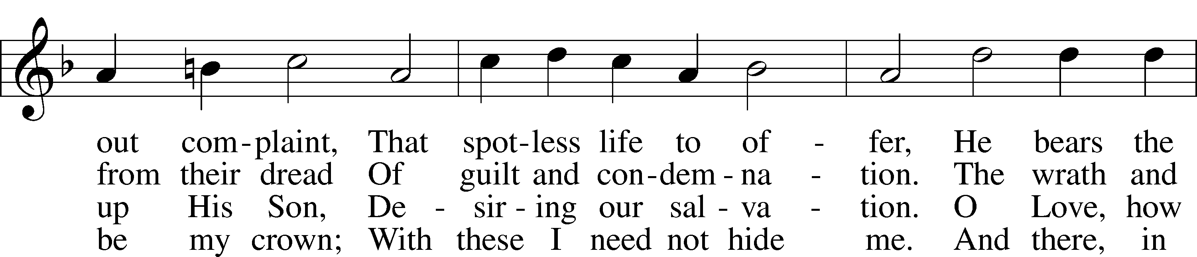
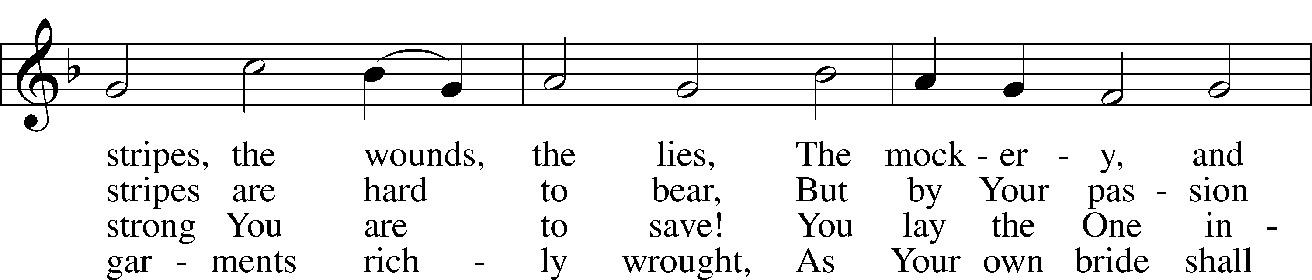
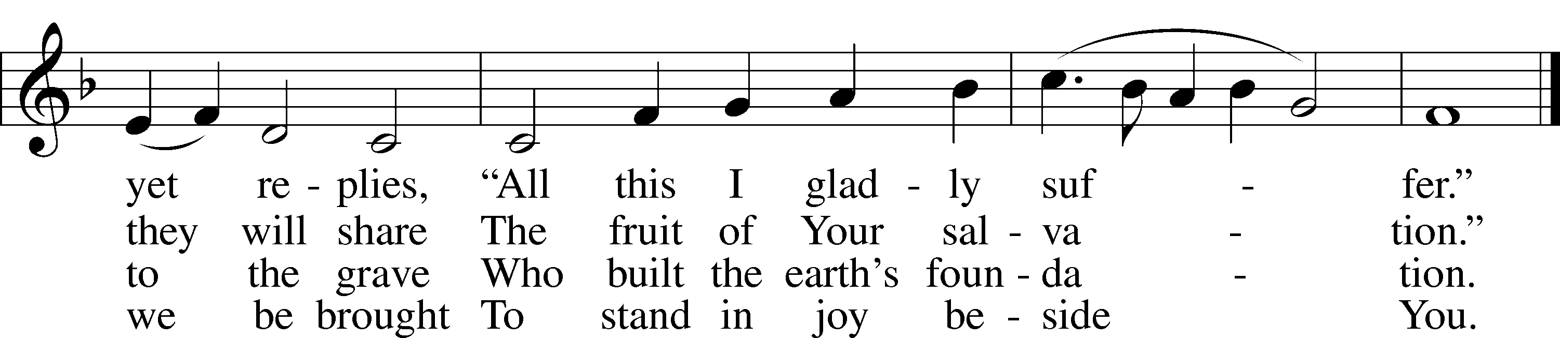
Text: Paul Gerhardt, 1607–76; tr. The Lutheran Hymnal, 1941, alt.
Tune: Wolfgang Dachstein, c. 1487–1553
Text: © 1941 Concordia Publishing House. Used by permission: LSB Hymn License no. 110002874
Tune: Public domain

Stand

Invocation/Confession & Absolution
P In the name of the Father and of the Son and of the Holy Spirit.
C Amen.

P Beloved in the Lord! Let us draw near with a true heart and confess our sins unto God our Father, beseeching Him in the name of our Lord Jesus Christ to grant us forgiveness.

P Our help is in the name of the Lord,
C who made heaven and earth.
P I said, I will confess my transgressions unto the Lord,
C and You forgave the iniquity of my sin.

Silence for reflection on God’s Word and for self-examination.

P O almighty God, merciful Father,
C I, a poor, miserable sinner, confess unto You all my sins and iniquities with which I have ever offended You and justly deserved Your temporal and eternal punishment. But I am heartily sorry for them and sincerely repent of them, and I pray You of Your boundless mercy and for the sake of the holy, innocent, bitter sufferings and death of Your beloved Son, Jesus Christ, to be gracious and merciful to me, a poor, sinful being.

P Upon this your confession, I, by virtue of my office, as a called and ordained servant of the Word, announce the grace of God unto all of you, and in the stead and by the command of my Lord Jesus Christ I forgive you all your sins in the name of the Father and of the Son and of the Holy Spirit.
C Amen.

Introit Psalm 116:1–4; antiphon: v. 5
Gracious is the Lord, and righteous;
our God is merciful.
I love the Lord, because He has heard
my voice and my pleas for mercy.
Because He inclined His ear to me,
therefore I will call on Him as long as I live.
The snares of death encompassed me; the pangs of Sheol laid hold on me;
I suffered distress and anguish.
Then I called on the name of the Lord:
“O Lord, I pray, deliver my soul!”
Gracious is the Lord, and righteous;
our God is merciful.

Kyrie LSB 186
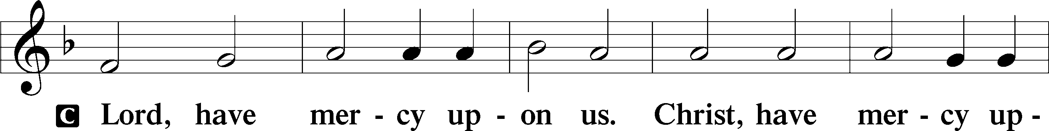
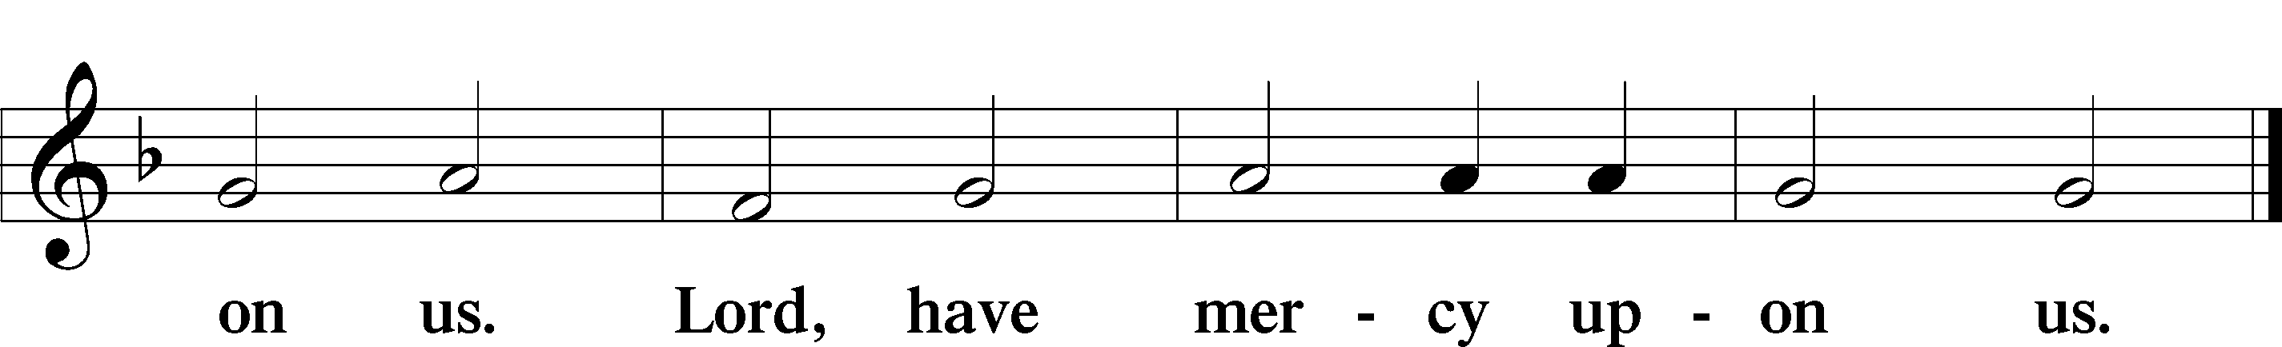

Salutation and Collect of the Day
P The Lord be with you.
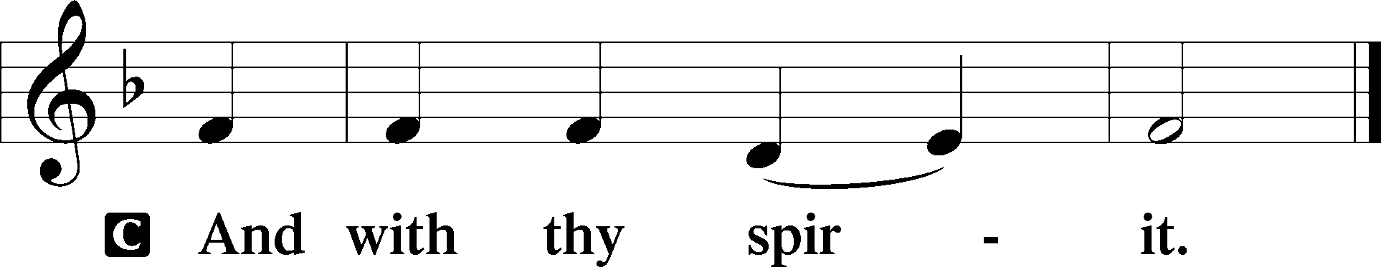

P Let us pray.
O Lord, in this wondrous Sacrament You have left us a remembrance of Your passion. Grant that we may so receive the sacred mystery of Your body and blood that the fruits of Your redemption may continually be manifest in us; for You live and reign with the Father and the Holy Spirit, one God, now and forever.

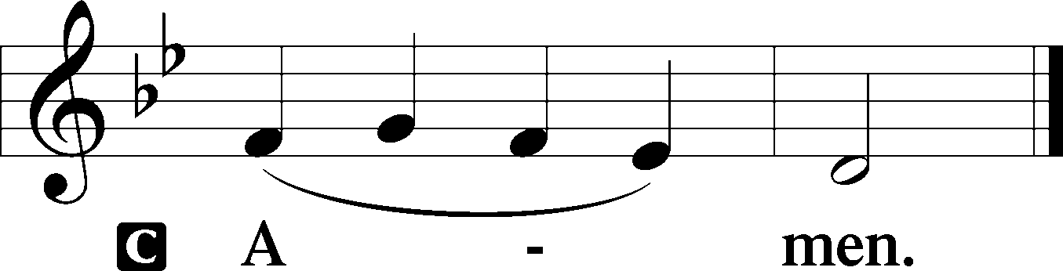

Sit

Old Testament Reading Exodus 24:3–11
³Moses came and told the people all the words of the Lord and all the just decrees. And all the people answered with one voice and said, “All the words that the Lord has spoken we will do.” ⁴And Moses wrote down all the words of the Lord. He rose early in the morning and built an altar at the foot of the mountain, and twelve pillars, according to the twelve tribes of Israel. ⁵And he sent young men of the people of Israel, who offered burnt offerings and sacrificed peace offerings of oxen to the Lord. ⁶And Moses took half of the blood and put it in basins, and half of the blood he threw against the altar. ⁷Then he took the Book of the Covenant and read it in the hearing of the people. And they said, “All that the Lord has spoken we will do, and we will be obedient.” ⁸And Moses took the blood and threw it on the people and said, “Behold the blood of the covenant that the Lord has made with you in accordance with all these words.” ⁹Then Moses and Aaron, Nadab, and Abihu, and seventy of the elders of Israel went up, ¹⁰and they saw the God of Israel. There was under His feet as it were a pavement of sapphire stone, like the very heaven for clearness. ¹¹And He did not lay His hand on the chief men of the people of Israel; they beheld God, and ate and drank.

A This is the Word of the Lord.
C Thanks be to God.

Epistle 1 Corinthians 10:16–17
¹⁶The cup of blessing that we bless — is it not a participation in the blood of Christ? The bread that we break — is it not a participation in the body of Christ? ¹⁷Because there is one bread, we who are many are one body, for we all partake of the one bread.

A This is the Word of the Lord.
C Thanks be to God.

Stand

Holy Gospel Mark 14:12–26
P The Holy Gospel according to St. Mark, the fourteenth chapter.

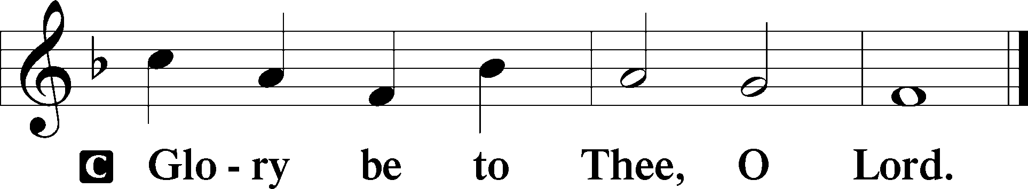

¹²On the first day of Unleavened Bread — when they sacrificed the Passover lamb — [Jesus’] disciples said to Him, “Where will You have us go and prepare for You to eat the Passover?” ¹³And He sent two of His disciples and said to them, “Go into the city, and a man carrying a jar of water will meet you. Follow him, ¹⁴and wherever he enters, say to the master of the house, ‘The Teacher says, Where is My guest room, where I may eat the Passover with My disciples?’ ¹⁵And he will show you a large upper room furnished and ready; there prepare for us.” ¹⁶And the disciples set out and went to the city and found it just as Jesus had told them, and they prepared the Passover. ¹⁷And when it was evening, Jesus came with the Twelve. ¹⁸And as they were reclining at table and eating, Jesus said, “Truly, I say to you, one of you will betray Me, one who is eating with Me.” ¹⁹They began to be sorrowful and to say to Him one after another, “Is it I?” ²⁰He said to them, “It is one of the Twelve, one who is dipping bread into the dish with Me. ²¹For the Son of Man goes as it is written of Him — but woe to that man by whom the Son of Man is betrayed! It would have been better for that man if he had not been born.” ²²And as they were eating, He took bread, and after blessing it broke it and gave it to them, and said, “Take; this is My body.” ²³And He took a cup, and when He had given thanks He gave it to them, and they all drank of it. ²⁴And He said to them, “This is My blood of the covenant, which is poured out for many. ²⁵Truly, I say to you, I will not drink again of the fruit of the vine until that day when I drink it new in the kingdom of God.” ²⁶And when they had sung a hymn, they went out to the Mount of Olives.

P This is the Gospel of the Lord.

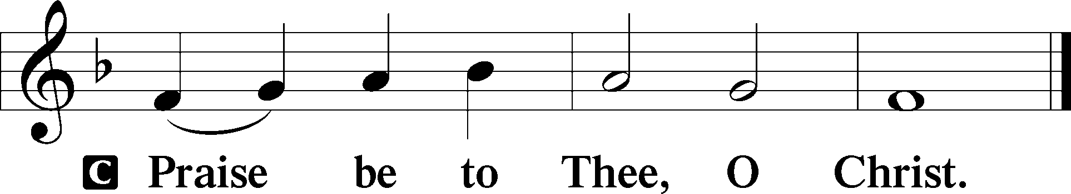

Nicene Creed
C I believe in one God,
the Father Almighty,
Maker of heaven and earth
and of all things visible and invisible.

And in one Lord Jesus Christ,
the only-begotten Son of God,
begotten of His Father before all worlds,
God of God, Light of Light,
Very God of Very God,
begotten, not made,
being of one substance with the Father,
by whom all things were made;
who for us men and for our salvation came down from heaven
and was incarnate by the Holy Spirit of the virgin Mary
and was made man;
and was crucified also for us under Pontius Pilate.
He suffered and was buried.
And the third day He rose again according to the Scriptures
and ascended into heaven
and sits at the right hand of the Father.
And He will come again with glory to judge both the living and the dead,
whose kingdom will have no end.

And I believe in the Holy Spirit,
the Lord and Giver of life,
who proceeds from the Father and the Son,
who with the Father and the Son together is worshiped and glorified,
who spoke by the prophets.
And I believe in one holy Christian and apostolic Church,
I acknowledge one Baptism for the remission of sins,
and I look for the resurrection of the dead
and the life of the world to come. Amen.

Sit

Sermon Hymn
451 Stricken, Smitten, and Afflicted
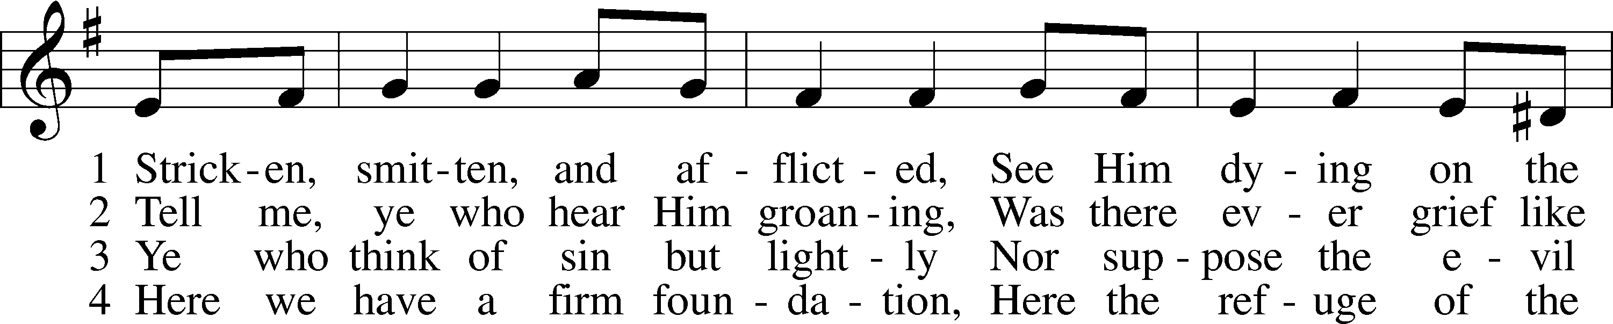
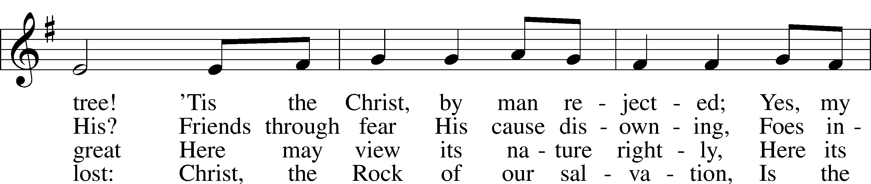
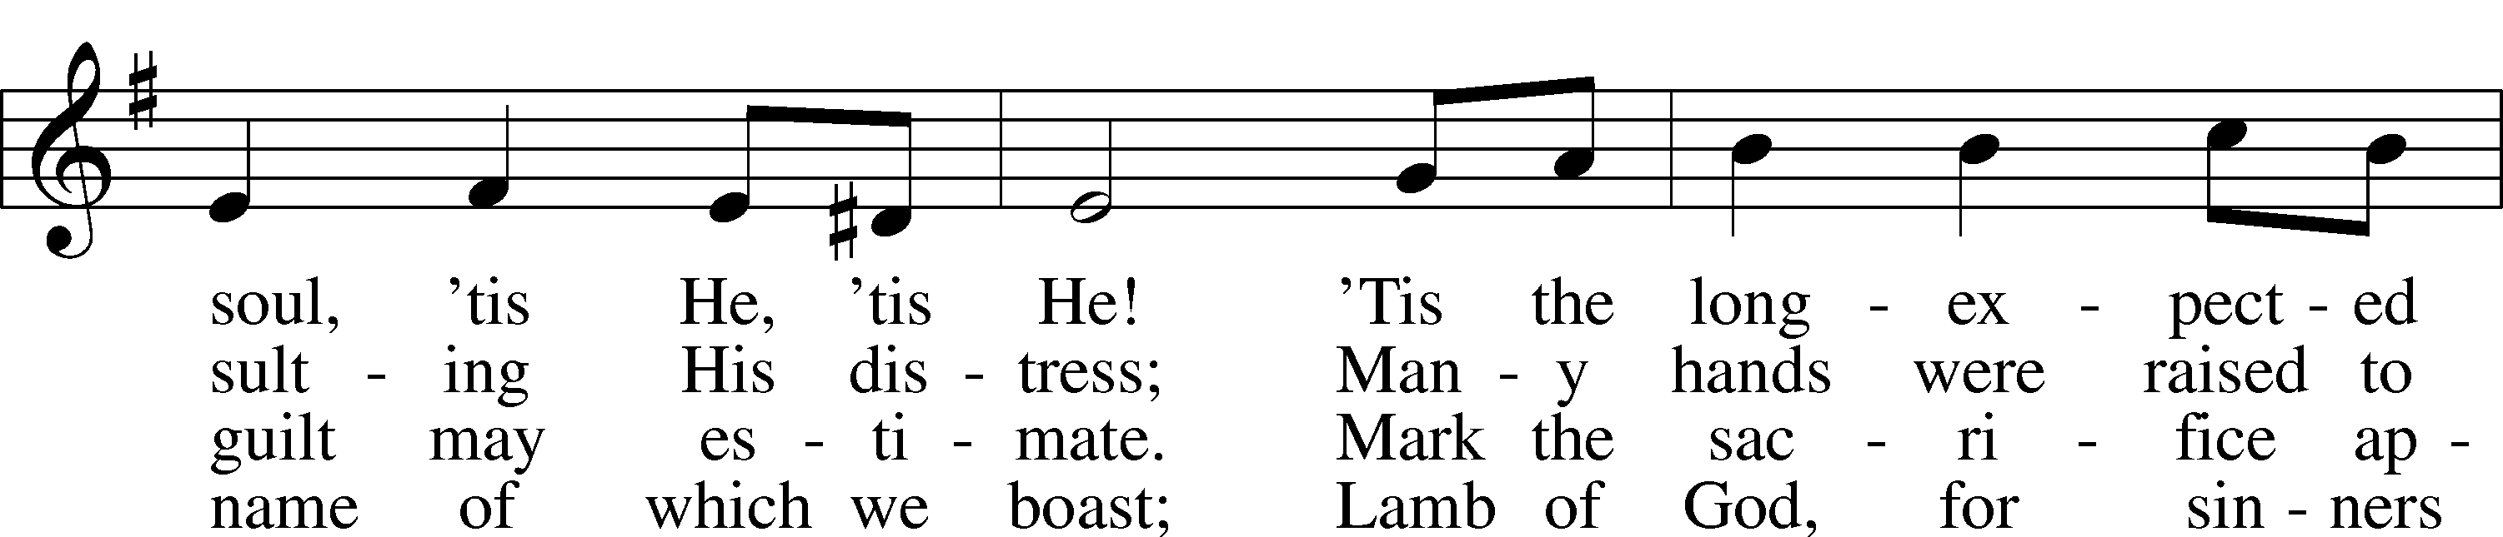
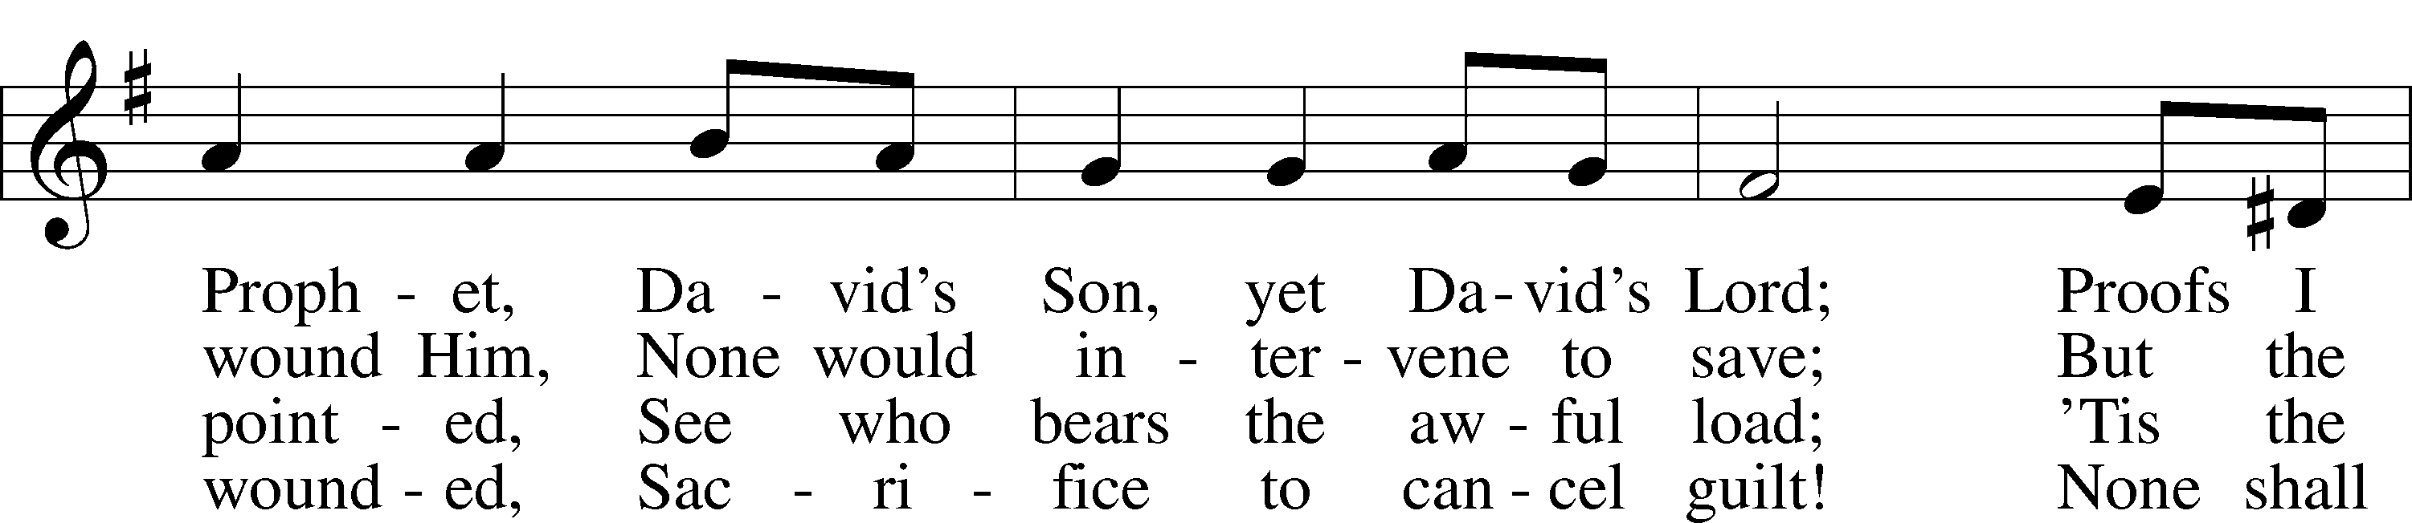
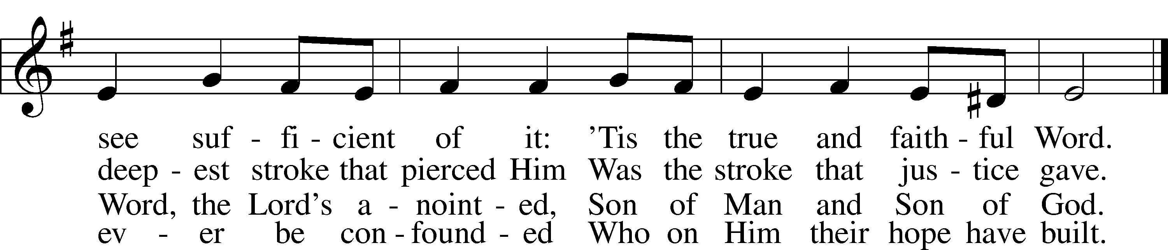
Text: Thomas Kelly, 1769–1855, alt.
Tune: Geistliche Volkslieder, 1850, Paderborn
Text and tune: Public domain

Sermon

Stand

Offertory LSB 192
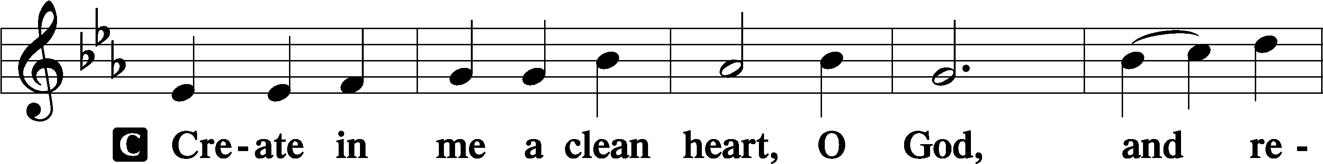
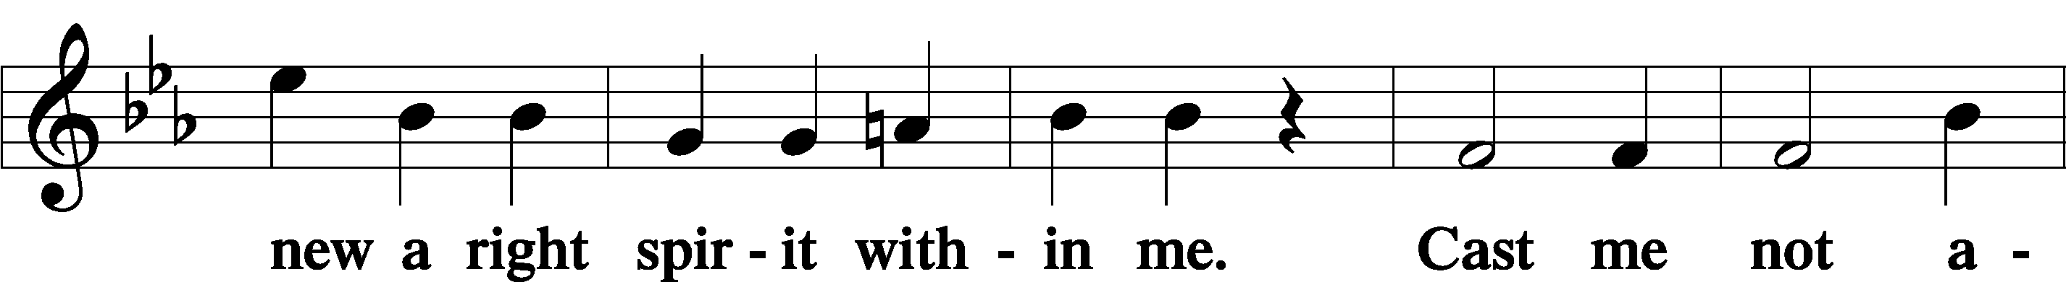
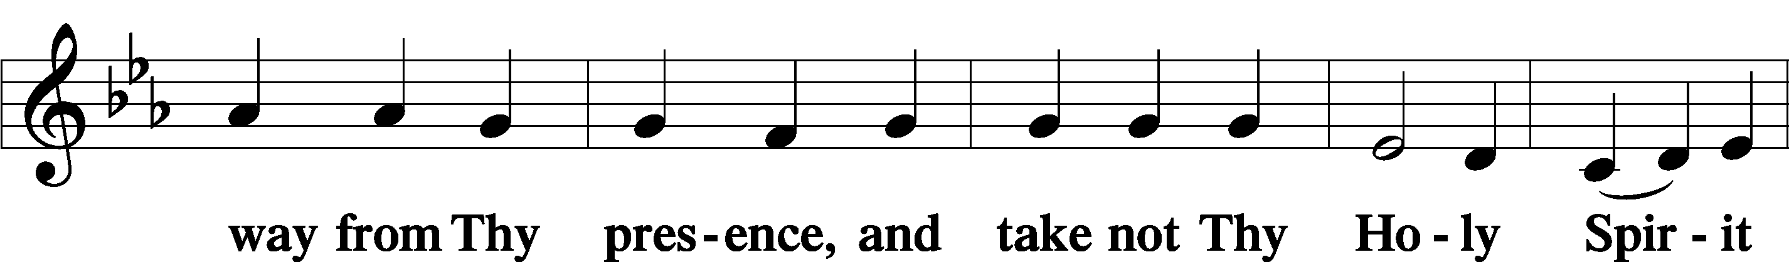
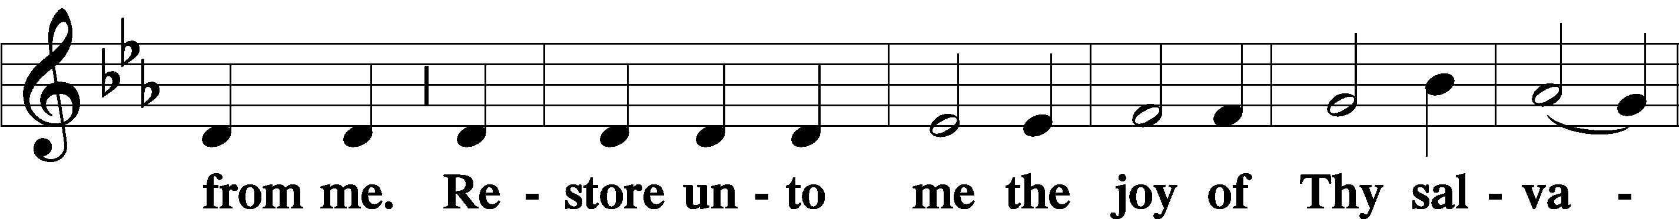
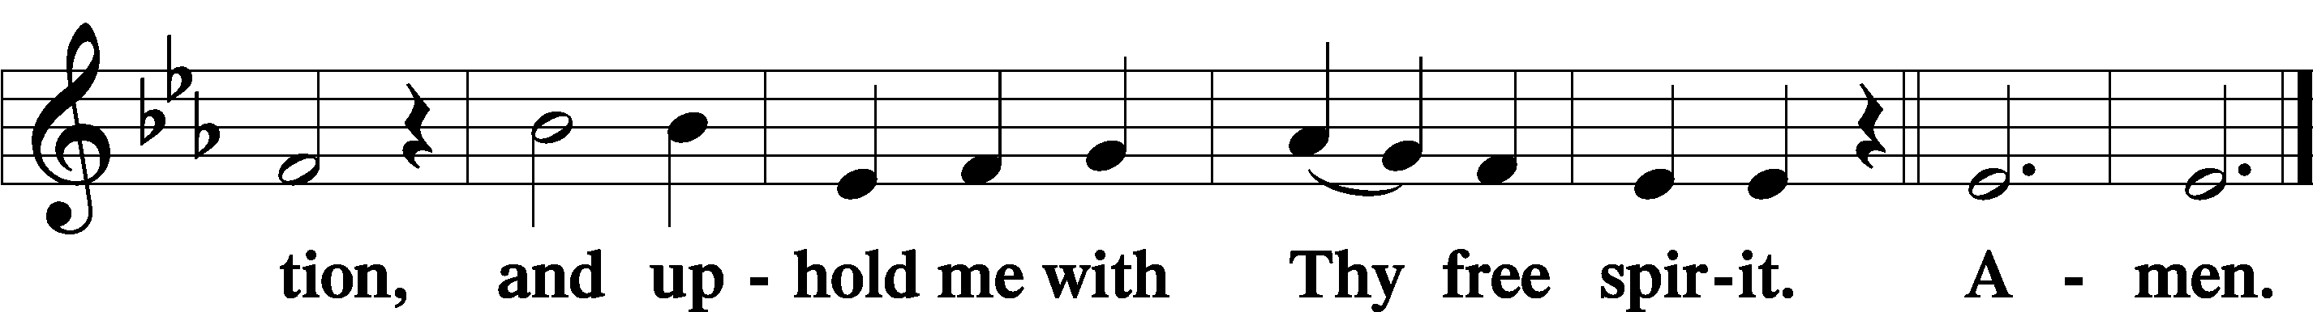

Sit

Offering

Stand

Prayer of the Church

Preface LSB 194
P The Lord be with you.
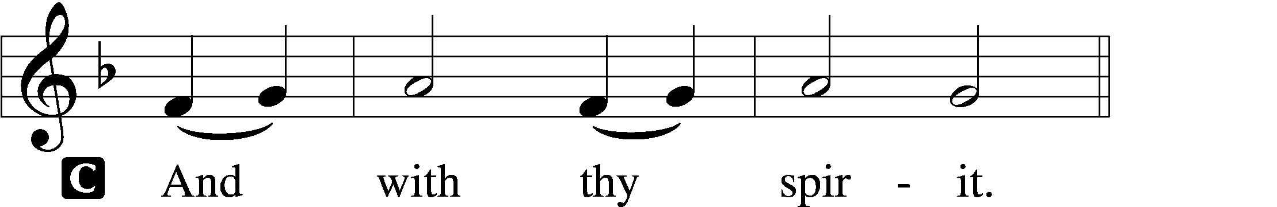

P Lift up your hearts.
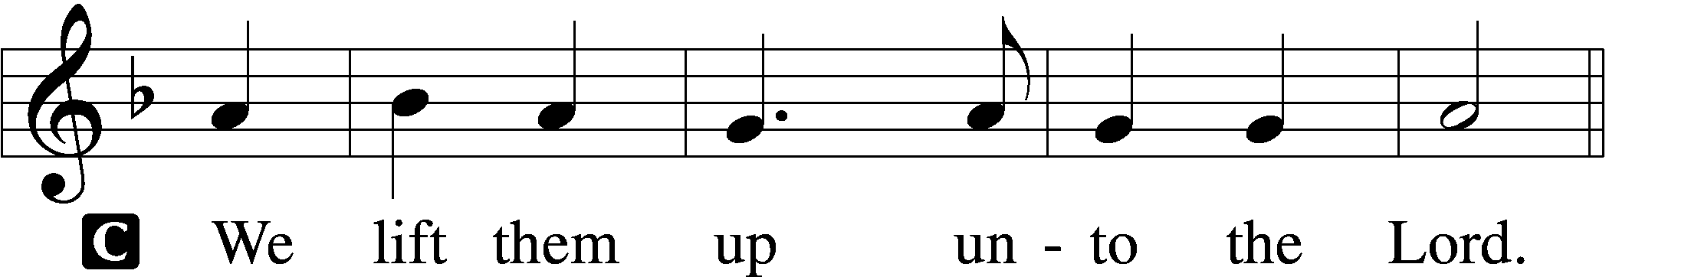

P Let us give thanks unto the Lord, our God.
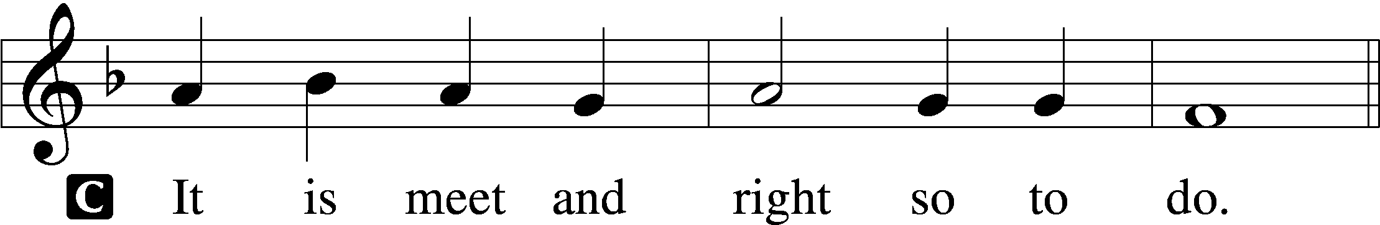

P It is truly meet, right, and salutary that we should at all times and in all places give thanks to You, holy Lord, almighty Father, everlasting God, through Jesus Christ, our Lord, who accomplished the salvation of mankind by the tree of the cross that, where death arose, there life also might rise again and that the serpent who overcame by the tree of the garden might likewise by the tree of the cross be overcome. Therefore with angels and archangels and with all the company of heaven we laud and magnify Your glorious name, evermore praising You and saying:

Sanctus LSB 195
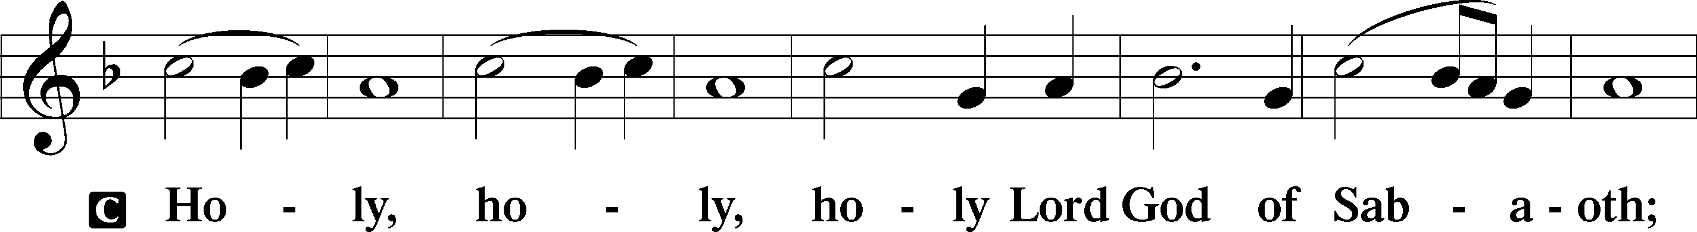
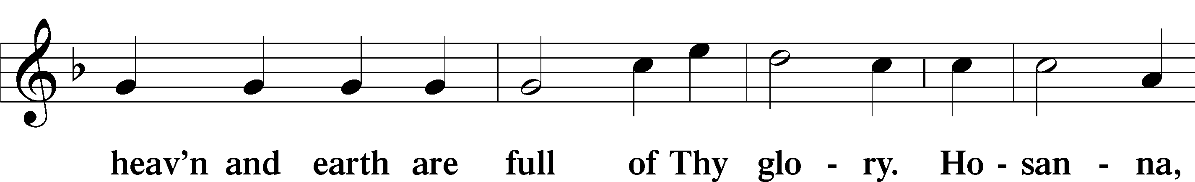
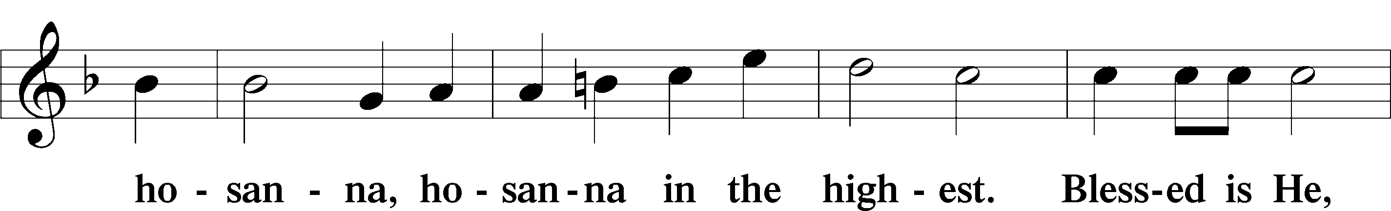
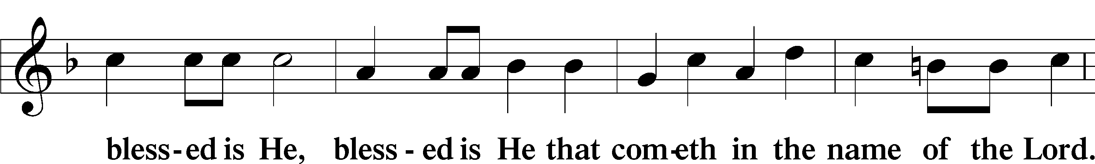
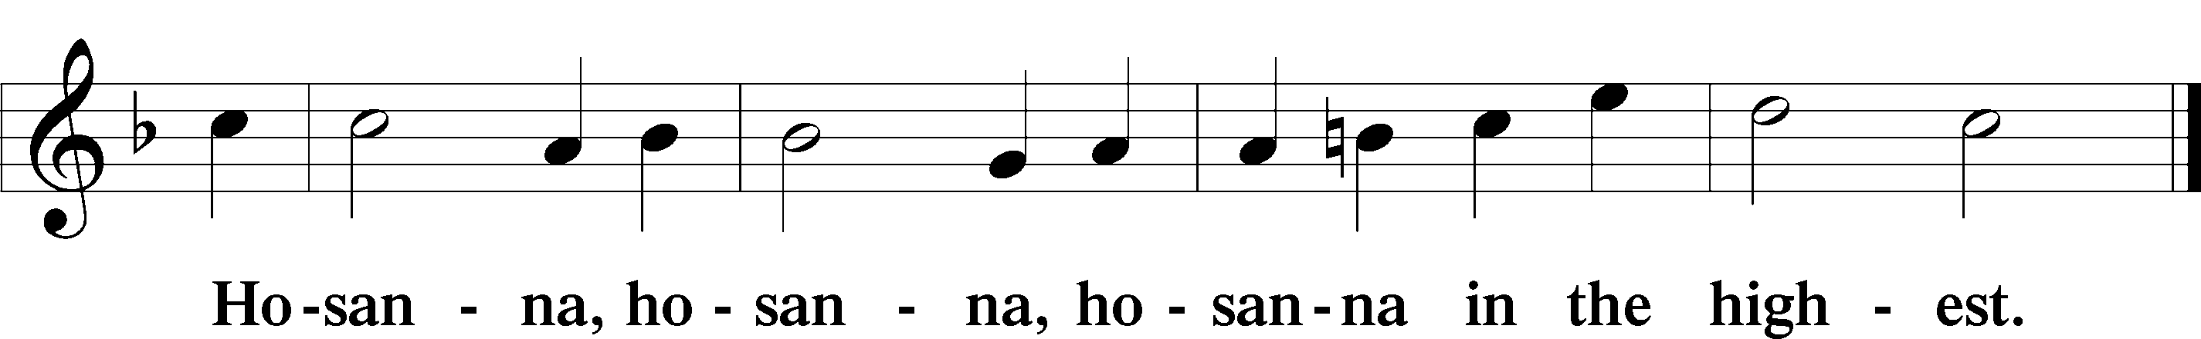

Lord’s Prayer LSB 196
P Our Father who art in heaven,
hallowed be Thy name,
Thy kingdom come,
Thy will be done on earth as it is in heaven;
give us this day our daily bread;
and forgive us our trespasses as we forgive those who trespass against us;
and lead us not into temptation,
but deliver us from evil.
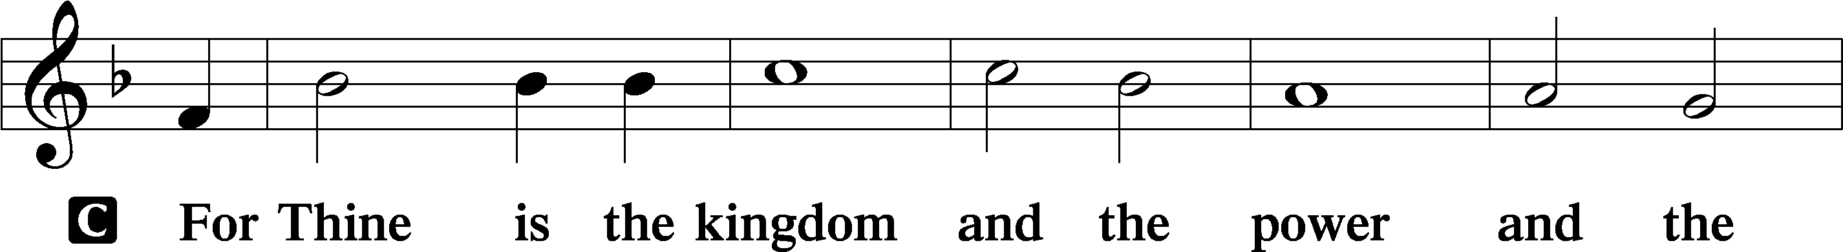
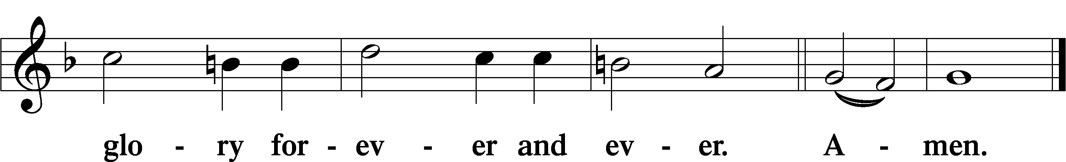

The Words of Our Lord LSB 197
P Our Lord Jesus Christ, on the night when He was betrayed, took bread, and when He had given thanks, He broke it and gave it to the disciples and said: “Take, eat; this is My body, which is given for you. This do in remembrance of Me.”

In the same way also He took the cup after supper, and when He had given thanks, He gave it to them, saying: “Drink of it, all of you; this cup is the new testament in My blood, which is shed for you for the forgiveness of sins. This do, as often as you drink it, in remembrance of Me.”

Pax Domini LSB 197
P The peace of the Lord be with you always.

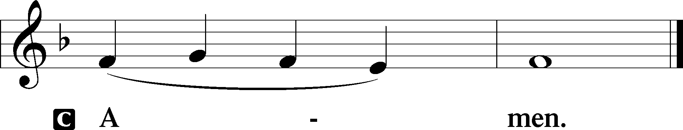

Agnus Dei LSB 198
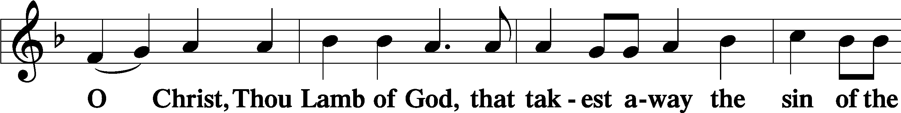
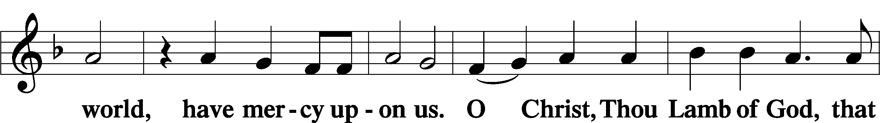
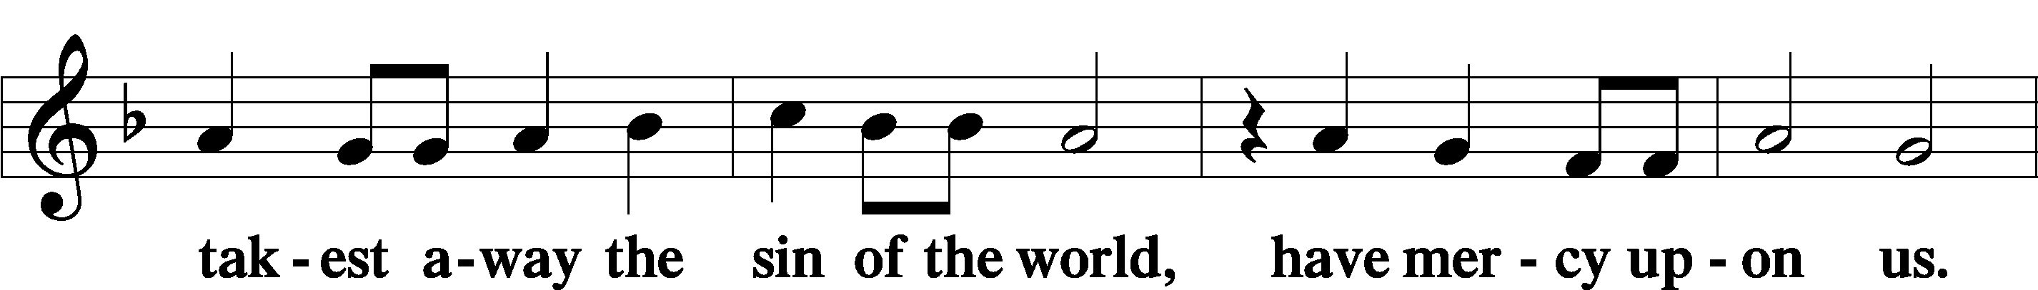
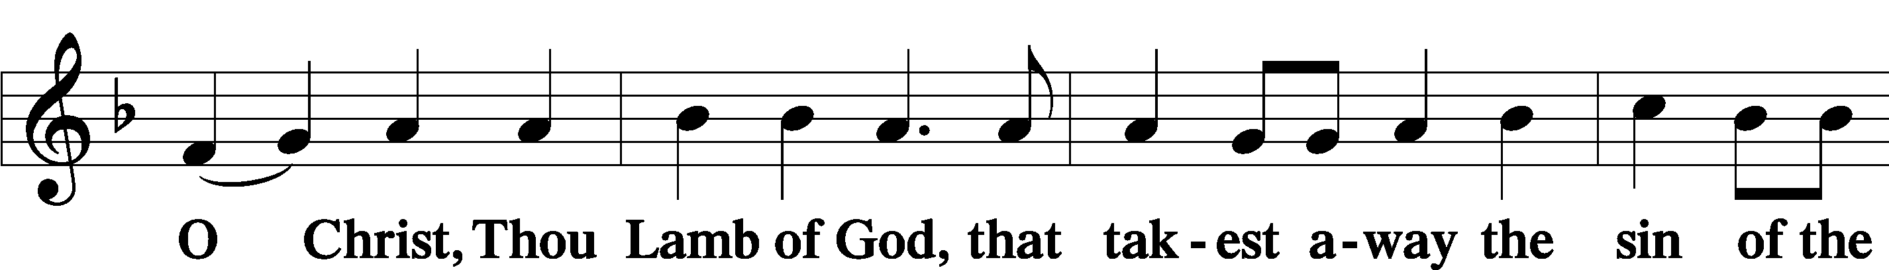
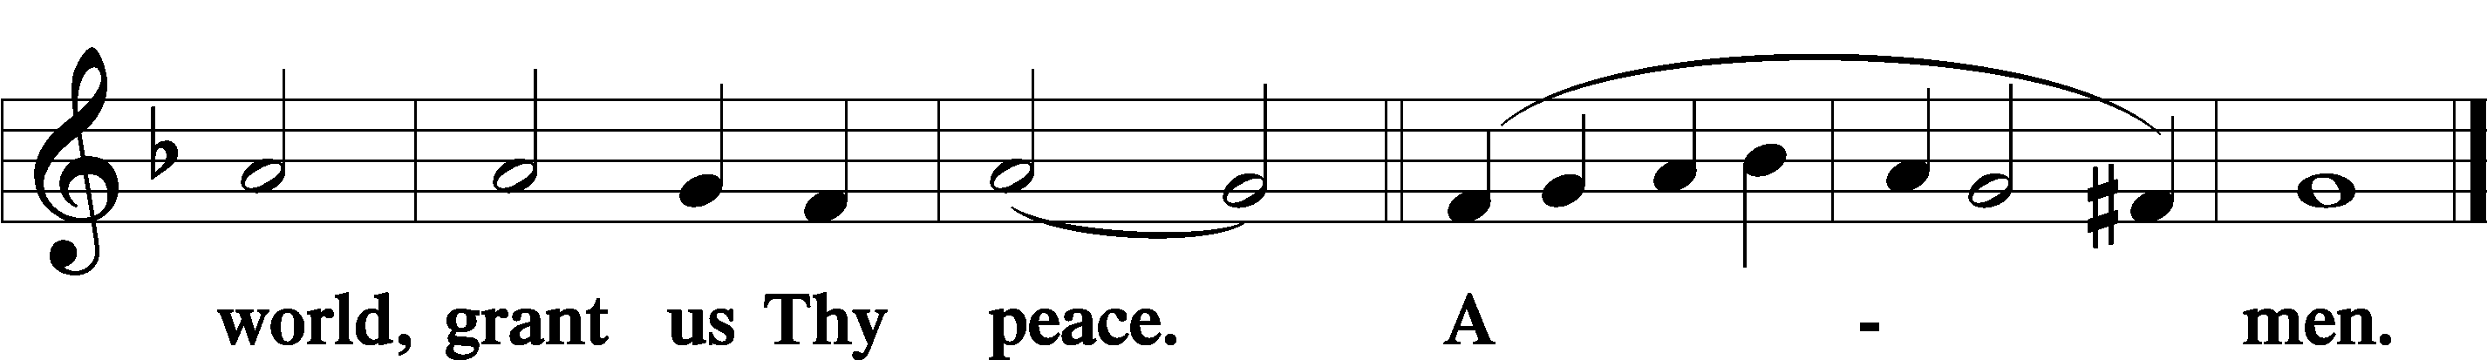

Sit

— The Distribution —

Distribution Hymn
634 The Death of Jesus Christ, Our Lord
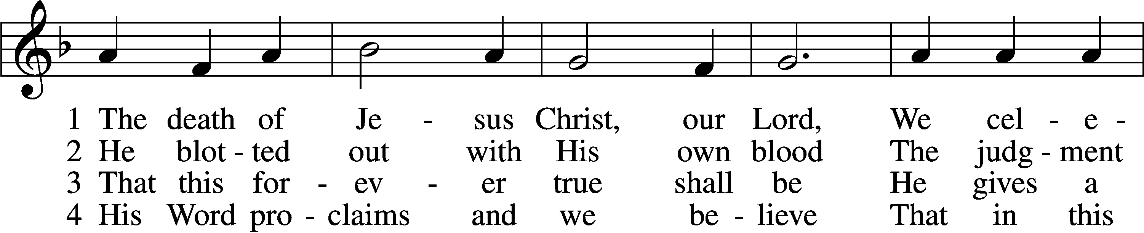
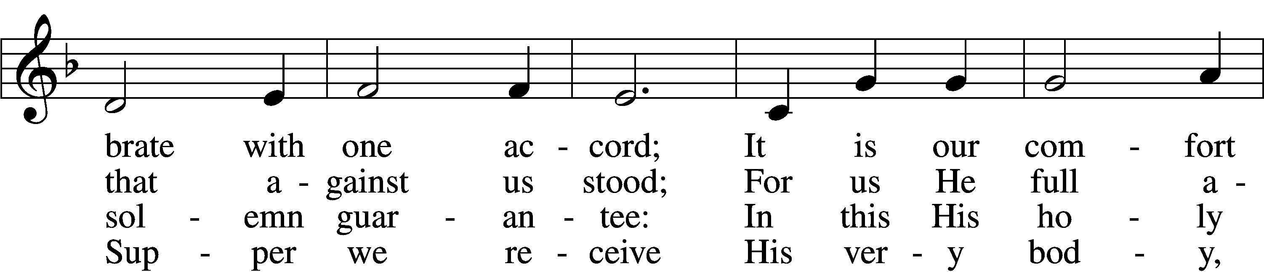
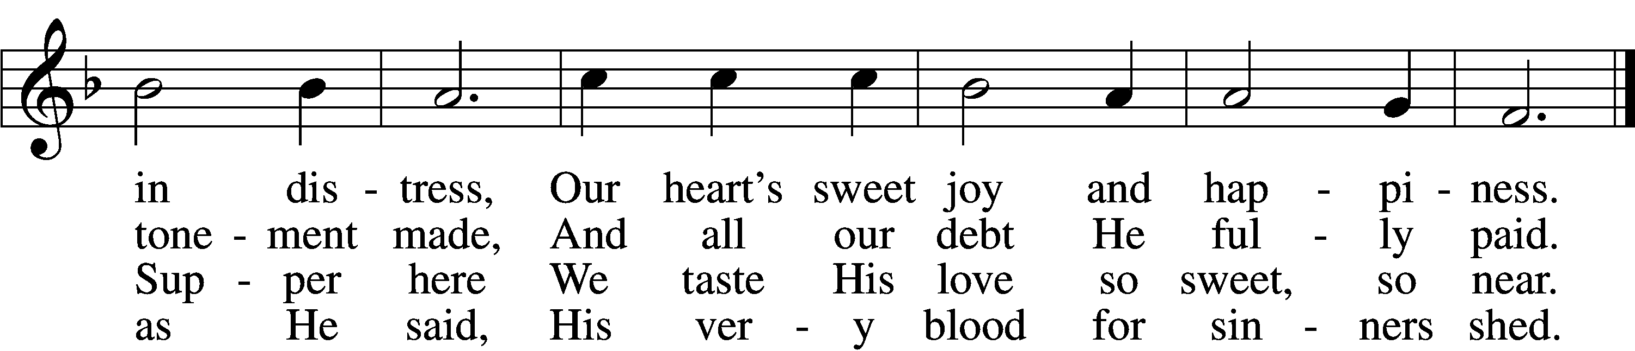

5 We dare not ask how this can be,
But simply hold the mystery
And trust this word where life begins:
“Given and shed for all your sins.”

6 They who this word do not believe
This food unworthily receive,
Salvation here will never find—
May we this warning keep in mind!

7 But blest is each believing guest
Who in these promises finds rest;
For Jesus shall in love remain
With all who here His grace obtain.

8 Help us sincerely to believe
That we may worthily receive
Your Supper and in You find rest.
Amen! They who believe are blest.
Text (sts. 1–4, 6–8): Haquin Spegel, 1645–1714; (sts. 1–4, 6–8): tr. Olof Olsson, 1841–1900, alt.; (st. 5): composite
Tune: Sammlung alter und neuer . . . Melodien, 1742
Text and tune: Public domain

Stand

Nunc Dimittis LSB 199
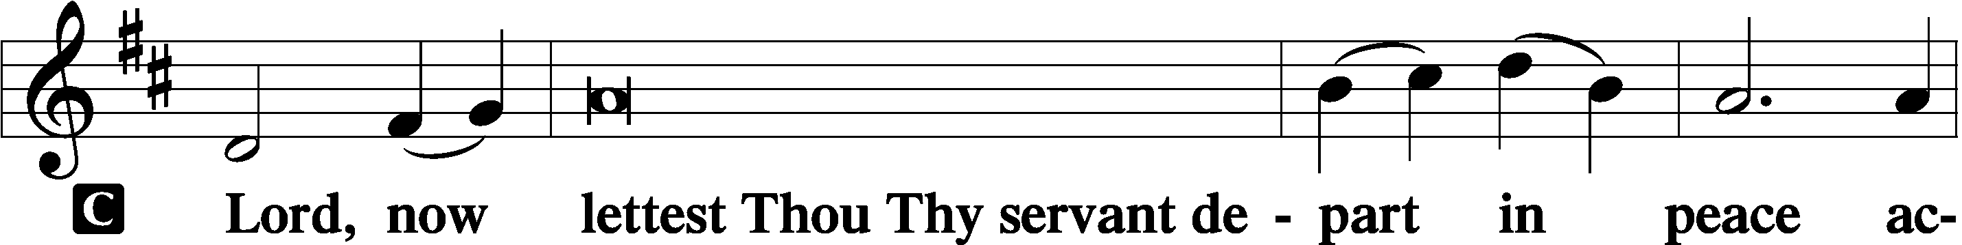

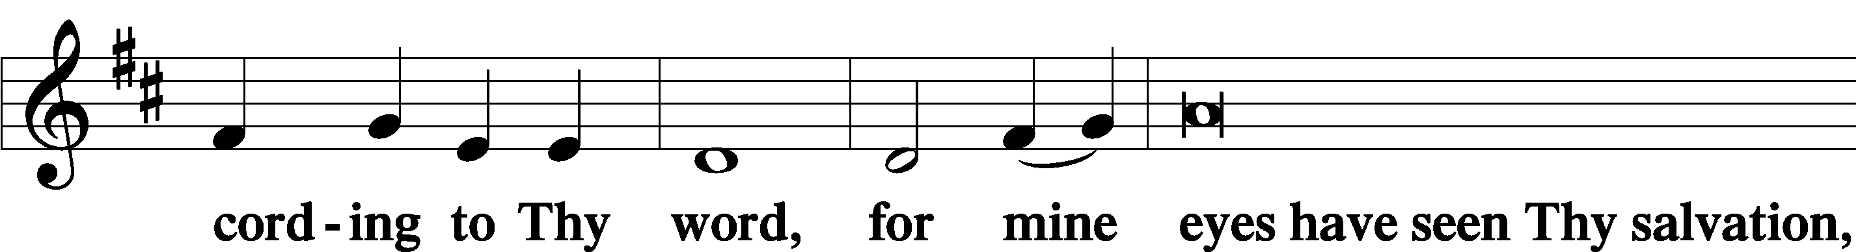

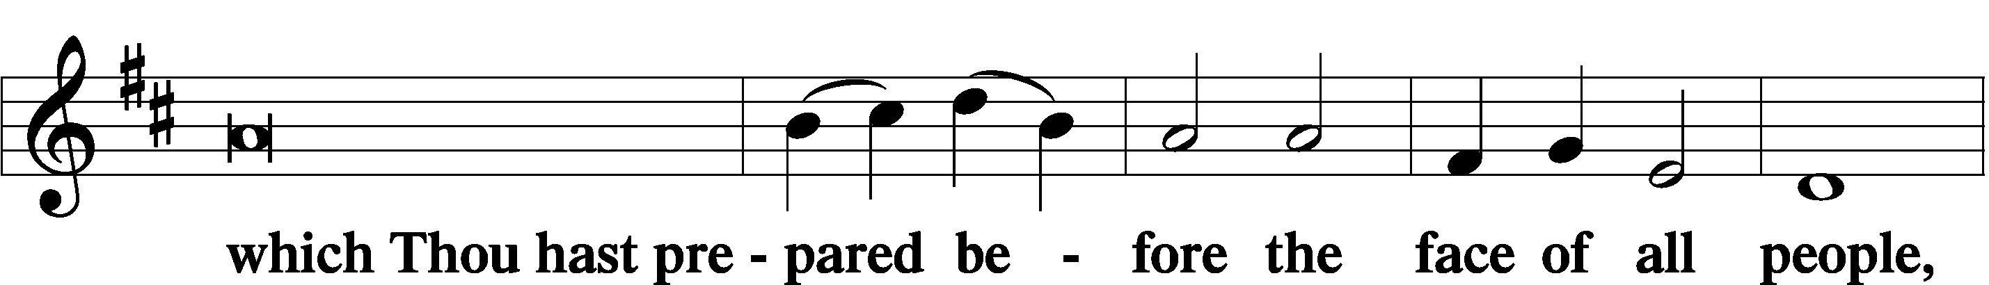

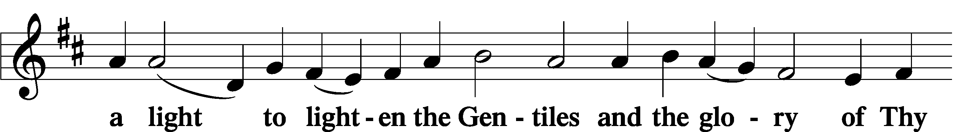

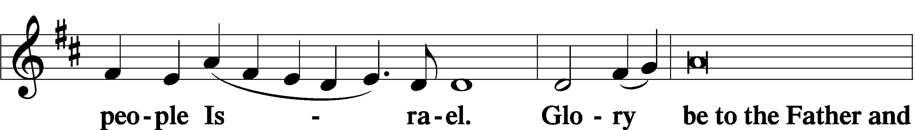

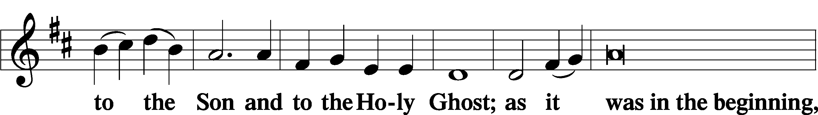

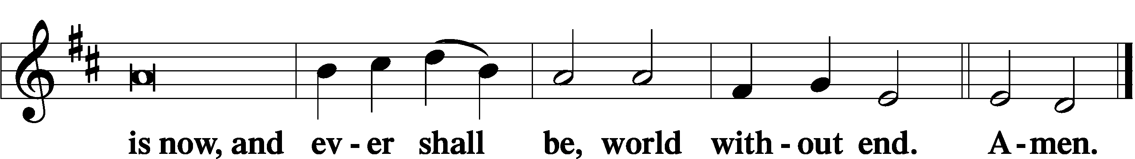

Thanksgiving LSB 200
A O give thanks unto the Lord, for He is good,

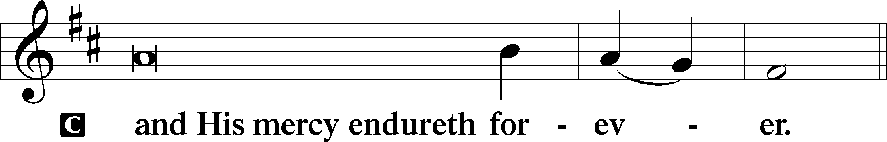

A Let us pray.
O God the Father, the fountain and source of all goodness, who in loving-kindness sent Your only-begotten Son into the flesh, we thank You that for His sake You have given us pardon and peace in this Sacrament, and we ask You not to forsake Your children but always to rule our hearts and minds by Your Holy Spirit that we may be enabled constantly to serve You; through Jesus Christ, Your Son, our Lord, who lives and reigns with You and the Holy Spirit, one God, now and forever.

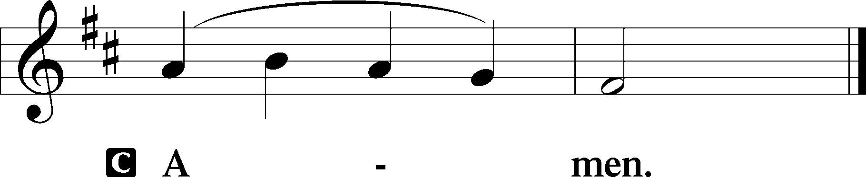

P The Lord be with you.

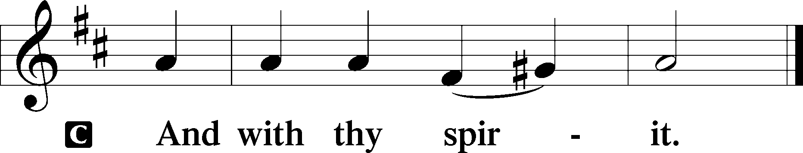

Benedicamus LSB 202
A Bless we the Lord.

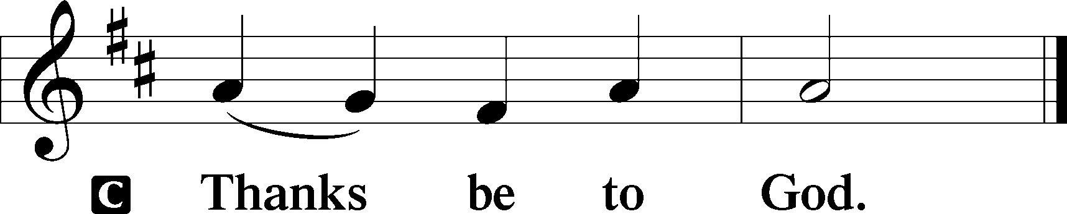

Benediction LSB 202
P The Lord bless you and keep you.
The Lord make His face shine upon you and be gracious unto you.
The Lord lift up His countenance upon you and give you peace.
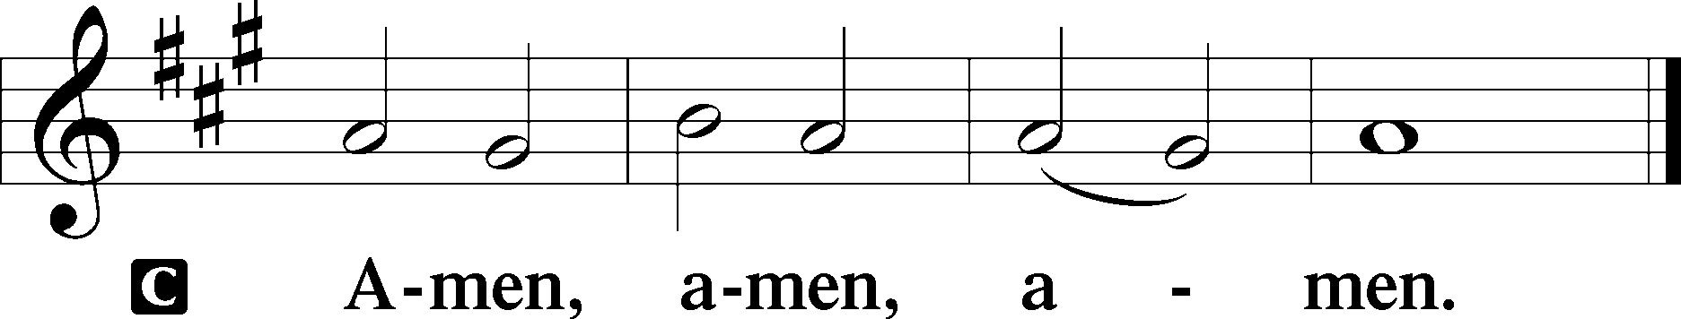

Closing Hymn
880 Now Rest beneath Night’s Shadow
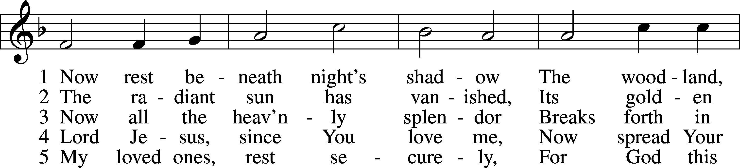
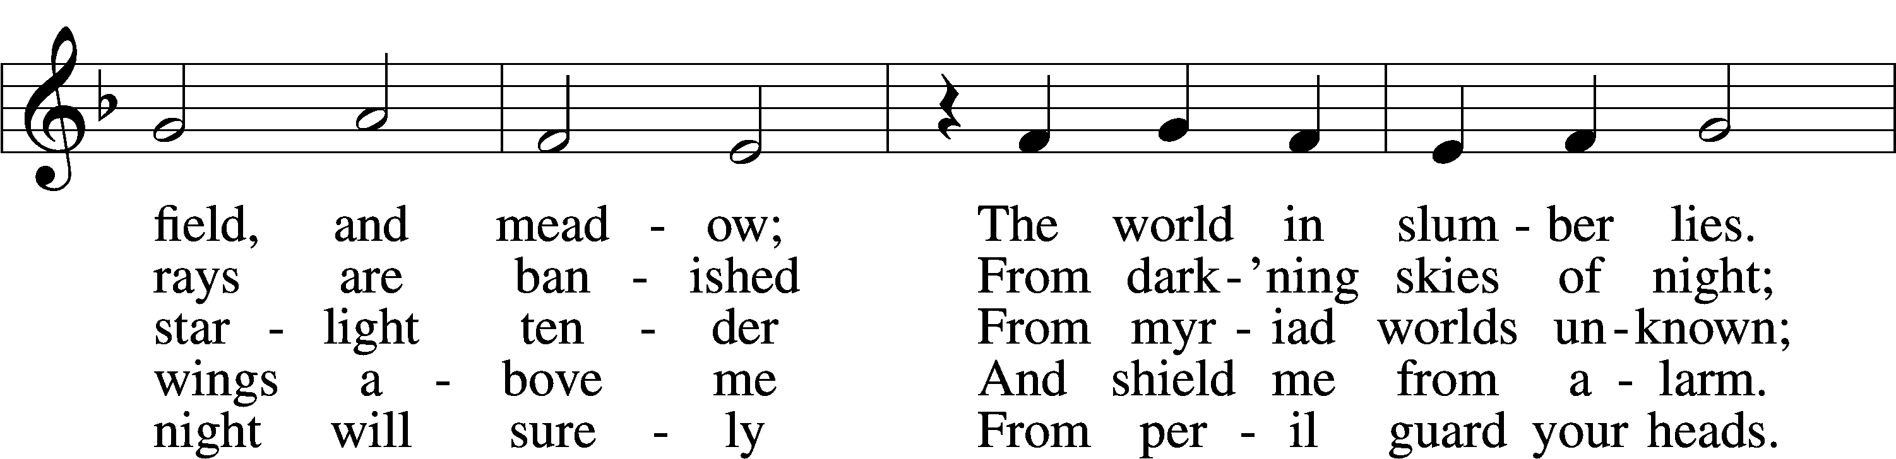
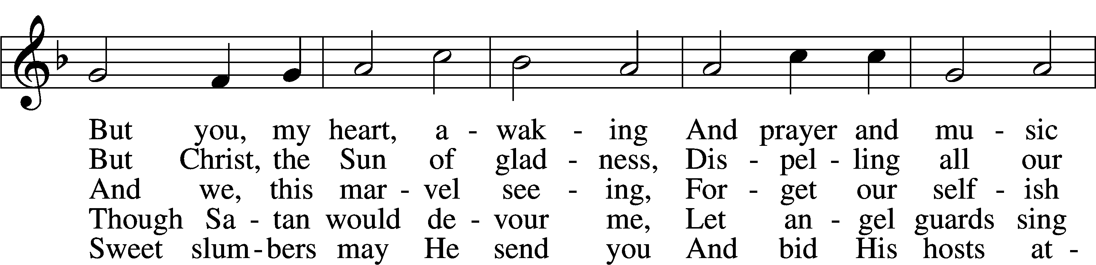
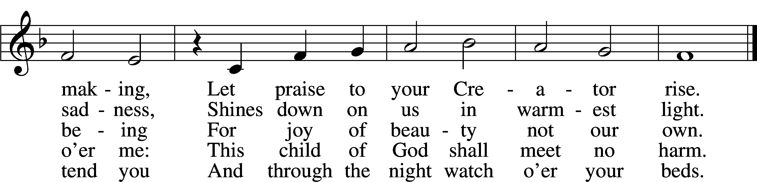
Text: Paul Gerhardt, 1607–76; tr. The Lutheran Hymnal, 1941, alt.
Tune: Heinrich Isaac, c. 1450–1517
Text and tune: Public domain

Acknowledgments
Divine Service, Setting Three from Lutheran Service Book
Unless otherwise indicated, Scripture quotations are from the ESV® Bible (The Holy Bible, English Standard Version®), copyright © 2001 by Crossway, a publishing ministry of Good News Publishers. Used by permission. All rights reserved.
Created by Lutheran Service Builder © 2024 Concordia Publishing House.

