Order of Service — March 29, 2024
(Good Friday)

Welcome/Announcements

Opening Hymn
425 When I Survey the Wondrous Cross
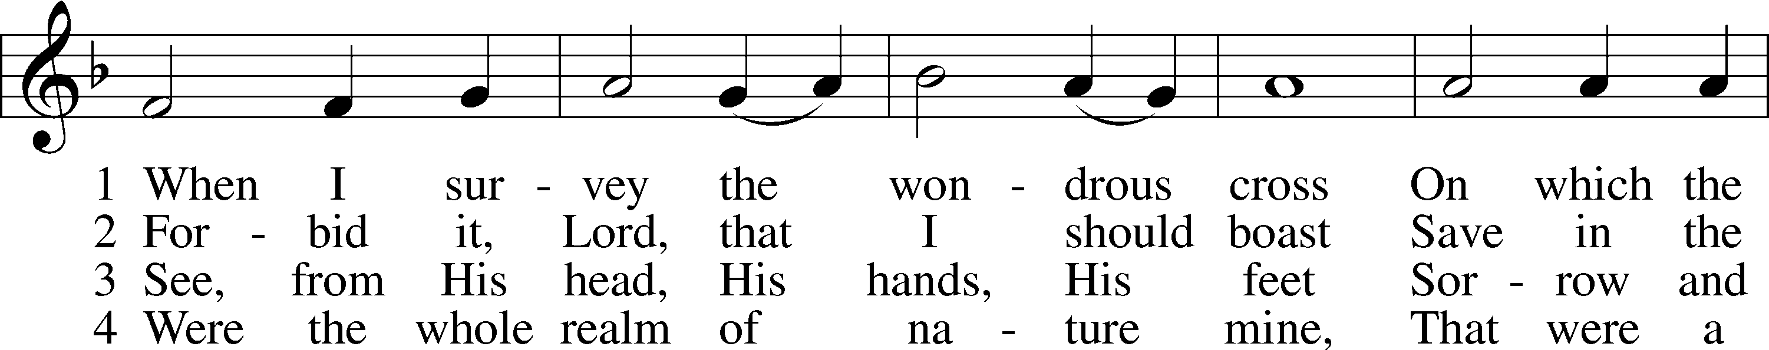
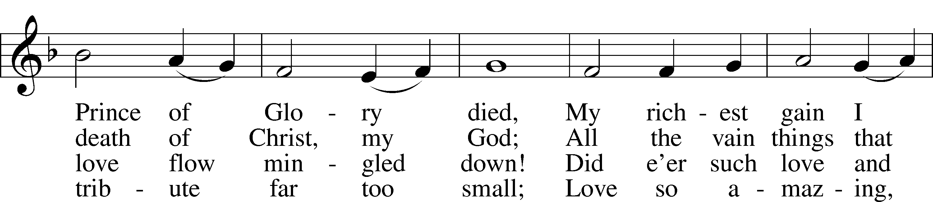
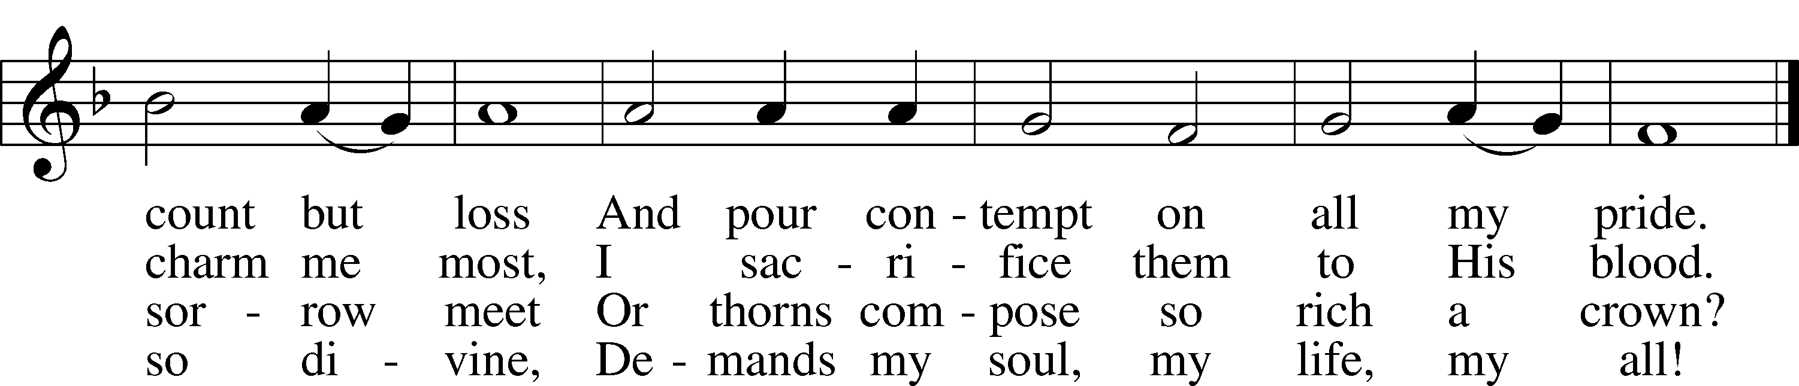
Text: Isaac Watts, 1674–1748
Tune: Lowell Mason, 1792–1872
Text and tune: Public domain

Stand

Invocation/ Confession & Absolution
P In the name of the Father and of the Son and of the Holy Spirit.
C Amen.

P Beloved in the Lord! Let us draw near with a true heart and confess our sins unto God our Father, beseeching Him in the name of our Lord Jesus Christ to grant us forgiveness.

P Our help is in the name of the Lord,
C who made heaven and earth.
P I said, I will confess my transgressions unto the Lord,
C and You forgave the iniquity of my sin.

Silence for reflection on God’s Word and for self-examination.

P O almighty God, merciful Father,
C I, a poor, miserable sinner, confess unto You all my sins and iniquities with which I have ever offended You and justly deserved Your temporal and eternal punishment. But I am heartily sorry for them and sincerely repent of them, and I pray You of Your boundless mercy and for the sake of the holy, innocent, bitter sufferings and death of Your beloved Son, Jesus Christ, to be gracious and merciful to me, a poor, sinful being.

P Upon this your confession, I, by virtue of my office, as a called and ordained servant of the Word, announce the grace of God unto all of you, and in the stead and by the command of my Lord Jesus Christ I forgive you all your sins in the name of the Father and of the Son and of the Holy Spirit.
C Amen.

Introit Psalm 38:1–4, 18, 22; antiphon: Isaiah 53:5
He was wounded for our transgressions; He was crushed for our iniquities;
upon Him was the chastisement that brought us peace, and with His stripes we are healed.
O Lord, rebuke me not in Your anger,
nor discipline me in Your wrath!
For Your arrows have sunk into me,
and Your hand has come down on me.
There is no soundness in my flesh because of Your indignation;
there is no health in my bones because of my sin.
For my iniquities have gone over my head;
like a heavy burden, they are too heavy for me.
I confess my iniquity;
I am sorry for my sin.
Make haste to help me,
O Lord, my salvation!
He was wounded for our transgressions; He was crushed for our iniquities;
upon Him was the chastisement that brought us peace, and with His stripes we are healed.

Kyrie LSB 186
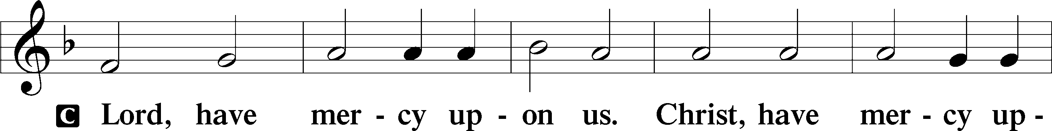
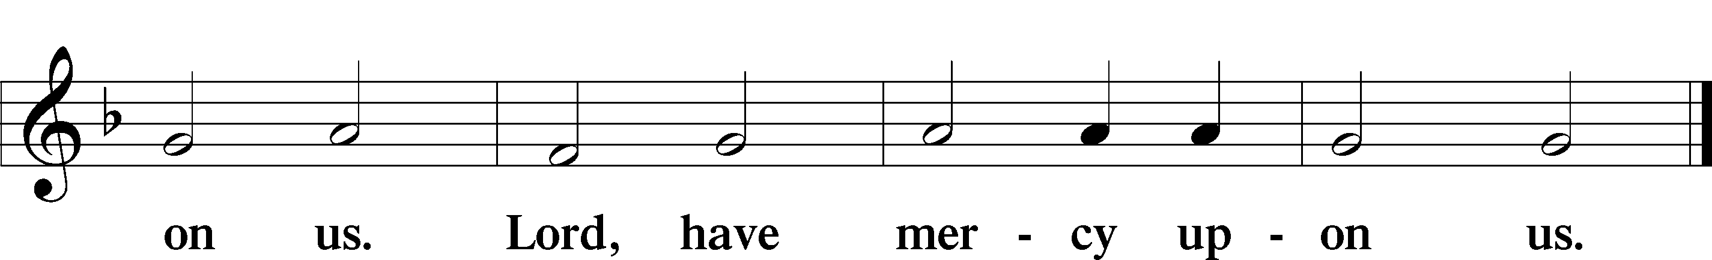

Salutation and Collect of the Day
P The Lord be with you.
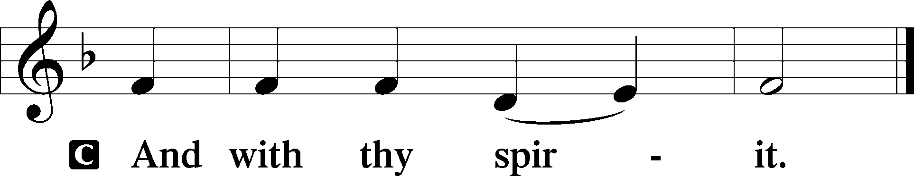

P Let us pray.
Almighty God, graciously behold this Your family for whom our Lord Jesus Christ was willing to be betrayed and delivered into the hands of sinful men to suffer death upon the cross; through the same Jesus Christ, Your Son, our Lord, who lives and reigns with You and the Holy Spirit, one God, now and forever.

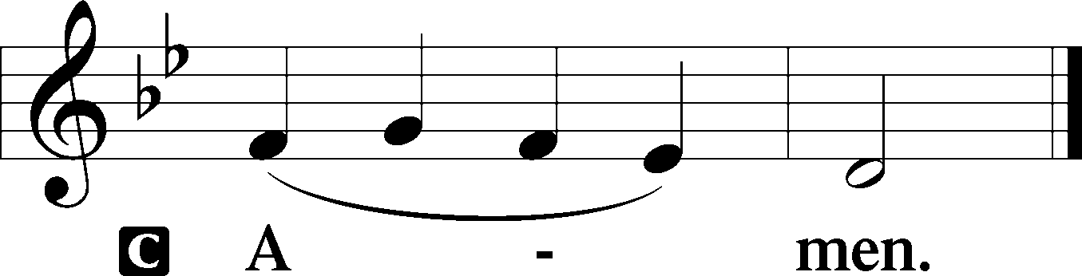

Sit

Old Testament Reading Isaiah 52:13—53:12
¹³Behold, My Servant shall act wisely;
He shall be high and lifted up,
and shall be exalted.
¹⁴As many were astonished at You—
His appearance was so marred, beyond human semblance,
and His form beyond that of the children of mankind—
¹⁵so shall He sprinkle many nations;
kings shall shut their mouths because of Him;
for that which has not been told them they see,
and that which they have not heard they understand.
¹Who has believed what they heard from us?
And to whom has the arm of the Lord been revealed?
²For He grew up before Him like a young plant,
and like a root out of dry ground;
He had no form or majesty that we should look at Him,
and no beauty that we should desire Him.
³He was despised and rejected by men;
a Man of Sorrows, and acquainted with grief;
and as one from whom men hide their faces
He was despised, and we esteemed Him not.
⁴Surely He has borne our griefs
and carried our sorrows;
yet we esteemed Him stricken,
smitten by God, and afflicted.
⁵But He was wounded for our transgressions;
He was crushed for our iniquities;
upon Him was the chastisement that brought us peace,
and with His stripes we are healed.
⁶All we like sheep have gone astray;
we have turned every one to his own way;
and the Lord has laid on Him
the iniquity of us all.
⁷He was oppressed, and He was afflicted,
yet He opened not His mouth;
like a lamb that is led to the slaughter,
and like a sheep that before its shearers is silent,
so He opened not His mouth.
⁸By oppression and judgment He was taken away;
and as for His generation, who considered
that He was cut off out of the land of the living,
stricken for the transgression of My people?
⁹And they made His grave with the wicked
and with a rich man in His death,
although He had done no violence,
and there was no deceit in His mouth.
¹⁰Yet it was the will of the Lord to crush Him;
He has put Him to grief;
when His soul makes an offering for sin,
He shall see His offspring; He shall prolong His days;
the will of the Lord shall prosper in His hand.
¹¹Out of the anguish of His soul He shall see and be satisfied;
by His knowledge shall the Righteous One — My Servant —
make many to be accounted righteous,
and He shall bear their iniquities.
¹²Therefore I will divide Him a portion with the many,
and He shall divide the spoil with the strong,
because He poured out His soul to death
and was numbered with the transgressors;
yet He bore the sin of many,
and makes intercession for the transgressors.

A This is the Word of the Lord.
C Thanks be to God.

Epistle Hebrews 4:14–16; 5:7–9
¹⁴Since then we have a great High Priest who has passed through the heavens — Jesus, the Son of God — let us hold fast our confession. ¹⁵For we do not have a High Priest who is unable to sympathize with our weaknesses, but One who in every respect has been tempted as we are, yet without sin. ¹⁶Let us then with confidence draw near to the throne of grace, that we may receive mercy and find grace to help in time of need. . . . ⁷In the days of His flesh, Jesus offered up prayers and supplications, with loud cries and tears, to Him who was able to save Him from death, and He was heard because of His reverence. ⁸Although He was a Son, He learned obedience through what He suffered. ⁹And being made perfect, He became the source of eternal salvation to all who obey Him.

A This is the Word of the Lord.
C Thanks be to God.

Stand

Holy Gospel John 18:1—19:42
P The Holy Gospel according to St. John, the eighteenth chapter.

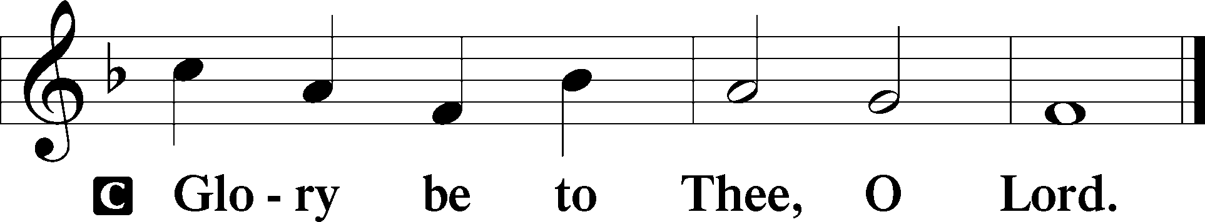

²⁸Then they led Jesus from the house of Caiaphas to the governor’s headquarters. It was early morning. They themselves did not enter the governor’s headquarters, so that they would not be defiled, but could eat the Passover. ²⁹So Pilate went outside to them and said, “What accusation do you bring against this Man?” ³⁰They answered him, “If this Man were not doing evil, we would not have delivered Him over to you.” ³¹Pilate said to them, “Take Him yourselves and judge Him by your own law.” The Jews said to him, “It is not lawful for us to put anyone to death.” ³²This was to fulfill the word that Jesus had spoken to show by what kind of death He was going to die.

³³So Pilate entered his headquarters again and called Jesus and said to him and said, “Are You the King of the Jews?” ³⁴Jesus answered, “Do you say this of your own accord, or did others say it to you about Me?” ³⁵Pilate answered, “Am I a Jew? Your own nation and the chief priests have delivered You over to me. What have You done?” ³⁶Jesus answered, “My Kingdom is not of this world. If My Kingdom were of this world, My servants would have been fighting, that I might not be delivered over to the Jews. But My Kingdom is not from the world.” ³⁷Then Pilate said to Him, “So You are a king?” Jesus answered, “You say that I am a king. For this purpose I was born and for this purpose I have come into the world—to bear witness to the Truth. Everyone who is of the Truth listens to My voice.” ³⁸Pilate said to Him, “And what is Truth?”

After Pilate had said this, he went back outside to the Jews and told them, “I find no guilt in Him. ³⁹But you have a custom that I should release one man for you at the Passover. So do you want me to release to you the King of the Jews?” ⁴⁰They cried out again, “Not this Man, but Barabbas!” Now Barabbas was a robber.

¹Then Pilate took Jesus and flogged Him. ²And the soldiers twisted together a crown of thorns and put it on His head and arrayed Him in a purple robe. ³They came up to Him, saying, “Hail, King of the Jews!” and struck Him with their hands. ⁴Pilate went out again and said to them, “See, I am bringing Him out to you that you may know that I find no guilt in Him.” ⁵So Jesus came out, wearing the crown of thorns and the purple robe. Pilate said to them, “Behold the Man!” ⁶When the chief priests and the officers saw Him, they cried out, “Crucify Him, crucify Him!” Pilate said to them, “Take Him yourselves and crucify Him, for I find no guilt in Him.” ⁷The Jews answered him, “We have a law, and according to that law He ought to die because He has made Himself the Son of God.” ⁸When Pilate heard this statement, he was even more afraid. ⁹He entered his headquarters again and said to Jesus, “Where are You from?” But Jesus gave him no answer. ¹⁰So Pilate said to Him, “You will not speak to me? Do You not know that I have authority to release You and authority to crucify You?” ¹¹Jesus answered him, “You would have no authority over Me at all unless it had been given you from above. Therefore he who delivered Me over to you has the greater sin.”

¹²From then on Pilate sought to release Him, but the Jews cried out, “If you release this Man, you are not Caesar’s friend. Everyone who makes himself a king opposes Caesar.” ¹³So when Pilate heard these words, he brought Jesus out and sat down on the judgment seat at a place called “The Stone Pavement”, and in Aramaic Gabbatha. ¹⁴Now it was the day of Preparation of the Passover. It was about the sixth hour. He said to the Jews, “Behold your King!” ¹⁵They cried out, “Away with Him, away with Him, crucify Him!” Pilate said to them, “Shall I crucify your King?” The chief priests answered, “We have no king but Caesar.” ¹⁶So he delivered Him over to them to be crucified.

So they took Jesus, ¹⁷and He went out, bearing His own cross, to the place called the “Place of a Skull”, which in Aramaic is called Golgotha. ¹⁸There they crucified Him, and with Him two others — one on either side, and Jesus between them. ¹⁹Pilate also wrote an inscription and put it on the cross. It read, “Jesus of Nazareth, the King of the Jews.” ²⁰Many of the Jews read this inscription, for the place where Jesus was crucified was near the city, and it was written in Aramaic, in Latin, and in Greek. ²¹So the chief priests of the Jews said to Pilate, “Do not write, ‘The King of the Jews,’ but rather, ‘This man said, I am King of the Jews.’” ²²Pilate answered, “What I have written I have written.”

²³When the soldiers had crucified Jesus, they took His garments and divided them into four parts — one part for each soldier — also His tunic. But the tunic was seamless, woven in one piece from top to bottom, ²⁴so they said to one another, “Let us not tear it, but cast lots for it to see whose it shall be.” This was to fulfill the Scripture which says, “They divided My garments among them, and for My clothing they cast lots.” So the soldiers did these things. ²⁵But standing by the cross of Jesus were His mother; and His mother’s sister, Mary the wife of Clopas; and Mary Magdalene. ²⁶When Jesus saw His mother and the disciple whom He loved standing nearby, He said to His mother, “Woman, behold, your Son!” ²⁷Then He said to the disciple, “Behold, your mother!” And from that hour the disciple took her to his own home.

²⁸After this, Jesus — knowing that all was now finished — said (to fulfill the Scripture), “I thirst.” ²⁹A jar full of sour wine stood there, so they put a sponge full of the sour wine on a hyssop branch and held it to His mouth. ³⁰When Jesus had received the sour wine, He said, “It is finished,” and He bowed His head and gave up His spirit.

³¹Since it was the Day of Preparation, and so that the bodies would not remain on the cross on the Sabbath (for that Sabbath was a high day), the Jews asked Pilate that their legs might be broken and that they might be taken away. ³²So the soldiers came and broke the legs of the first, and of the other who had been crucified with Him. ³³But when they came to Jesus and saw that He was already dead, they did not break His legs. ³⁴But one of the soldiers pierced His side with a spear, and at once there came out blood and water. ³⁵He who saw it has borne witness—his testimony is true, and he knows that he is telling the truth—that you also may believe. ³⁶For these things took place that the Scripture might be fulfilled: “Not one of His bones will be broken.” ³⁷And again another Scripture says, “They will look on Him whom they have pierced.”

³⁸After these things, Joseph of Arimathea — who was a disciple of Jesus, but secretly for fear of the Jews — asked Pilate that he might take away the body of Jesus, and Pilate gave him permission. So he came and took away His body. ³⁹Nicodemus — who earlier had come to Jesus by night — also came, bringing a mixture of myrrh and aloes, about seventy-five pounds in weight. ⁴⁰So they took the body of Jesus and bound it in linen cloths with the spices, as is the burial custom of the Jews. ⁴¹Now in the place where He was crucified there was a garden, and in the garden a new tomb in which no one had yet been laid. ⁴²So because of the Jewish Day of Preparation, since the tomb was close at hand, they laid Jesus there.

P This is the Gospel of the Lord.

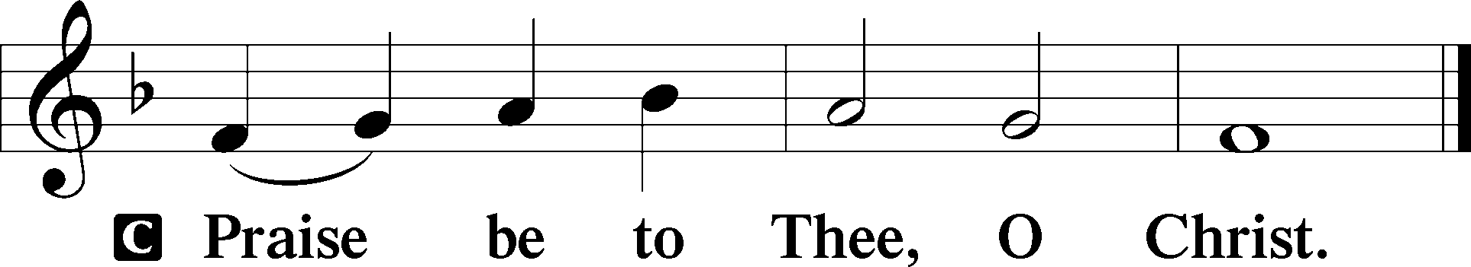

Nicene Creed
C I believe in one God,
the Father Almighty,
Maker of heaven and earth
and of all things visible and invisible.

And in one Lord Jesus Christ,
the only-begotten Son of God,
begotten of His Father before all worlds,
God of God, Light of Light,
Very God of Very God,
begotten, not made,
being of one substance with the Father,
by whom all things were made;
who for us men and for our salvation came down from heaven
and was incarnate by the Holy Spirit of the virgin Mary
and was made man;
and was crucified also for us under Pontius Pilate.
He suffered and was buried.
And the third day He rose again according to the Scriptures
and ascended into heaven
and sits at the right hand of the Father.
And He will come again with glory to judge both the living and the dead,
whose kingdom will have no end.

And I believe in the Holy Spirit,
the Lord and Giver of life,
who proceeds from the Father and the Son,
who with the Father and the Son together is worshiped and glorified,
who spoke by the prophets.
And I believe in one holy Christian and apostolic Church,
I acknowledge one Baptism for the remission of sins,
and I look for the resurrection of the dead
and the life of the world to come. Amen.

Sit

Sermon Hymn
450 O Sacred Head, Now Wounded
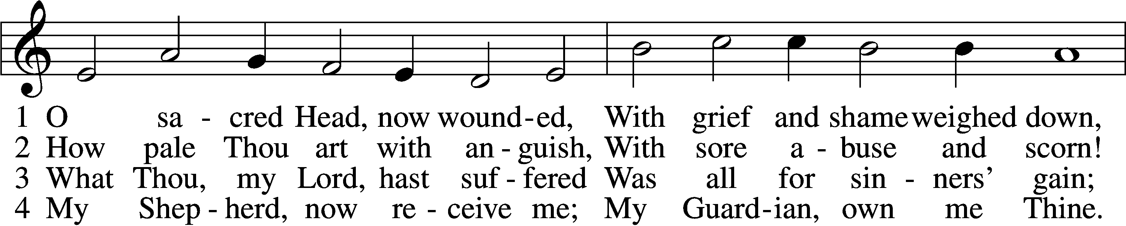
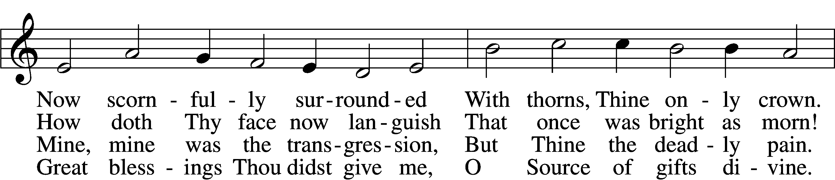
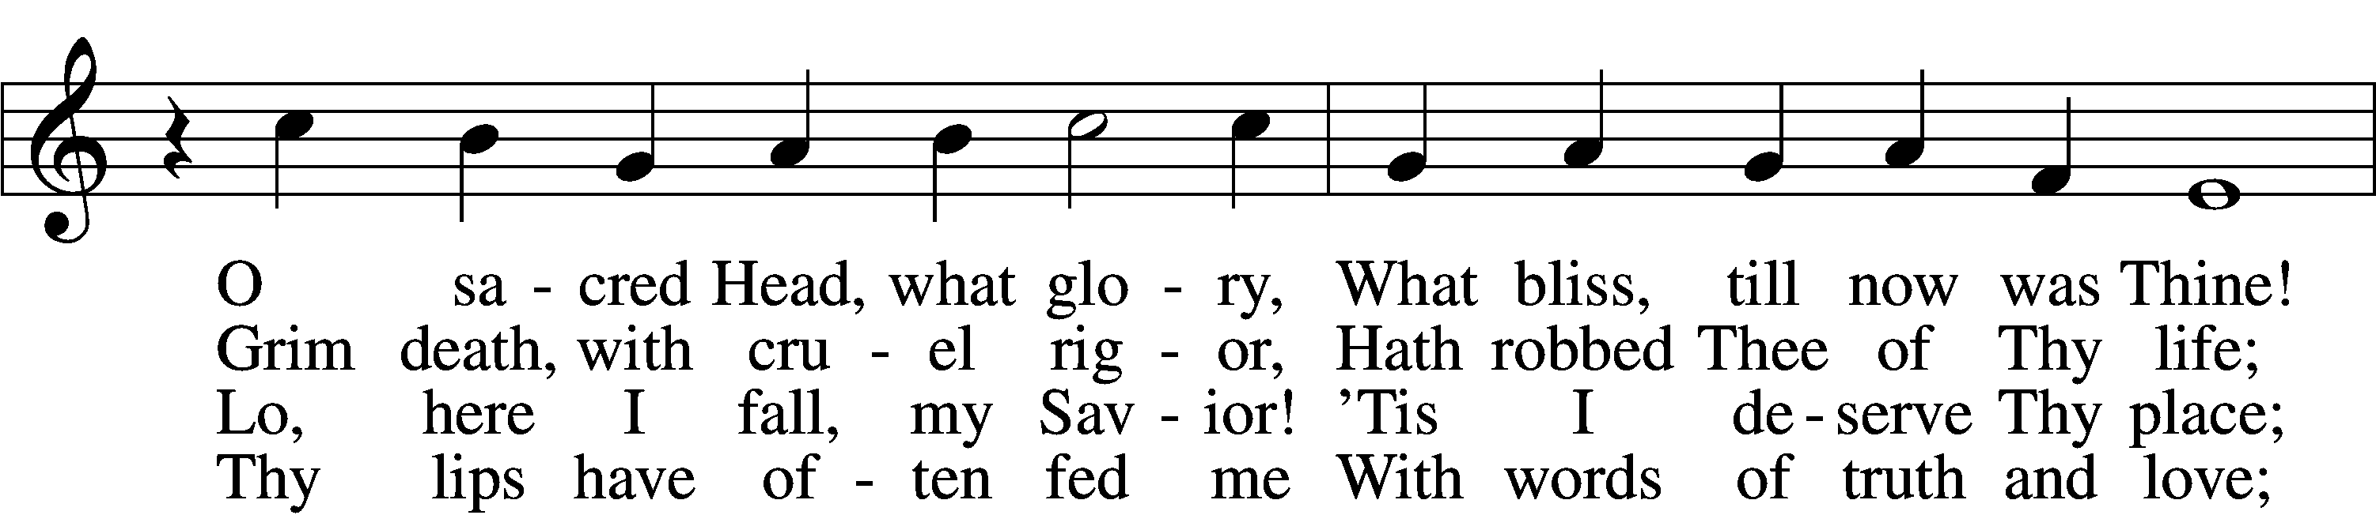
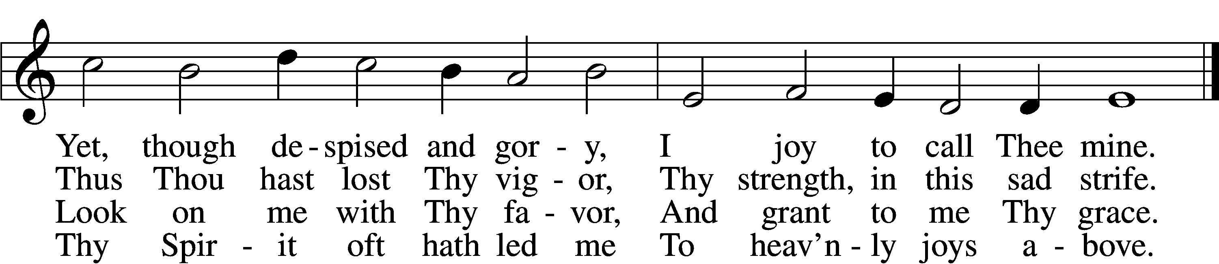

5 What language shall I borrow
To thank Thee, dearest Friend,
For this Thy dying sorrow,
Thy pity without end?
O make me Thine forever!
And should I fainting be,
Lord, let me never, never,
Outlive my love for Thee.

6 My Savior, be Thou near me
When death is at my door;
Then let Thy presence cheer me,
Forsake me nevermore!
When soul and body languish,
O leave me not alone,
But take away mine anguish
By virtue of Thine own!

7 Be Thou my consolation,
My shield, when I must die;
Remind me of Thy passion
When my last hour draws nigh.
Mine eyes shall then behold Thee,
Upon Thy cross shall dwell,
My heart by faith enfold Thee.
Who dieth thus dies well.
Text: attr. Bernard of Clairvaux, 1091–1153; German version, Paul Gerhardt, 1607–76; tr. The Lutheran Hymnal, 1941, alt.
Tune: Hans Leo Hassler, 1564–1612
Text: © 1941 Concordia Publishing House. Used by permission: LSB Hymn License no. 110002874
Tune: Public domain

Sermon

Stand

Offertory LSB 192
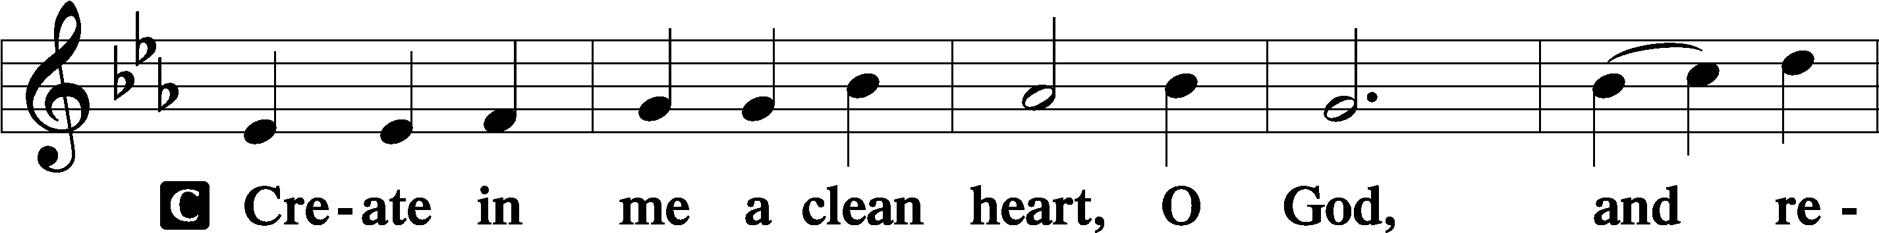
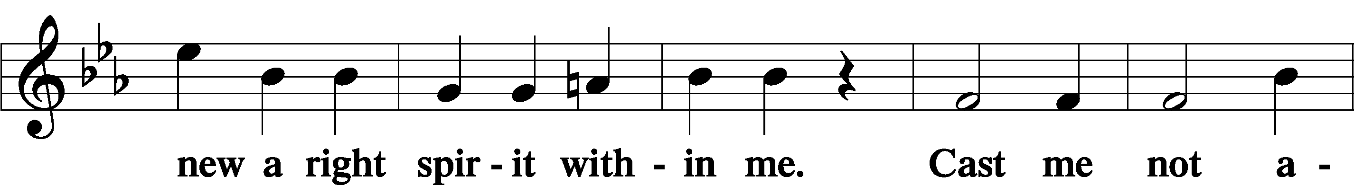
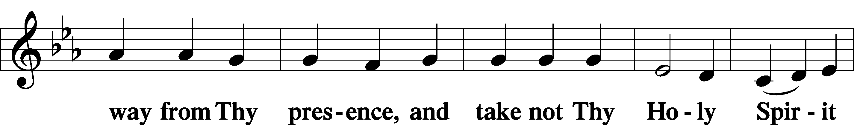
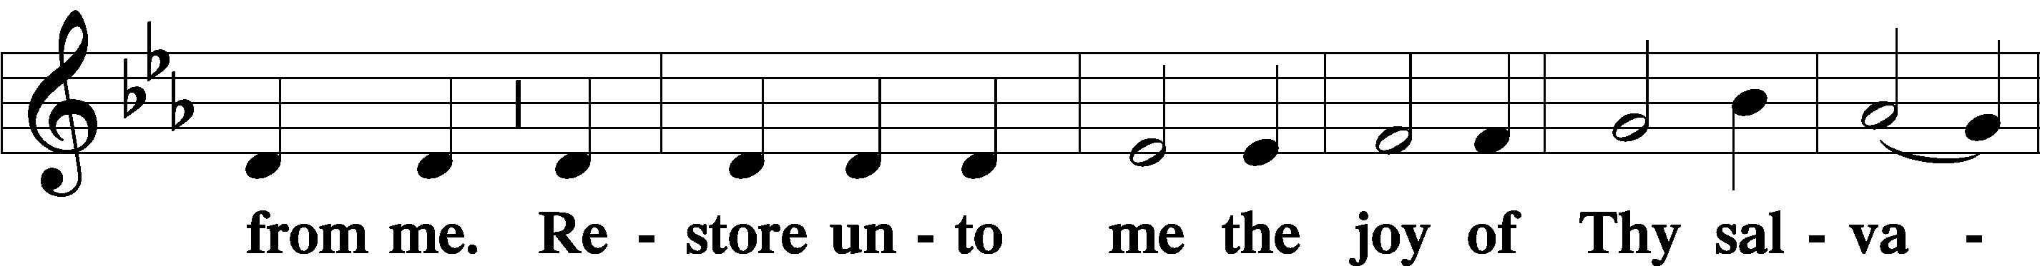
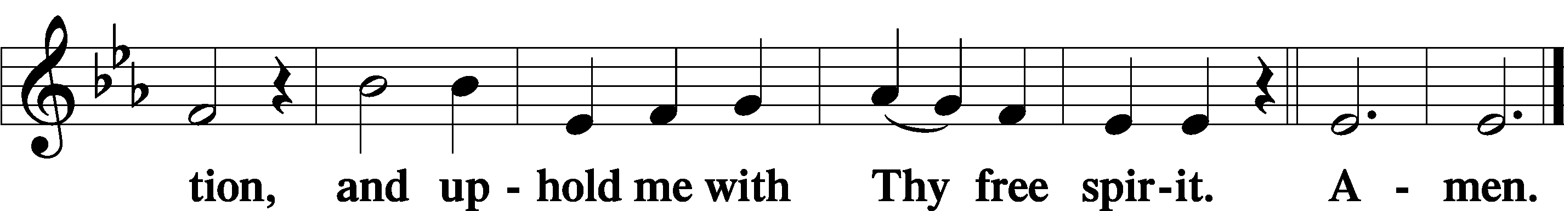

Sit

Offering

Stand

Prayer of the Church

Preface LSB 194
P The Lord be with you.
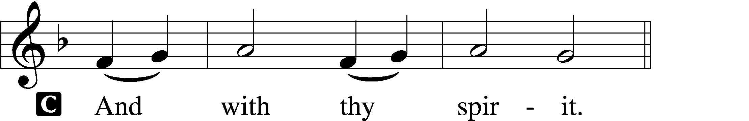

P Lift up your hearts.
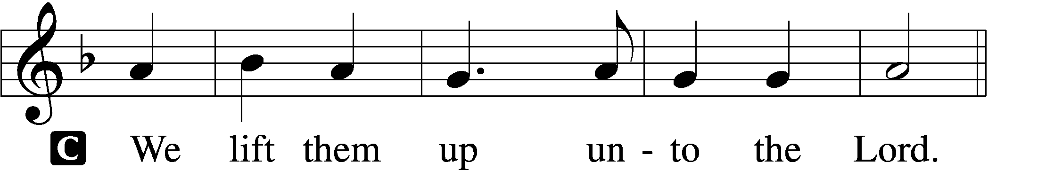

P Let us give thanks unto the Lord, our God.
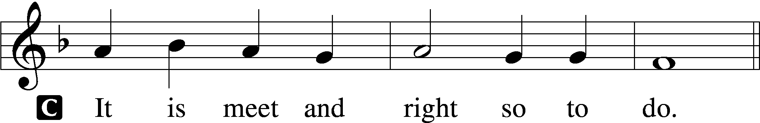

P It is truly meet, right, and salutary that we should at all times and in all places give thanks to You, holy Lord, almighty Father, everlasting God, through Jesus Christ, our Lord, who accomplished the salvation of mankind by the tree of the cross that, where death arose, there life also might rise again and that the serpent who overcame by the tree of the garden might likewise by the tree of the cross be overcome. Therefore with angels and archangels and with all the company of heaven we laud and magnify Your glorious name, evermore praising You and saying:

Sanctus LSB 195
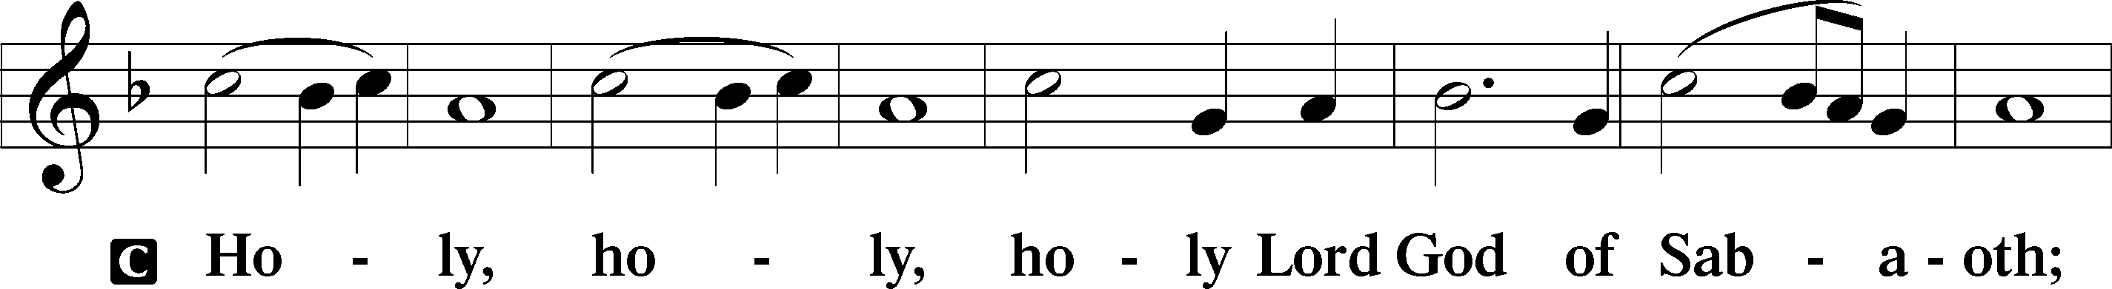
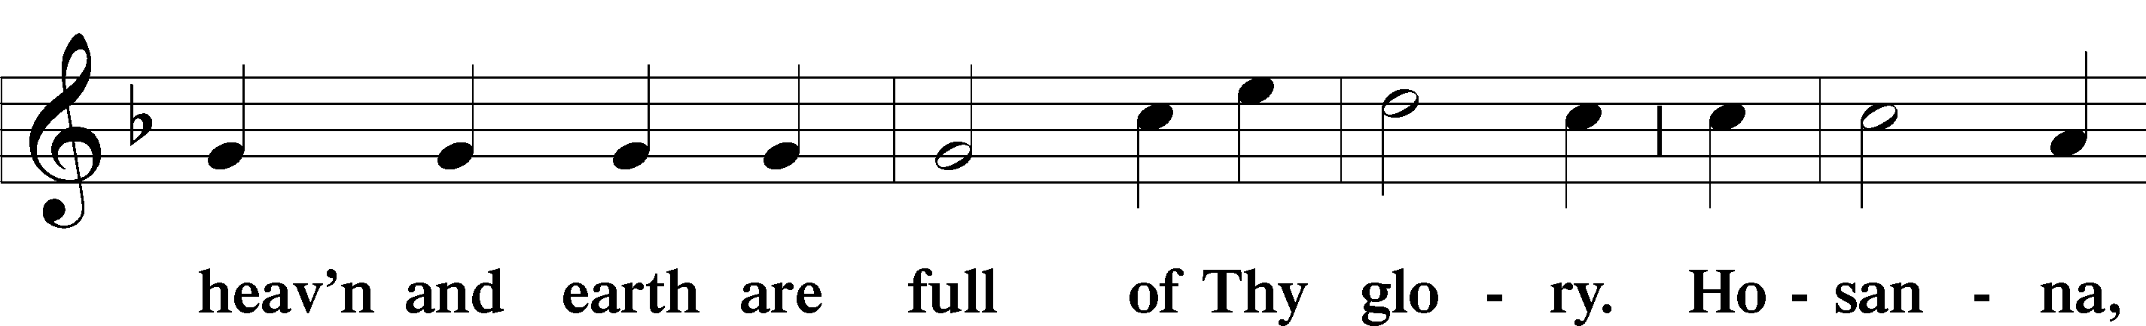
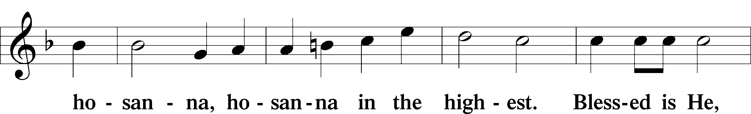
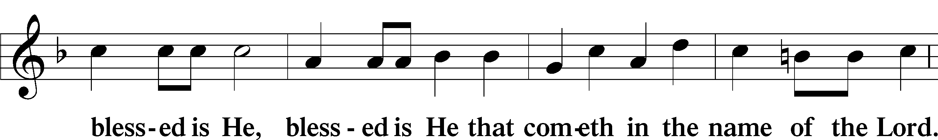
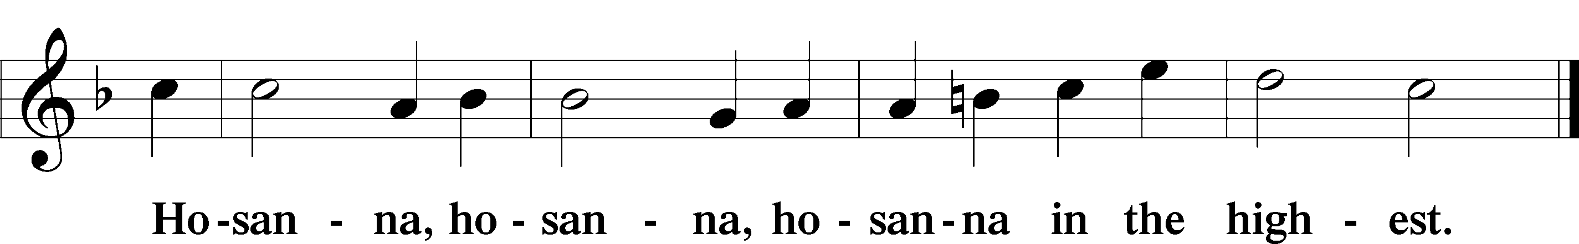

Lord’s Prayer LSB 196
P Our Father who art in heaven,
hallowed be Thy name,
Thy kingdom come,
Thy will be done on earth as it is in heaven;
give us this day our daily bread;
and forgive us our trespasses as we forgive those who trespass against us;
and lead us not into temptation,
but deliver us from evil.
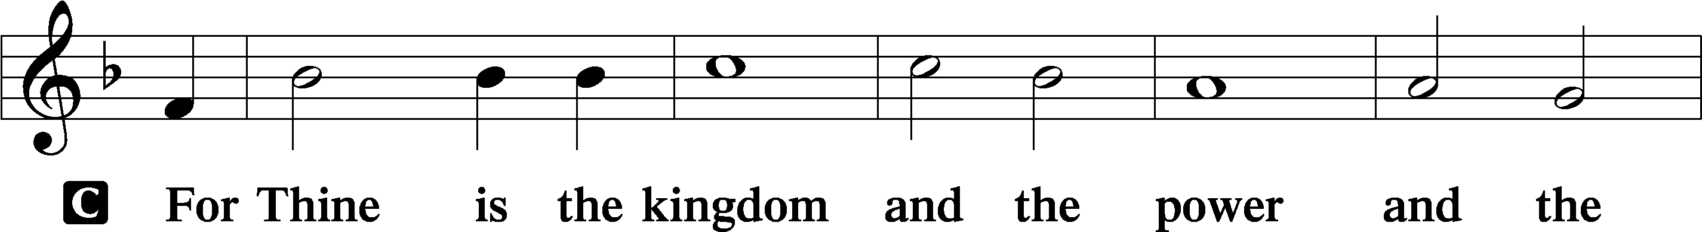
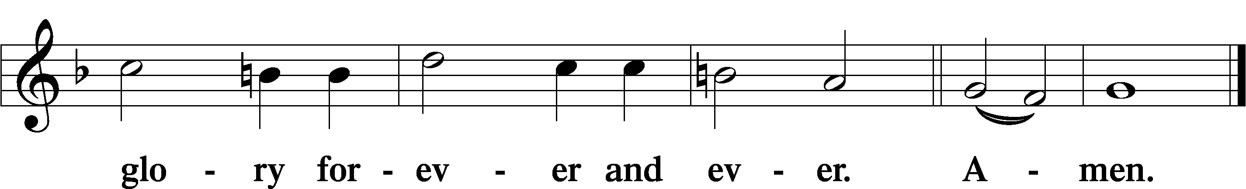

The Words of Our Lord LSB 197
P Our Lord Jesus Christ, on the night when He was betrayed, took bread, and when He had given thanks, He broke it and gave it to the disciples and said: “Take, eat; this is My body, which is given for you. This do in remembrance of Me.”

In the same way also He took the cup after supper, and when He had given thanks, He gave it to them, saying: “Drink of it, all of you; this cup is the new testament in My blood, which is shed for you for the forgiveness of sins. This do, as often as you drink it, in remembrance of Me.”

Pax Domini LSB 197
P The peace of the Lord be with you always.

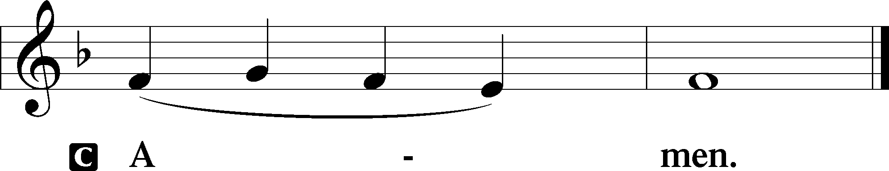

Agnus Dei LSB 198
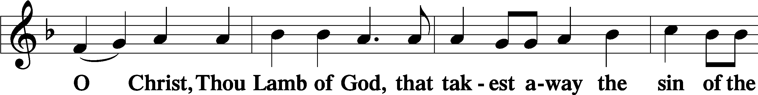
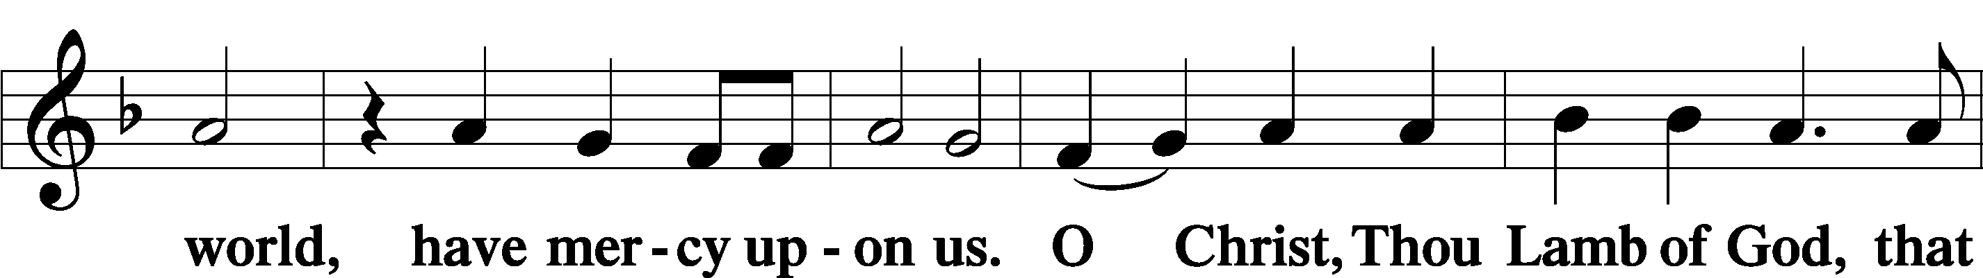
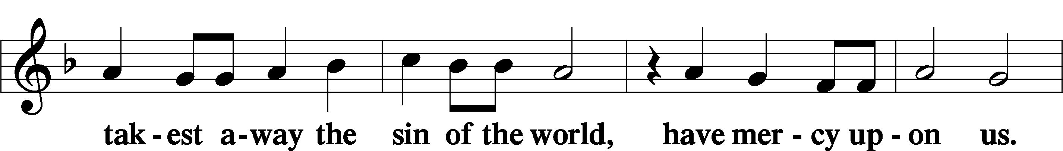
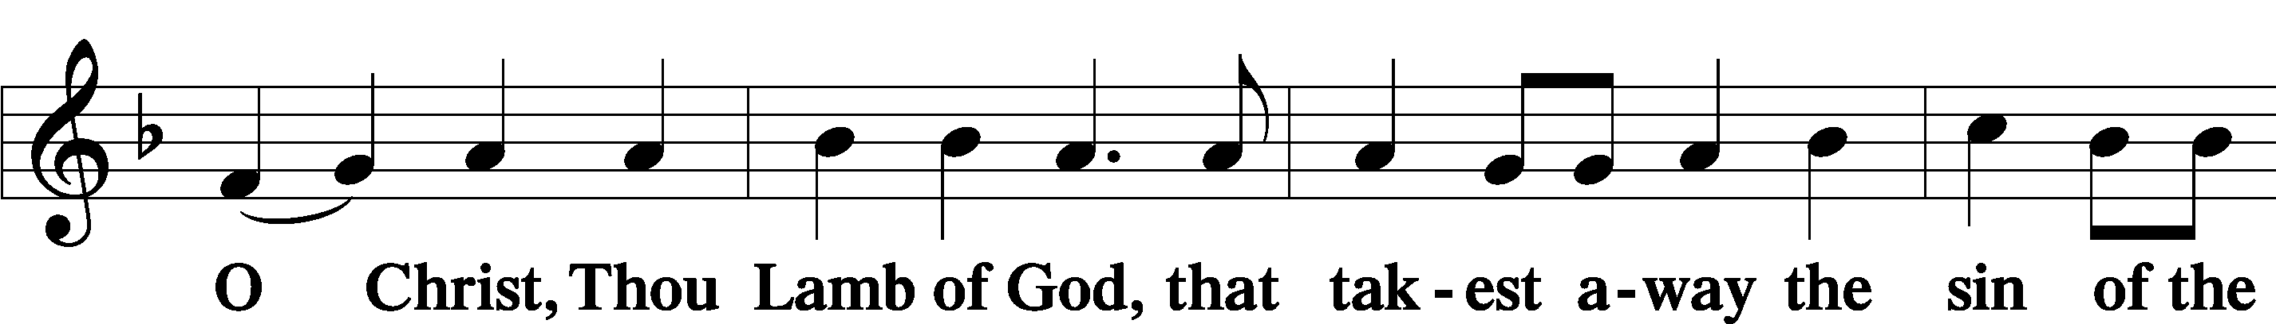
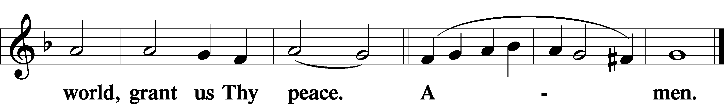

Sit

— The Distribution —

Distribution Hymn
453 Upon the Cross Extended
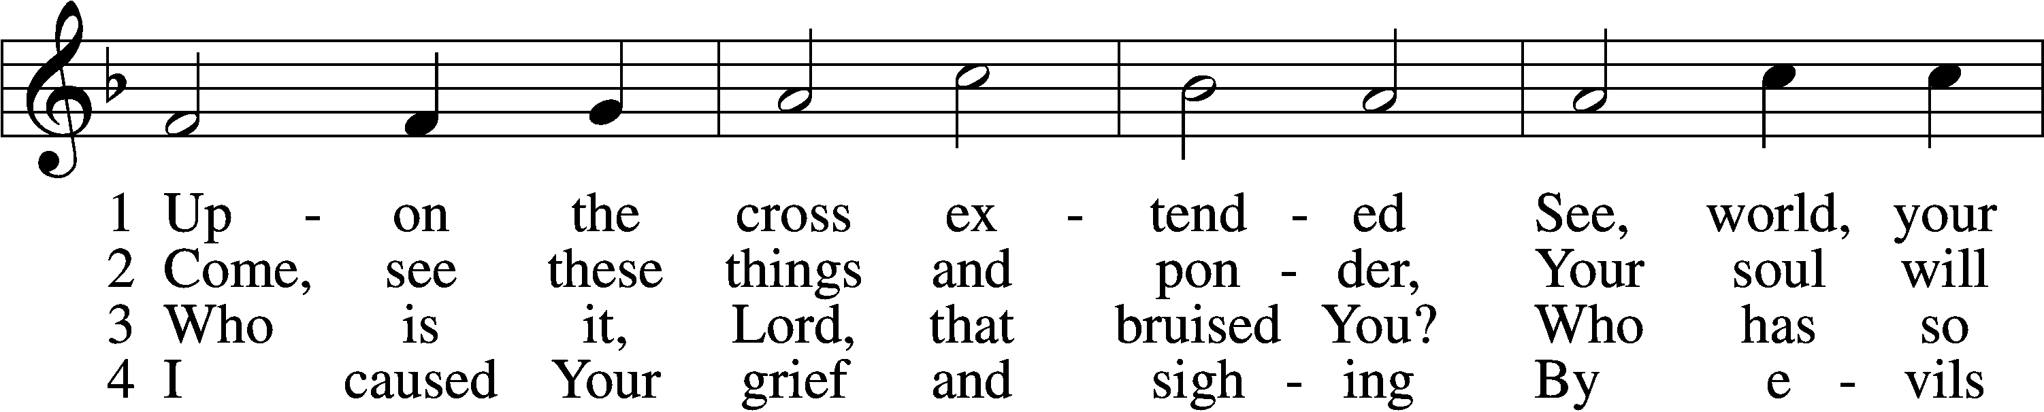
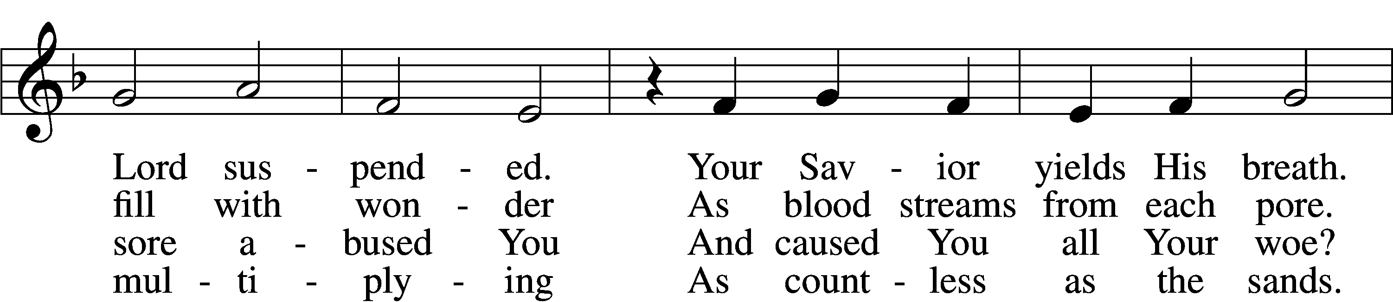
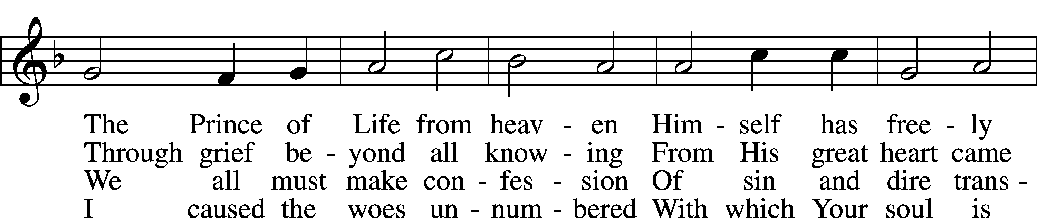
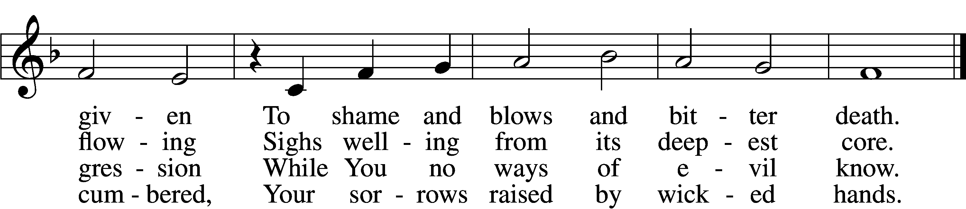

5 Your soul in griefs unbounded,
Your head with thorns surrounded,
You died to ransom me.
The cross for me enduring,
The crown for me securing,
You healed my wounds and set me free.

6 Your cords of love, my Savior,
Bind me to You forever,
I am no longer mine.
To You I gladly tender
All that my life can render
And all I have to You resign.

7 Your cross I place before me;
Its saving pow’r restore me,
Sustain me in the test.
It will, when life is ending,
Be guiding and attending
My way to Your eternal rest.
Text: Paul Gerhardt, 1607–76; tr. John Kelly, 1833–90, alt.
Tune: Heinrich Isaac, c. 1450–1517
Text and tune: Public domain

Stand

Nunc Dimittis LSB 199
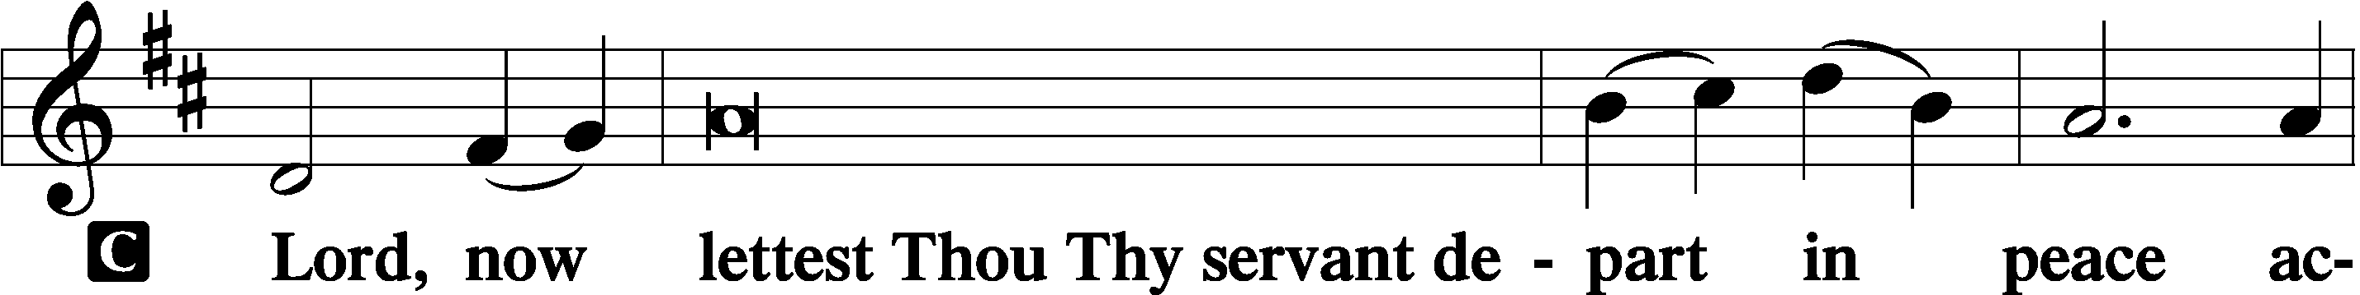

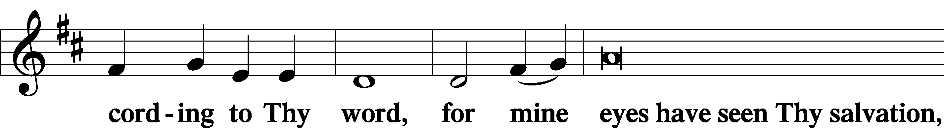

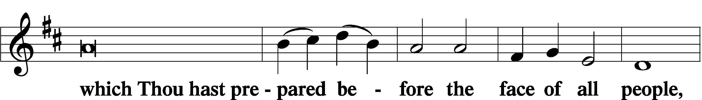

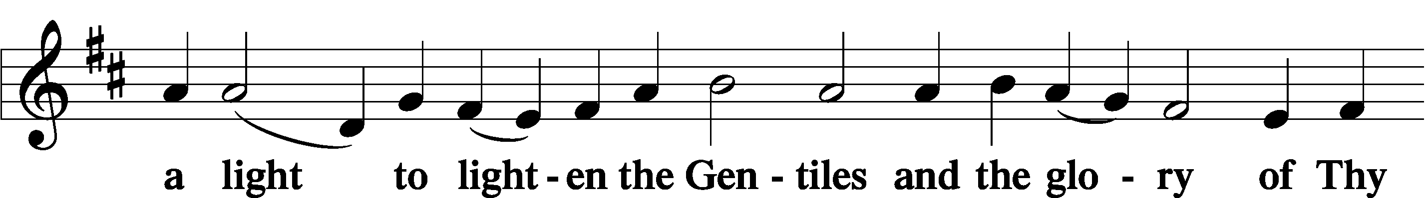

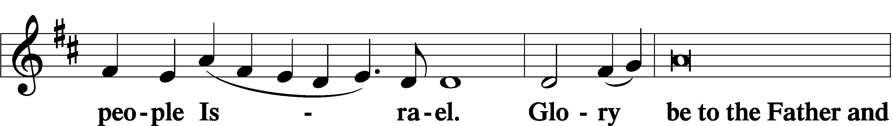

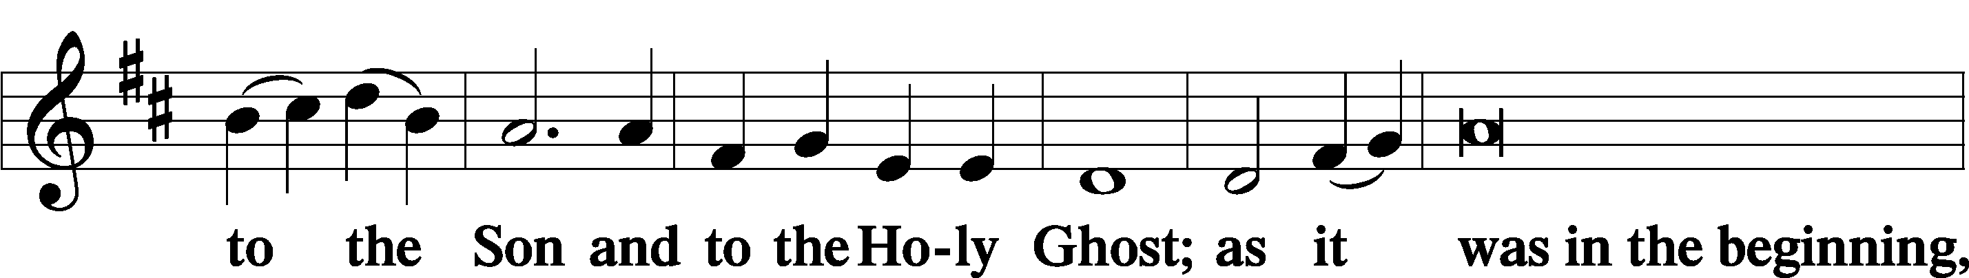

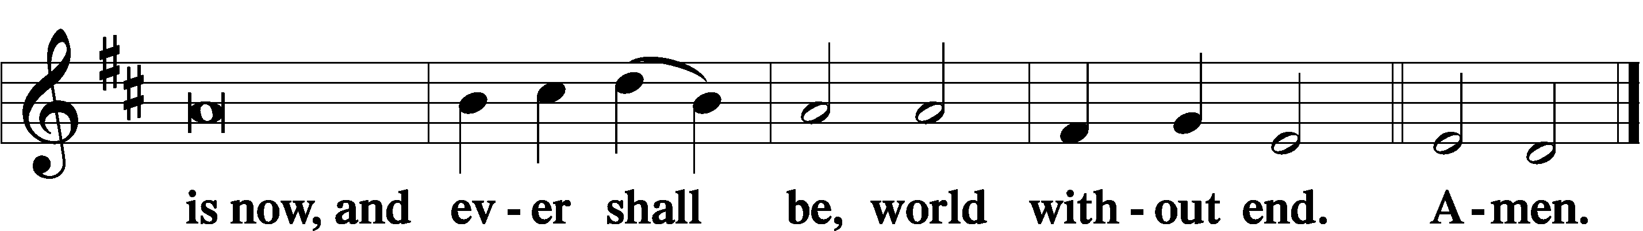

Thanksgiving LSB 200
A O give thanks unto the Lord, for He is good,

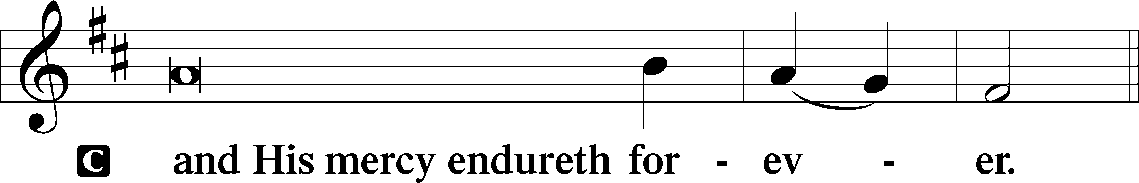

A Let us pray.
O God the Father, the fountain and source of all goodness, who in loving-kindness sent Your only-begotten Son into the flesh, we thank You that for His sake You have given us pardon and peace in this Sacrament, and we ask You not to forsake Your children but always to rule our hearts and minds by Your Holy Spirit that we may be enabled constantly to serve You; through Jesus Christ, Your Son, our Lord, who lives and reigns with You and the Holy Spirit, one God, now and forever.

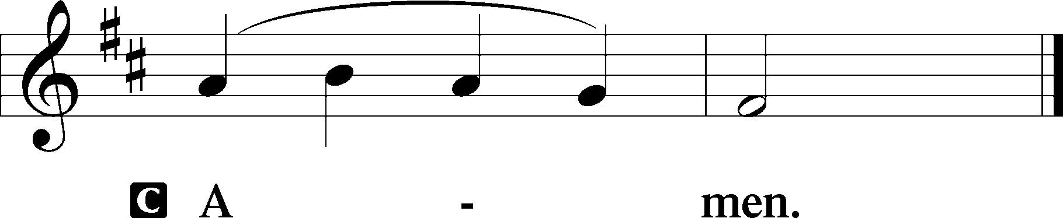

P The Lord be with you.

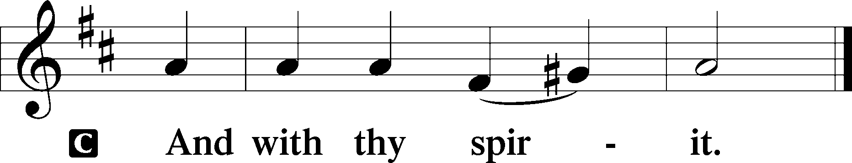

Benedicamus LSB 202
A Bless we the Lord.

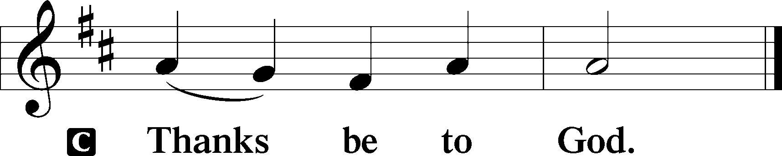

Benediction LSB 202
P The Lord bless you and keep you.
The Lord make His face shine upon you and be gracious unto you.
The Lord lift up His countenance upon you and give you peace.
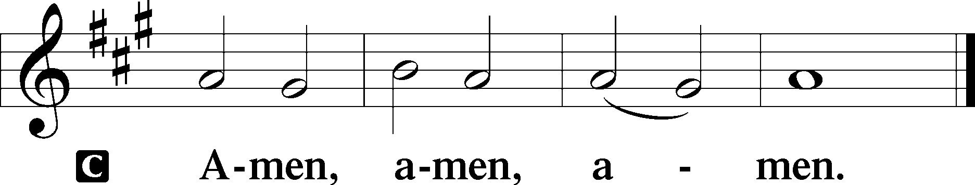

Closing Hymn
452 O Perfect Life of Love
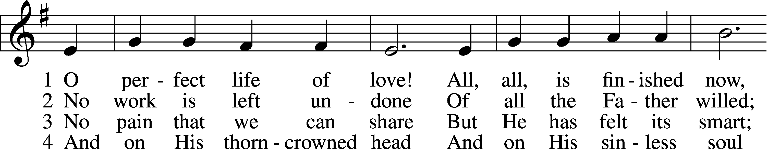
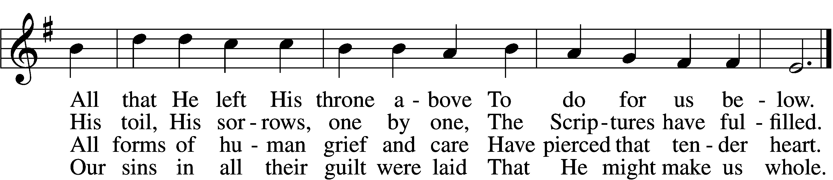

5 In perfect love He dies;
For me He dies, for me.
O all-atoning Sacrifice,
I cling by faith to Thee.

6 In ev’ry time of need,
Before the judgment throne,
Thy work, O Lamb of God, I’ll plead,
Thy merits, not mine own.

7 Yet work, O Lord, in me
As Thou for me hast wrought;
And let my love the answer be
To grace Thy love has brought.
Text: Henry W. Baker, 1821–77, alt.
Tune: William Daman, c. 1540–1591
Text and tune: Public domain

Acknowledgments
Divine Service, Setting Three from Lutheran Service Book
Unless otherwise indicated, Scripture quotations are from the ESV® Bible (The Holy Bible, English Standard Version®), copyright © 2001 by Crossway, a publishing ministry of Good News Publishers. Used by permission. All rights reserved.
Created by Lutheran Service Builder © 2024 Concordia Publishing House.

