Order of Service — May 24, 2023
(Pentecost/6th Grade Graduation)

Welcome/Announcements

Opening Hymn
497 Come, Holy Ghost, God and Lord
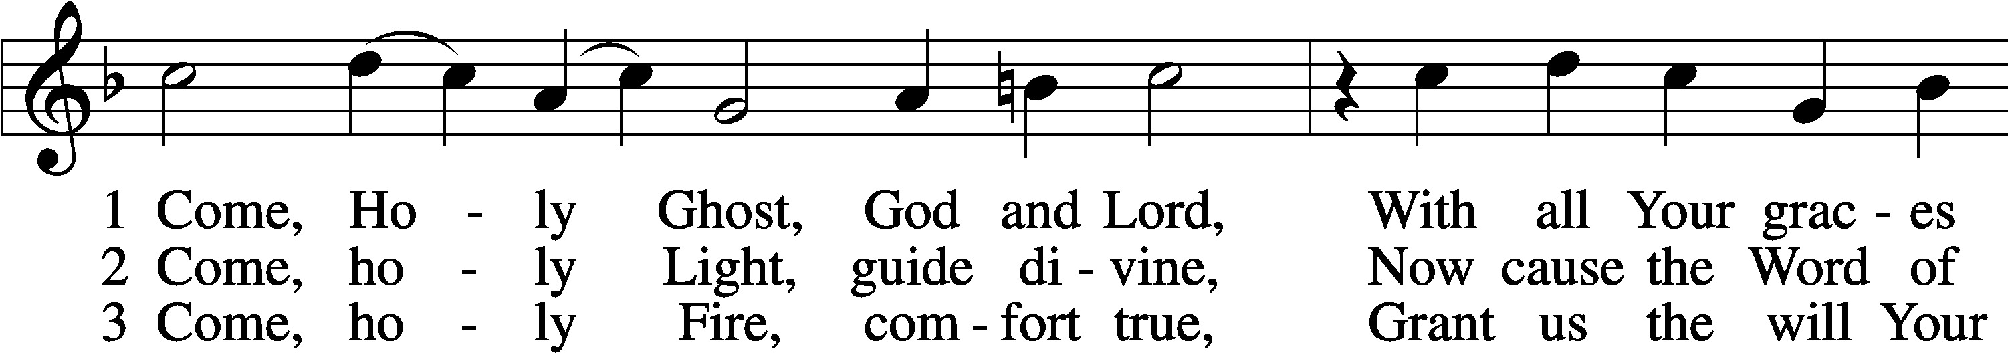
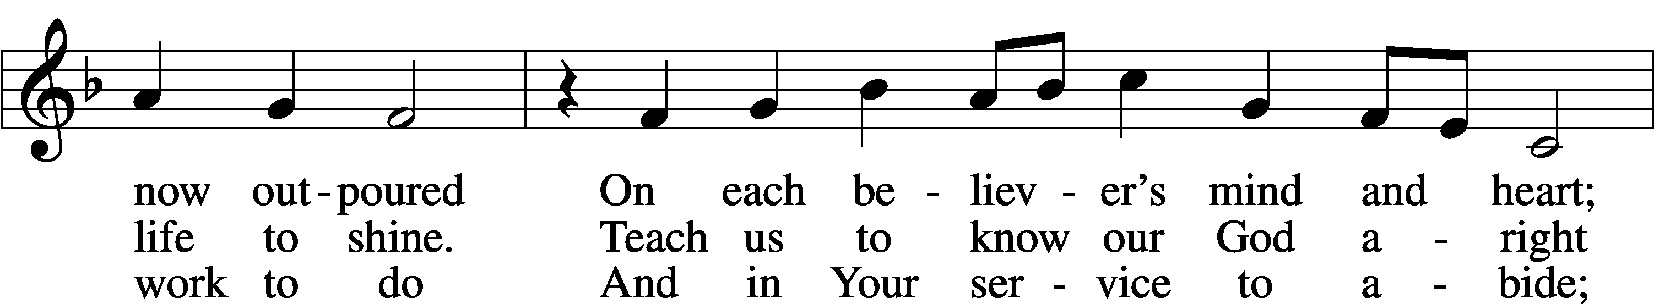
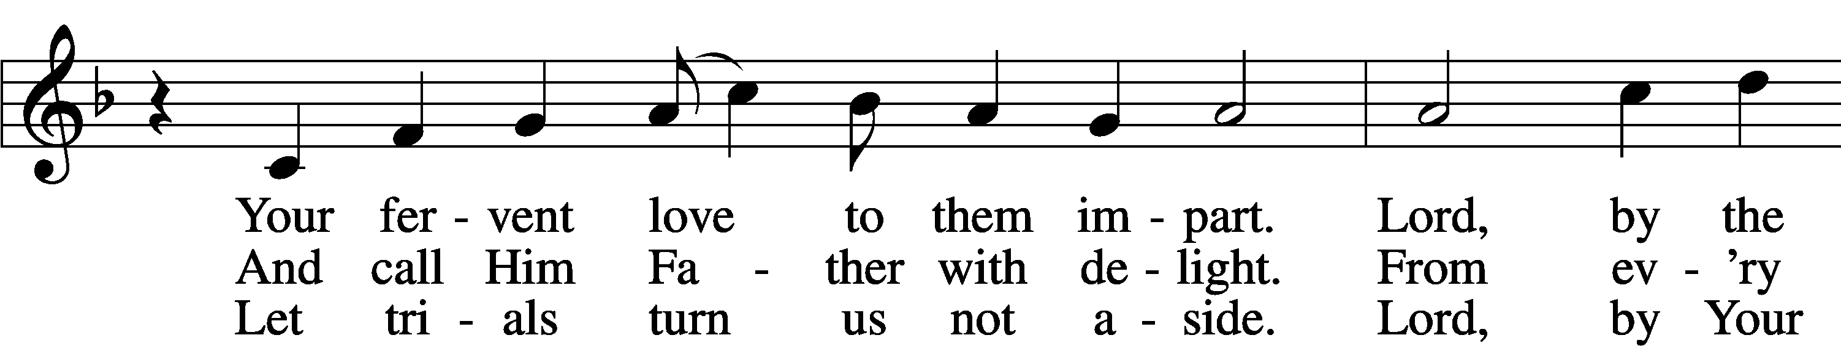
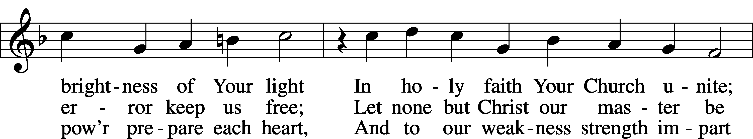
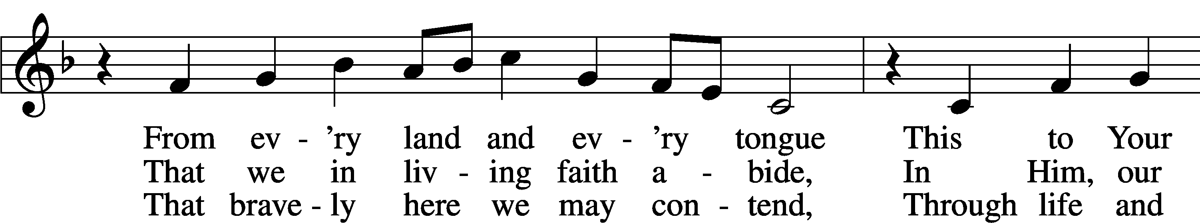
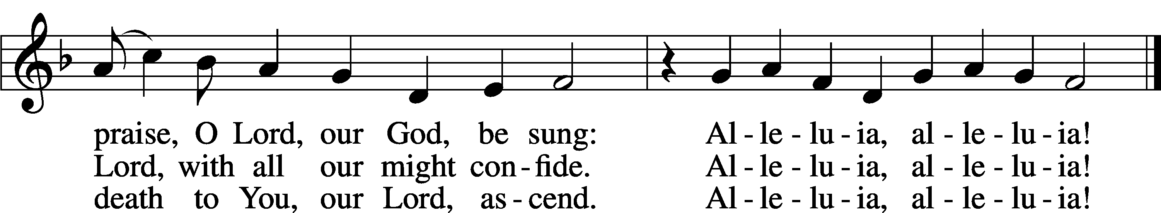
Text: tr. The Lutheran Hymnal, 1941, alt.; (st. 1): German, 15th cent.; (sts. 2–3): Martin Luther, 1483–1546
Tune: Eyn Enchiridion oder Handbüchlein, 1524, Erfurt
Text: © 1941 Concordia Publishing House. Used by permission: LSB Hymn License no. 110002874
Tune: Public domain

Stand

Opening Versicles
L This is the day which the Lord has made;
C let us rejoice and be glad in it.
L From the rising of the sun to its setting,
C the name of the Lord is to be praised.

L Better is one day in Your courts than a thousand elsewhere;
C I would rather be a doorkeeper in the house of my God than dwell in the tents of the wicked.
L Make me to know Your ways, O Lord.
C Teach me Your paths.
L Sanctify us in Your truth.
C Your Word is truth.

L From the rising of the sun to its setting,
C the name of the Lord is to be praised.

C Glory be to the Father and to the Son and to the Holy Spirit;
as it was in the beginning, is now, and will be forever. Amen.

Old Testament Canticle LSB 261
C The Lord God is my strength and my song, and He has become my salvation.

With joy will you draw water from the wells of salvation.
And you will say in that day:
“Give thanks to the Lord, call upon His name,
make known His deeds among the peoples,
proclaim that His name is exalted.”

The Lord God is my strength and my song, and He has become my salvation.

Sing praises to the Lord, for He has done gloriously;
let this be made known in all the earth.
Shout, and sing for joy, O inhabitants of Zion, for great in your midst is the Holy One of Israel.

The Lord God is my strength and my song, and He has become my salvation.

Glory be to the Father and to the Son
and to the Holy Spirit;
as it was in the beginning,
is now, and will be forever. Amen.

The Lord God is my strength and my song, and He has become my salvation.

Sit

Reading Numbers 11:24–30
L A reading from Numbers, the eleventh chapter.

²⁴Moses went out and told the people the words of the Lord. And he gathered seventy men of the elders of the people and placed them around the tent. ²⁵Then the Lord came down in the cloud and spoke to him, and took some of the Spirit that was on him and put it on the seventy elders. And as soon as the Spirit rested on them, they prophesied. But they did not continue doing it. ²⁶Now two men remained in the camp, one named Eldad, and the other named Medad, and the Spirit rested on them. They were among those registered, but they had not gone out to the tent, and so they prophesied in the camp. ²⁷And a young man ran and told Moses, “Eldad and Medad are prophesying in the camp.” ²⁸And Joshua the son of Nun, the assistant of Moses from his youth, said, “My lord Moses, stop them.” ²⁹But Moses said to him, “Are you jealous for my sake? Would that all the Lord’s people were prophets, that the Lord would put his Spirit on them!” ³⁰And Moses and the elders of Israel returned to the camp.

Reading Acts 2:1–21
¹When the day of Pentecost arrived, they were all together in one place. ²And suddenly there came from heaven a sound like a mighty rushing wind, and it filled the entire house where they were sitting. ³And divided tongues as of fire appeared to them and rested on each one of them. ⁴And they were all filled with the Holy Spirit and began to speak in other tongues as the Spirit gave them utterance. ⁵Now there were dwelling in Jerusalem Jews, devout men from every nation under heaven. ⁶And at this sound the multitude came together, and they were bewildered, because each one was hearing them speak in his own language. ⁷And they were amazed and astonished, saying, “Are not all these who are speaking Galileans? ⁸So how is it that we hear, each of us in his own native language? ⁹Parthians and Medes and Elamites and residents of Mesopotamia, Judea and Cappadocia, Pontus and Asia, ¹⁰Phrygia and Pamphylia, Egypt and the parts of Libya belonging to Cyrene, and visitors from Rome, ¹¹both Jews and proselytes, Cretans and Arabians—we hear them telling in our own tongues the mighty works of God.” ¹²And all were amazed and perplexed, saying to one another, “What does this mean?” ¹³But others mocking said, “They are filled with new wine.” ¹⁴But Peter, standing with the Eleven, lifted up his voice and addressed them, “Men of Judea and all who dwell in Jerusalem, let this be known to you, and give ear to my words. ¹⁵For these men are not drunk, as you suppose, since it is only the third hour of the day. ¹⁶But this is what was uttered through the prophet Joel: ¹⁷‘And in the last days it shall be, God declares, that I will pour out My Spirit on all flesh, and your sons and your daughters shall prophesy, and your young men shall see visions, and your old men shall dream dreams; ¹⁸even on My male servants and female servants in those days I will pour out My Spirit, and they shall prophesy. ¹⁹And I will show wonders in the heavens above and signs on the earth below, blood, and fire, and vapor of smoke; ²⁰the sun shall be turned to darkness and the moon to blood, before the Day of the Lord comes — the great and magnificent day. ²¹And it shall come to pass that everyone who calls upon the name of the Lord shall be saved.’ "

Reading John 7:37–39
³⁷On the last day of the feast — the great day — Jesus stood up and cried out, “If anyone thirsts, let him come to Me and drink. ³⁸Whoever believes in Me, as the Scripture has said, ‘Out of His heart will flow rivers of living water.’” ³⁹Now this He said about the Spirit, whom those who believed in Him were to receive, for as yet the Spirit had not been given, because Jesus was not yet glorified.

L This is the Word of the Lord.
C Thanks be to God.
Stand

Responsory
L Forever, O Lord, Your Word is firmly set in the heavens.
C Lord, I love the habitation of Your house and the place where Your glory dwells.
L Blessed are those who hear the Word of God and keep it.
C Lord, I love the habitation of Your house and the place where Your glory dwells.
L Glory be to the Father and to the Son and to the Holy Spirit.
C Lord, I love the habitation of Your house and the place where Your glory dwells.

Ten Commandments
C You shall have no other gods.
You shall not misuse the name of the Lord your God.
Remember the Sabbath day by keeping it holy.
Honor your father and your mother.
You shall not murder.
You shall not commit adultery.
You shall not steal.
You shall not give false testimony against your neighbor.
You shall not covet your neighbor’s house.
You shall not covet your neighbor’s wife, or his manservant or maidservant, his ox or donkey, or anything that belongs to your neighbor.

Apostles’ Creed
C I believe in God, the Father Almighty,
Maker of heaven and earth.

And in Jesus Christ, His only Son, our Lord,
who was conceived by the Holy Spirit,
born of the virgin Mary,
suffered under Pontius Pilate,
was crucified, died and was buried.
He descended into hell.
The third day He rose again from the dead.
He ascended into heaven
and sits at the right hand of God the Father Almighty.
From thence He will come to judge the living and the dead.

I believe in the Holy Spirit,
the holy Christian Church,
the communion of saints,
the forgiveness of sins,
the resurrection of the body,
and the life everlasting. Amen.

Lord’s Prayer
C Our Father who art in heaven,
hallowed be Thy name,
Thy kingdom come,
Thy will be done on earth
as it is in heaven;
give us this day our daily bread;
and forgive us our trespasses
as we forgive those
who trespass against us;
and lead us not into temptation,
but deliver us from evil.
For Thine is the kingdom
and the power and the glory
forever and ever. Amen.

Sit

Sermon Hymn
864 Shepherd of Tender Youth
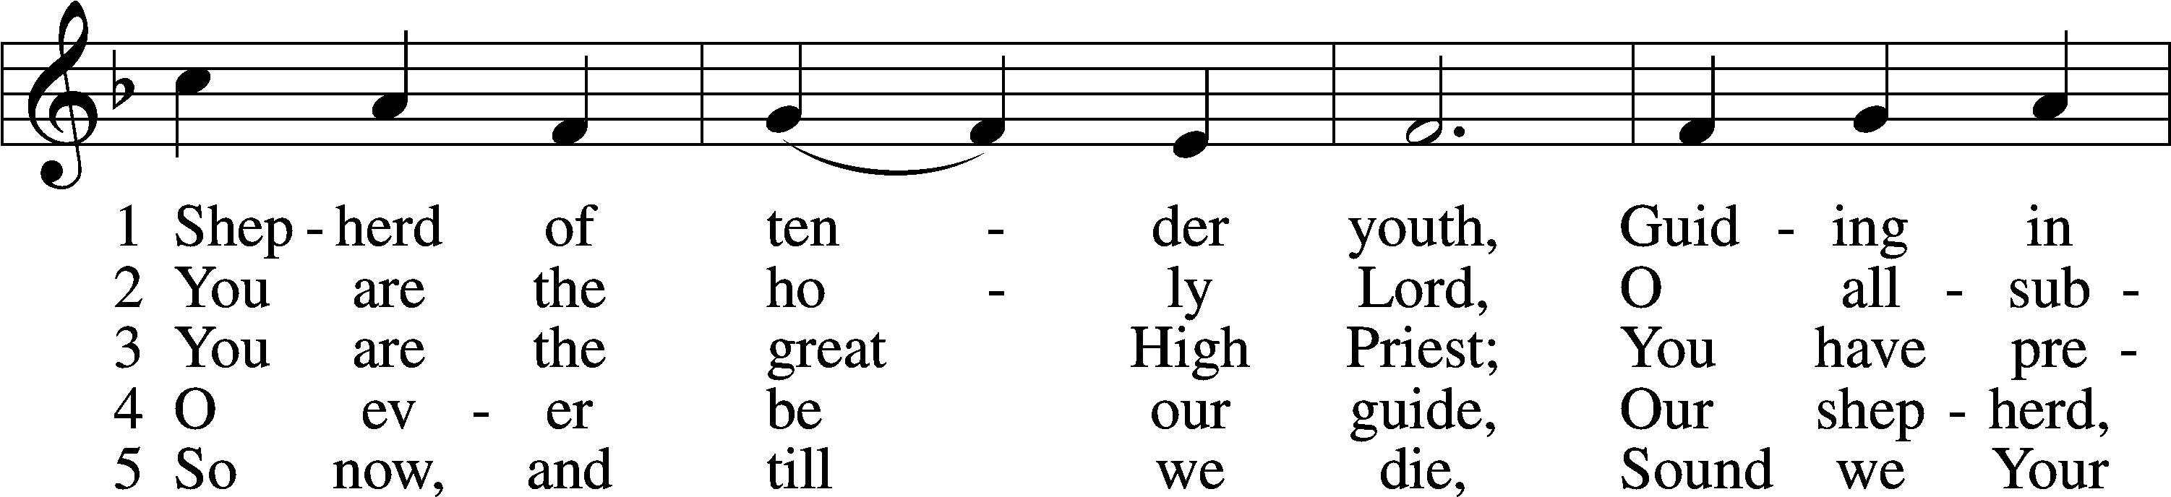
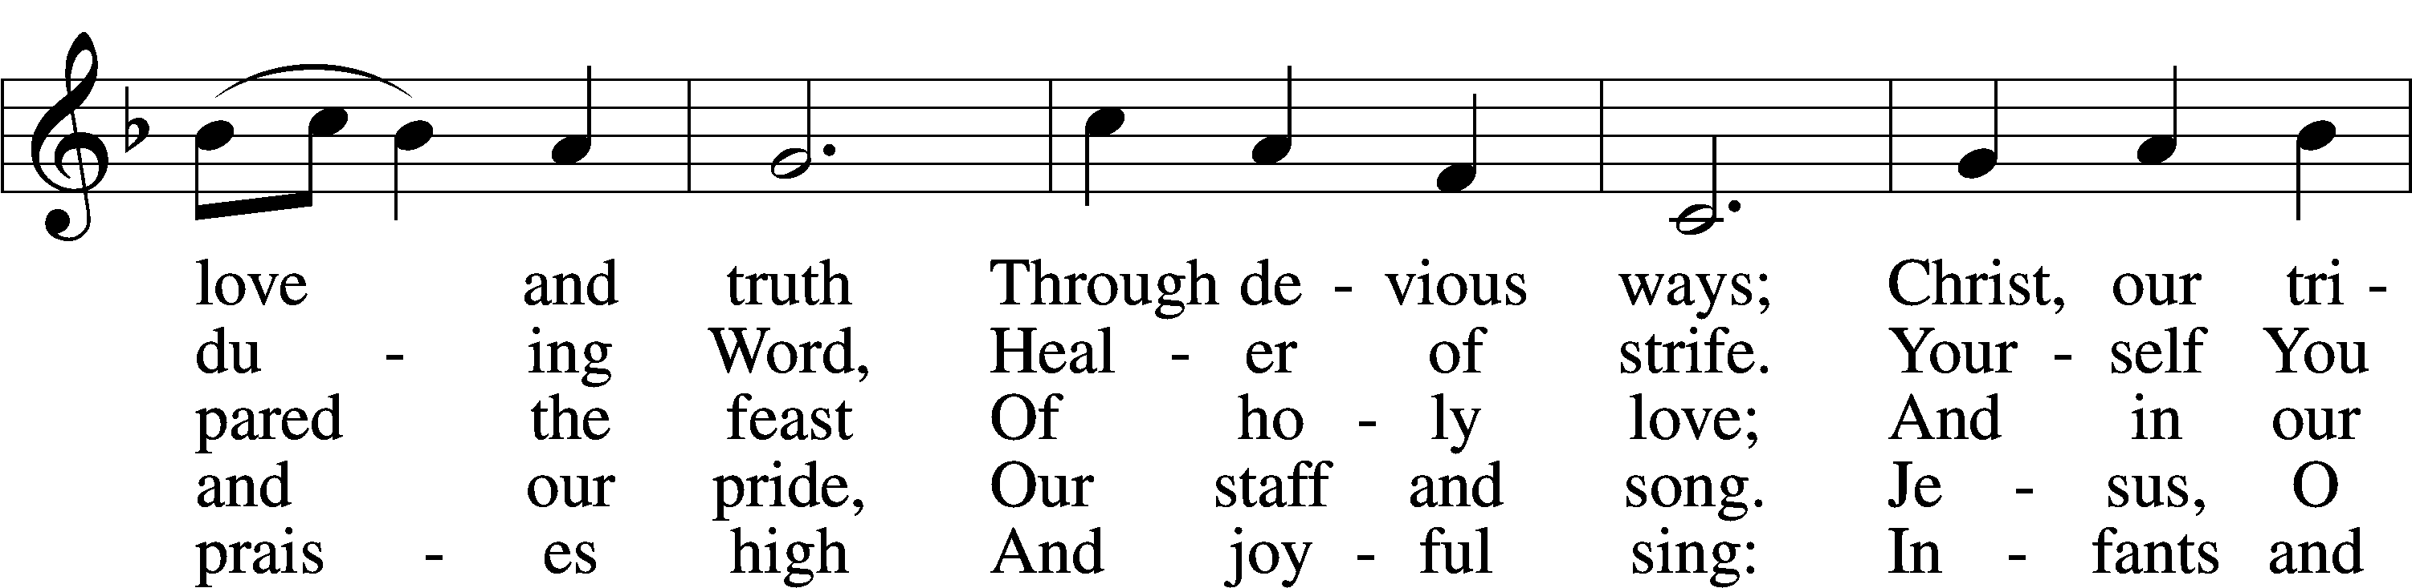
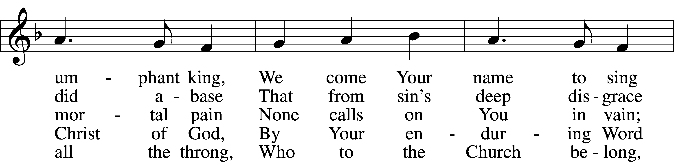
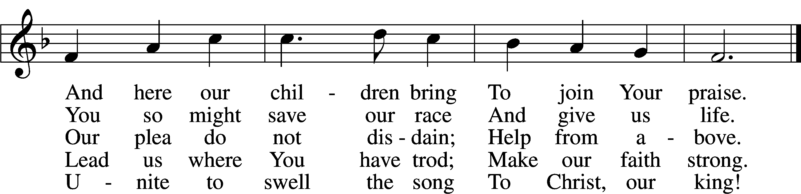
Text: attr. Clement of Alexandria, c. 170–c. 220; tr. Henry M. Dexter, 1821–90, alt.
Tune: Felice de Giardini, 1716–96
Text and tune: Public domain

Sermon

Hymn
498 Come, Holy Ghost, Creator Blest
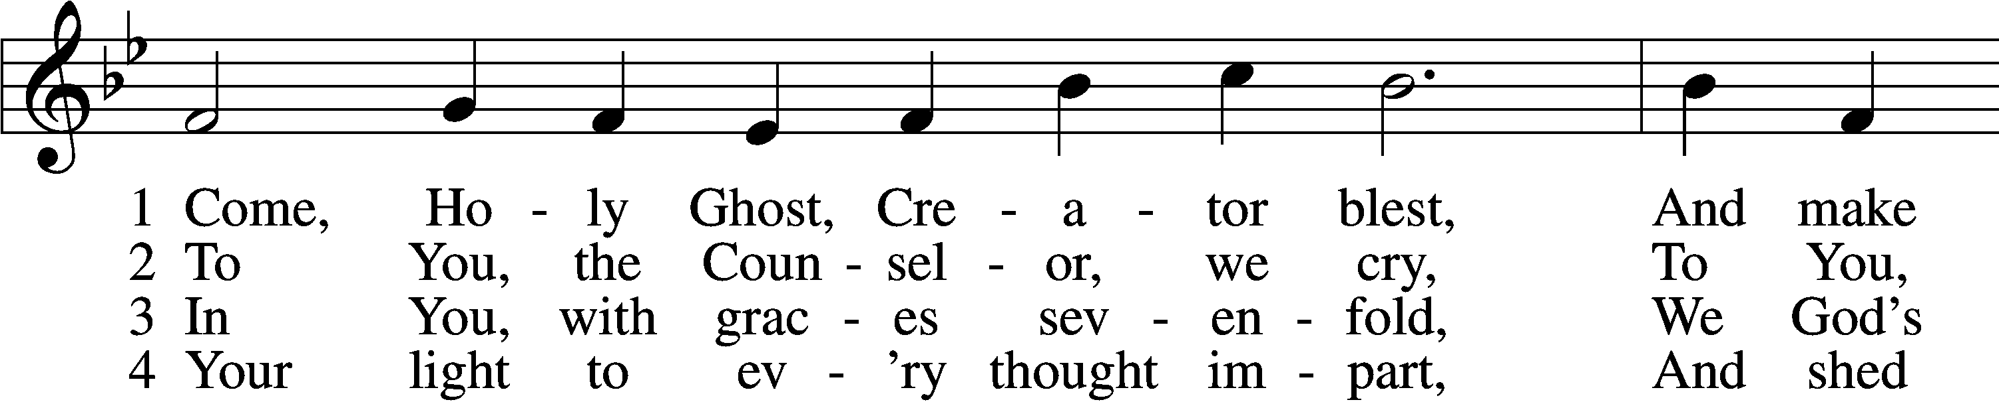
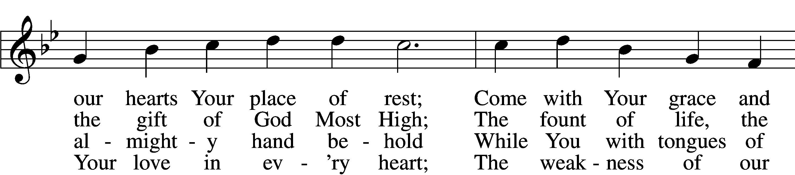
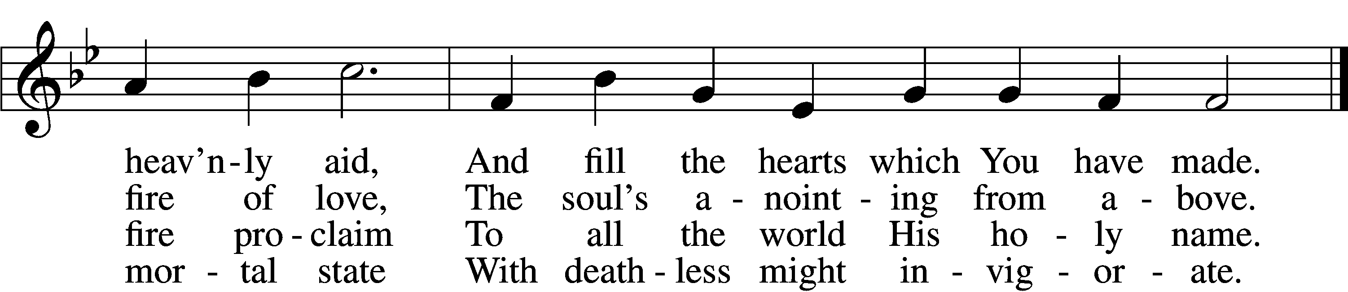

5 Drive far away our wily foe,
And Your abiding peace bestow;
With You as our protecting guide,
No evil can with us abide.

6 Teach us to know the Father, Son,
And You, from both, as Three in One
That we Your name may ever bless
And in our lives the truth confess.

D 7 Praise we the Father and the Son
And Holy Spirit, with them One,
And may the Son on us bestow
The gifts that from the Spirit flow!
Text: attr. Rabanus Maurus, 776–856; tr. Edward Caswall, 1814–78, alt.
Tune: Geistliche Lieder auffs new gebessert, 1533, Wittenberg, ed. Joseph Klug
Text and tune: Public domain

Rite of Graduation/Presentation of Diplomas

Offering

Stand

Prayer
L In peace let us pray to the Lord:
C Lord, have mercy.
L For the gift of divine peace and of pardon, with all our heart and with all our mind, let us pray to the Lord:
C Lord, have mercy.
L For the holy Christian Church, here and scattered throughout the world, and for the proclamation of the Gospel and the calling of all to faith, let us pray to the Lord:
C Lord, have mercy.
L For this nation, for our cities and communities, and for the common welfare of us all, let us pray to the Lord:
C Lord, have mercy.
L For seasonable weather and for the fruitfulness of the earth, let us pray to the Lord:
C Lord, have mercy.
L For those who labor, for those whose work is difficult or dangerous, and for all who travel, let us pray to the Lord:
C Lord, have mercy.
L For all those in need, for the hungry and homeless, for the widowed and orphaned, and for all those in prison, let us pray to the Lord:
C Lord, have mercy.
L For the sick and dying and for all those who care for them, let us pray to the Lord:
C Lord, have mercy.
L For . . . [additional bids for prayer may be inserted here] . . . let us pray to the Lord:
C Lord, have mercy.
L Finally, for these and for all our needs of body and soul, let us pray to the Lord:
C Lord, have mercy. Christ, have mercy. Lord, have mercy.

Collect for the Word
L Gracious Father, Your Son grew in wisdom and stature and in favor with God and all people. Bless, guide, and govern the children and young people of Your Church by Your Holy Spirit, that they may grow in grace and in the knowledge of Your Word. Grant that they may serve You well and usefully, developing their talents not for their own sakes but to Your glory and for the welfare of their neighbor. Protect and defend them from all danger and harm, giving Your holy angels charge over them; through Jesus Christ, our Lord.
C Amen.

Evening Prayer
C I thank You, my heavenly Father, through Jesus Christ, Your dear Son, that You have graciously kept me this day; and I pray that You would forgive me all my sins where I have done wrong, and graciously keep me this night. For into Your hands I commend myself, my body and soul, and all things. Let Your holy angel be with me, that the evil foe may have no power over me. Amen.

New Testament Canticle LSB 266
C Christ has been raised from the dead! Alleluia. Alleluia.

Christ our Passover Lamb has been sacrificed.
Raised from the dead, He will never die again.
Death has no more dominion over Him.

Christ has been raised from the dead! Alleluia. Alleluia.

Dying, Christ dies to sin, once for all.
Living, He lives to God.
Count yourselves as dead to sin and alive to God in Christ Jesus, our Lord.

Christ has been raised from the dead! Alleluia. Alleluia.

Blessing
L Let us bless the Lord.
C Thanks be to God.

L The almighty and merciful Lord, the Father, the Son, and the Holy Spirit, bless and preserve us.
C Amen.

Closing Hymn
861 Christ Be My Leader
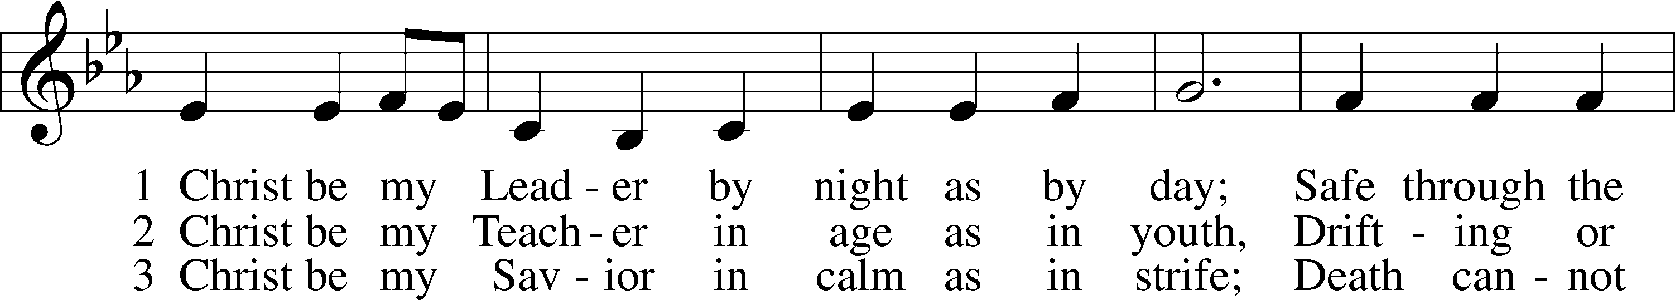
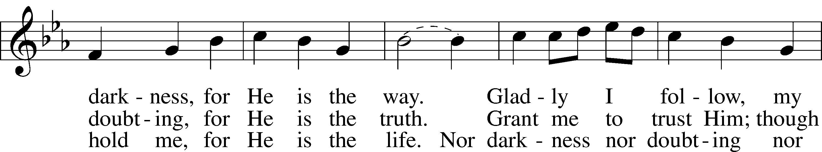
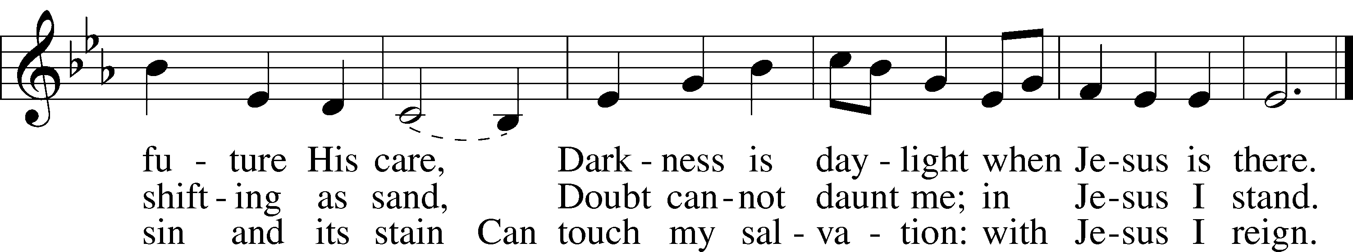
Text: Timothy Dudley-Smith, 1926
Tune: Irish
Text: © 1964, renewed 1992 Hope Publishing Co. Used by permission: LSB Hymn License no. 110002874
Tune: Public domain

Acknowledgments
Service of Prayer and Preaching from Lutheran Service Book
Unless otherwise indicated, Scripture quotations are from the ESV® Bible (The Holy Bible, English Standard Version®), copyright © 2001 by Crossway, a publishing ministry of Good News Publishers. Used by permission. All rights reserved.
Created by Lutheran Service Builder © 2023 Concordia Publishing House.

