Order of Service — May 28, 2023
(The Day of Pentecost)

Welcome/Announcements

Opening Hymn
497 Come, Holy Ghost, God and Lord
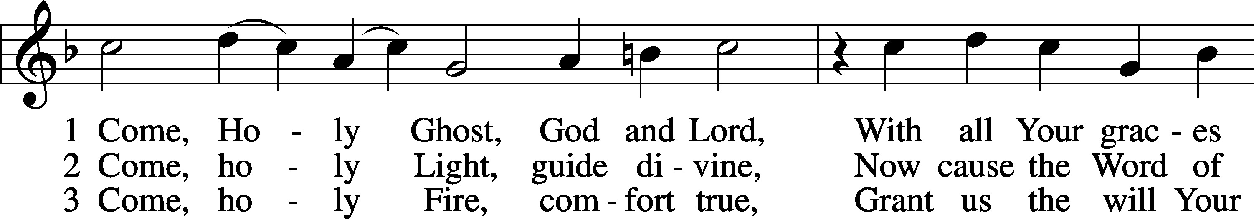
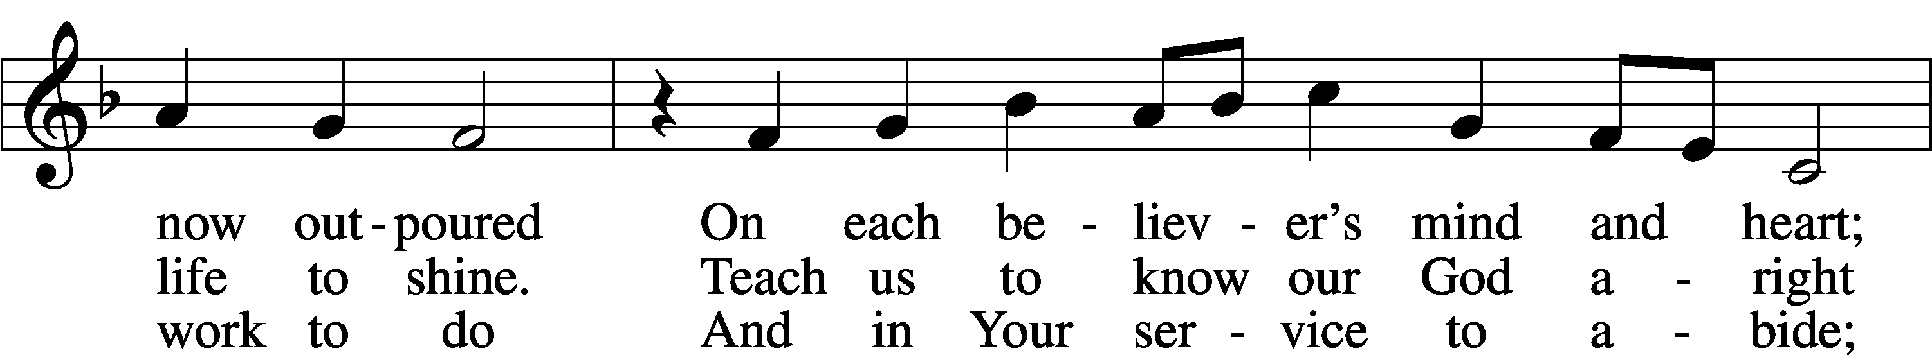
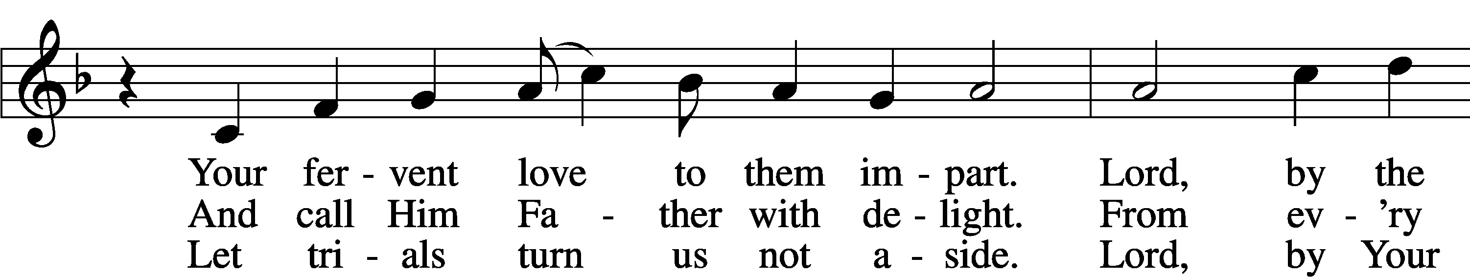
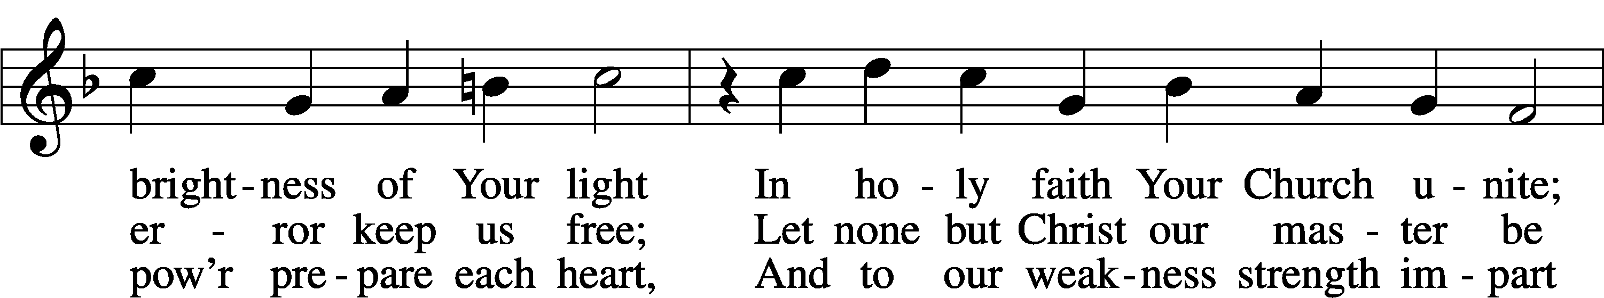
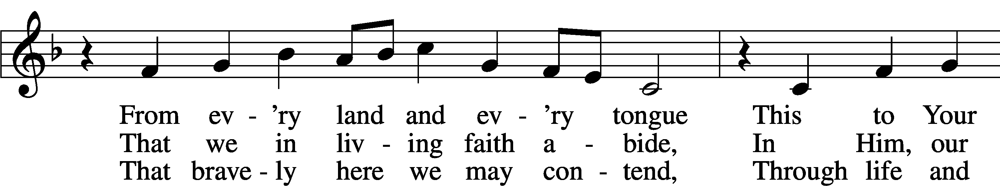
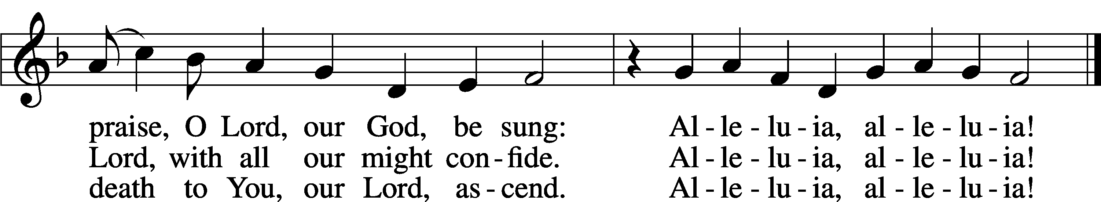
Text: tr. The Lutheran Hymnal, 1941, alt.; (st. 1): German, 15th cent.; (sts. 2–3): Martin Luther, 1483–1546
Tune: Eyn Enchiridion oder Handbüchlein, 1524, Erfurt
Text: © 1941 Concordia Publishing House. Used by permission: LSB Hymn License no. 110002874
Tune: Public domain

Stand

Invocation/Confession & Absolution
P In the name of the Father and of the Son and of the Holy Spirit.
C Amen.

P Beloved in the Lord! Let us draw near with a true heart and confess our sins unto God our Father, beseeching Him in the name of our Lord Jesus Christ to grant us forgiveness.

P Our help is in the name of the Lord,
C who made heaven and earth.
P I said, I will confess my transgressions unto the Lord,
C and You forgave the iniquity of my sin.

Silence for reflection on God’s Word and for self-examination.

P Almighty God, our Maker and Redeemer, we poor sinners confess unto You that we are by nature sinful and unclean and that we have sinned against You by thought, word, and deed. Wherefore we flee for refuge to Your infinite mercy, seeking and imploring Your grace for the sake of our Lord Jesus Christ.
C O most merciful God, who has given Your only-begotten Son to die for us, have mercy upon us and for His sake grant us remission of all our sins; and by Your Holy Spirit increase in us true knowledge of You and of Your will and true obedience to Your Word, to the end that by Your grace we may come to everlasting life; through Jesus Christ, our Lord. Amen.

P Almighty God, our heavenly Father, has had mercy upon us and has given His only Son to die for us and for His sake forgives us all our sins. To those who believe on His name He gives power to become the children of God and has promised them His Holy Spirit. He that believes and is baptized shall be saved.
Grant this, Lord, unto us all.
C Amen.

Stand

Introit Psalm 104:24, 27–28, 30; antiphon: Liturgical Text
Come, Holy Spirit, fill the hearts of the faithful,
and kindle in them the fire of Your love. Alleluia.
O Lord, how manifold are Your works! In wisdom have You made them all;
the earth is full of Your creatures.
These all look to You,
to give them their food in due season.
When You give it to them, they gather it up;
when You open Your hand, they are filled with good things.
When You send forth Your Spirit, they are created,
and You renew the face of the ground.
Glory be to the Father and to the Son
and to the Holy Spirit;
as it was in the beginning,
is now, and will be forever. Amen.
Come, Holy Spirit, fill the hearts of the faithful,
and kindle in them the fire of Your love. Alleluia.

Kyrie LSB 186
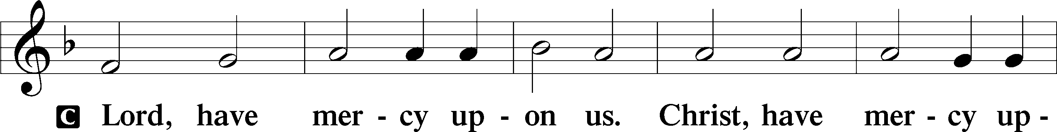
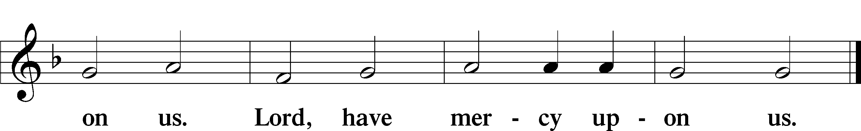

Gloria in Excelsis LSB 187
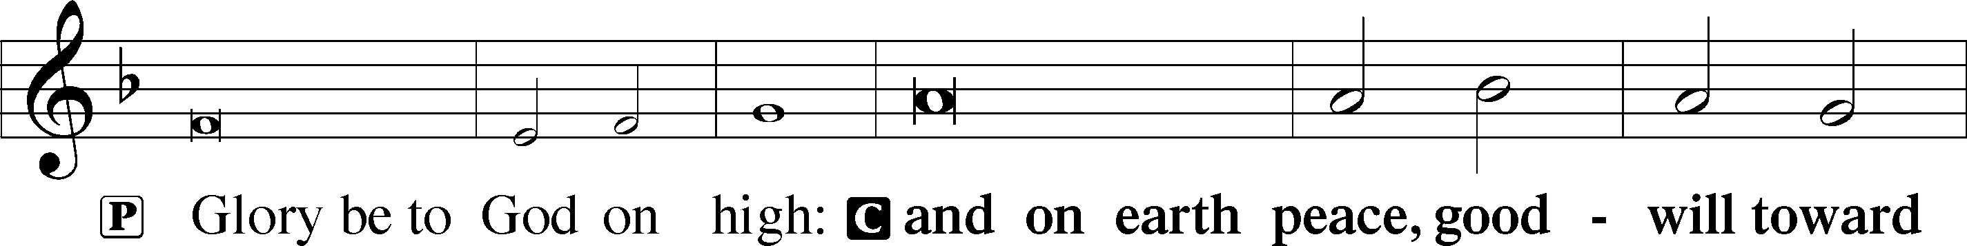
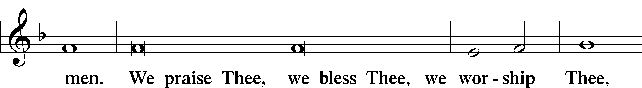
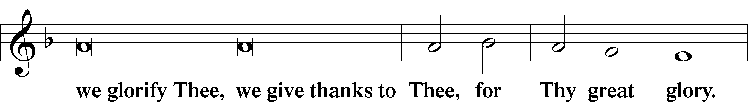
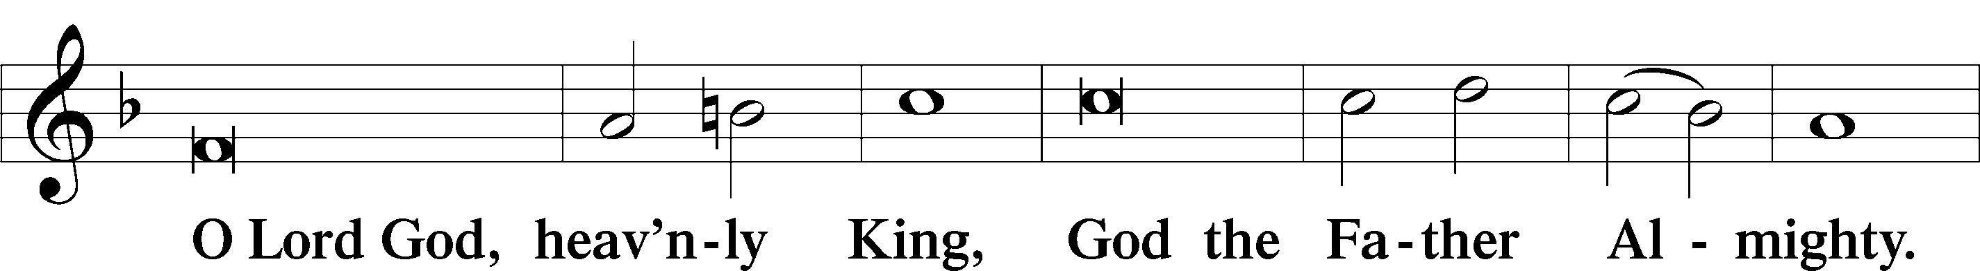
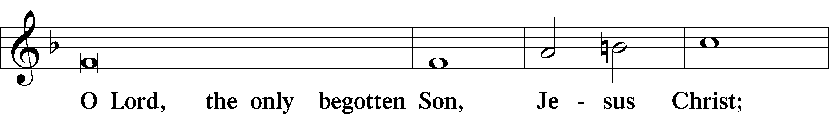
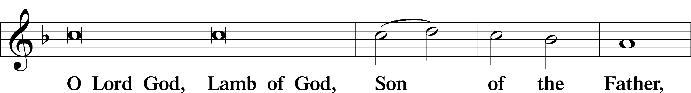
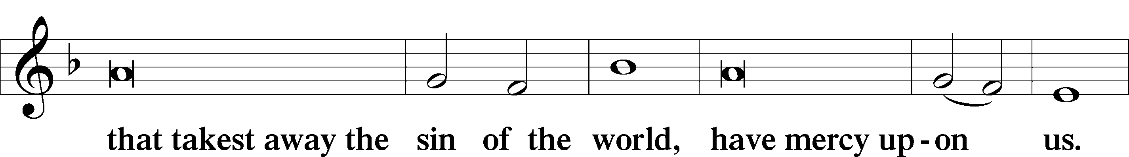
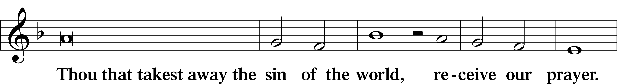
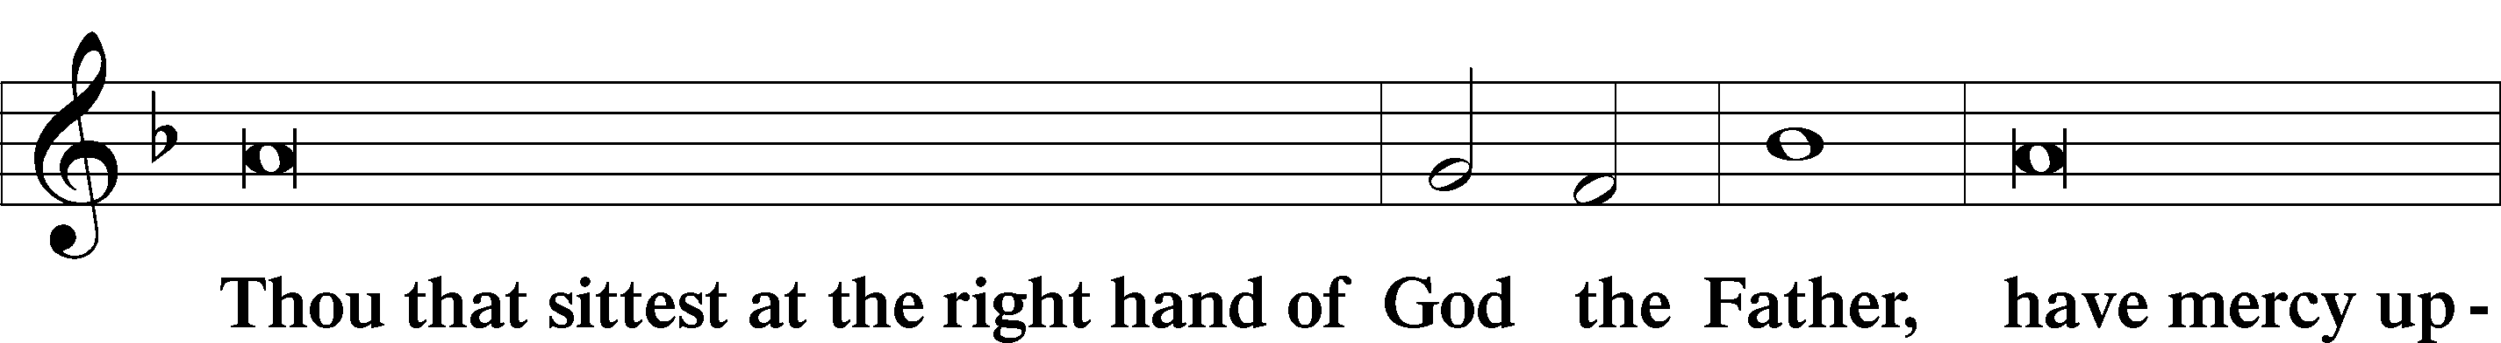
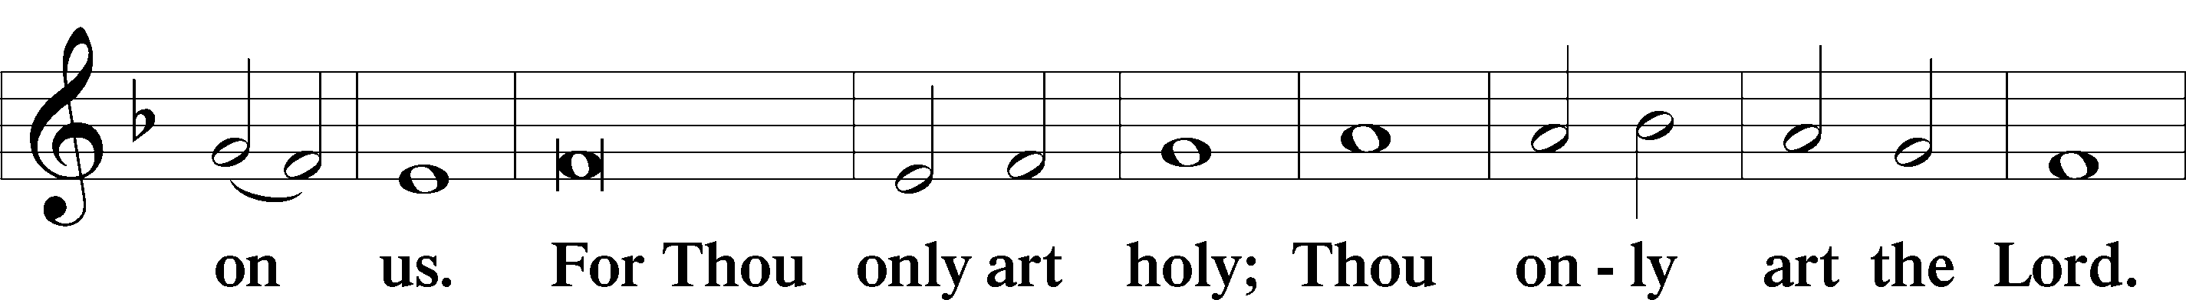
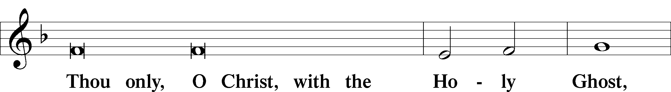
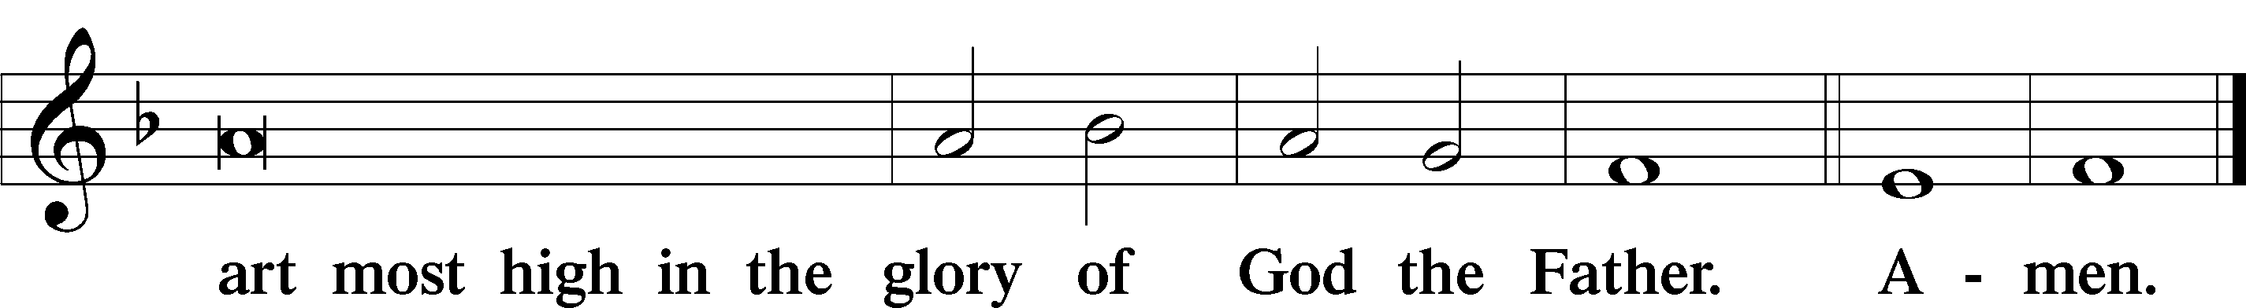

Salutation and Collect of the Day
P The Lord be with you.
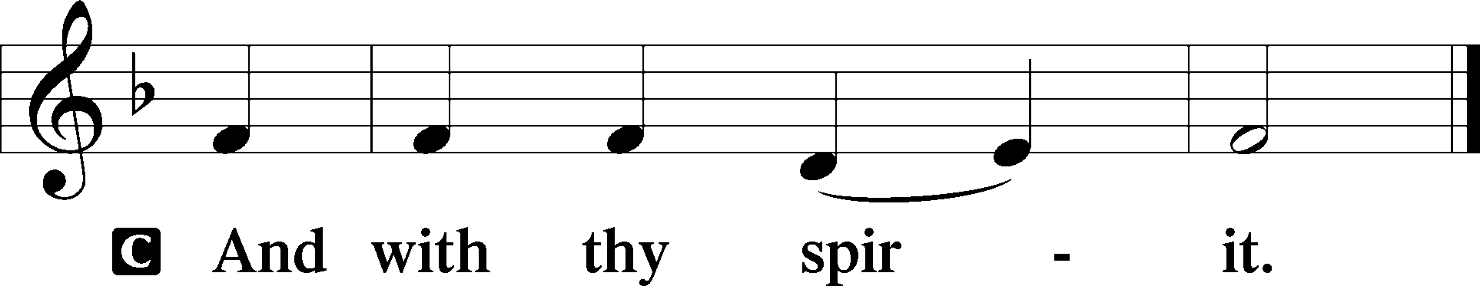

P Let us pray.
O God, on this day You once taught the hearts of Your faithful people by sending them the light of Your Holy Spirit. Grant us in our day by the same Spirit to have a right understanding in all things and evermore to rejoice in His holy consolation; through Jesus Christ, Your Son, our Lord, who lives and reigns with You and the Holy Spirit, one God, now and forever.

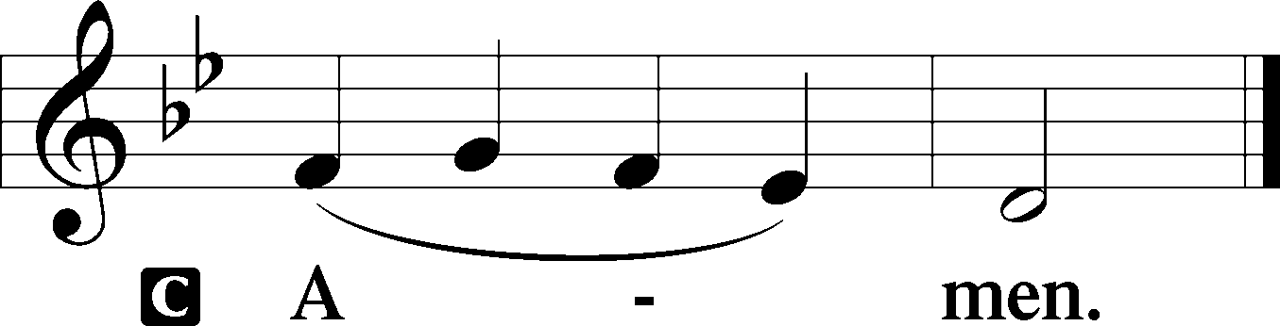

Sit

Old Testament Reading Numbers 11:24–30
²⁴Moses went out and told the people the words of the Lord. And he gathered seventy men of the elders of the people and placed them around the tent. ²⁵Then the Lord came down in the cloud and spoke to him, and took some of the Spirit that was on him and put it on the seventy elders. And as soon as the Spirit rested on them, they prophesied. But they did not continue doing it. ²⁶Now two men remained in the camp, one named Eldad, and the other named Medad, and the Spirit rested on them. They were among those registered, but they had not gone out to the tent, and so they prophesied in the camp. ²⁷And a young man ran and told Moses, “Eldad and Medad are prophesying in the camp.” ²⁸And Joshua the son of Nun, the assistant of Moses from his youth, said, “My lord Moses, stop them.” ²⁹But Moses said to him, “Are you jealous for my sake? Would that all the Lord’s people were prophets, that the Lord would put His Spirit on them!” ³⁰And Moses and the elders of Israel returned to the camp.

A This is the Word of the Lord.
C Thanks be to God.

Second Reading Acts 2:1–21
¹When the day of Pentecost arrived, they were all together in one place. ²And suddenly there came from heaven a sound like a mighty rushing wind, and it filled the entire house where they were sitting. ³And divided tongues as of fire appeared to them and rested on each one of them. ⁴And they were all filled with the Holy Spirit and began to speak in other tongues as the Spirit gave them utterance. ⁵Now there were dwelling in Jerusalem Jews, devout men from every nation under heaven. ⁶And at this sound the multitude came together, and they were bewildered, because each one was hearing them speak in his own language. ⁷And they were amazed and astonished, saying, “Are not all these who are speaking Galileans? ⁸So how is it that we hear, each of us in his own native language? ⁹Parthians and Medes and Elamites and residents of Mesopotamia, Judea and Cappadocia, Pontus and Asia, ¹⁰Phrygia and Pamphylia, Egypt and the parts of Libya belonging to Cyrene, and visitors from Rome, ¹¹both Jews and proselytes, Cretans and Arabians—we hear them telling in our own tongues the mighty works of God.” ¹²And all were amazed and perplexed, saying to one another, “What does this mean?” ¹³But others mocking said, “They are filled with new wine.” ¹⁴But Peter, standing with the Eleven, lifted up his voice and addressed them, “Men of Judea and all who dwell in Jerusalem, let this be known to you, and give ear to my words. ¹⁵For these men are not drunk, as you suppose, since it is only the third hour of the day. ¹⁶But this is what was uttered through the prophet Joel: ¹⁷‘And in the last days it shall be, God declares, that I will pour out My Spirit on all flesh, and your sons and your daughters shall prophesy, and your young men shall see visions, and your old men shall dream dreams; ¹⁸even on My male servants and female servants in those days I will pour out My Spirit, and they shall prophesy. ¹⁹And I will show wonders in the heavens above and signs on the earth below, blood, and fire, and vapor of smoke; ²⁰the sun shall be turned to darkness and the moon to blood, before the Day of the Lord comes — the great and magnificent day. ²¹And it shall come to pass that everyone who calls upon the name of the Lord shall be saved.’ "

A This is the Word of the Lord.
C Thanks be to God.

Stand

Alleluia LSB 190
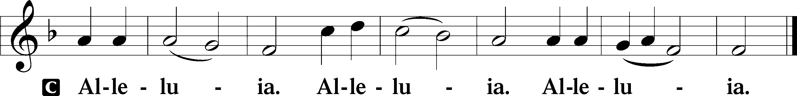

Holy Gospel John 7:37–39
P The Holy Gospel according to St. John, the seventh chapter.

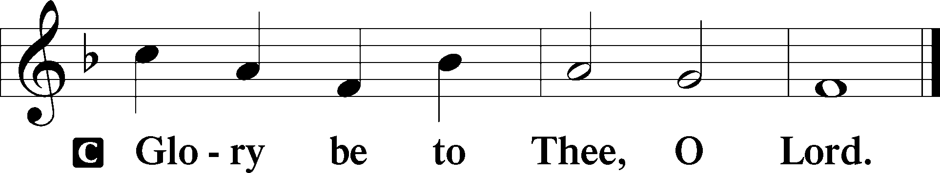

³⁷On the last day of the feast — the great day — Jesus stood up and cried out, “If anyone thirsts, let him come to Me and drink. ³⁸Whoever believes in Me, as the Scripture has said, ‘Out of His heart will flow rivers of living water.’” ³⁹Now this He said about the Spirit, whom those who believed in Him were to receive, for as yet the Spirit had not been given, because Jesus was not yet glorified.

P This is the Gospel of the Lord.

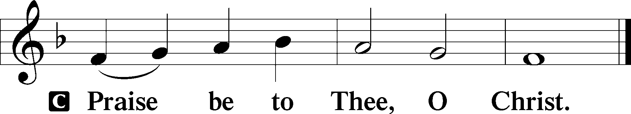

Apostles’ Creed
C I believe in God, the Father Almighty,
Maker of heaven and earth.

And in Jesus Christ, His only Son, our Lord,
who was conceived by the Holy Spirit,
born of the virgin Mary,
suffered under Pontius Pilate,
was crucified, died and was buried.
He descended into hell.
The third day He rose again from the dead.
He ascended into heaven
and sits at the right hand of God the Father Almighty.
From thence He will come to judge the living and the dead.

I believe in the Holy Spirit,
the holy Christian Church,
the communion of saints,
the forgiveness of sins,
the resurrection of the body,
and the life everlasting. Amen.

Sit

Hymn of the Day
TLH 235 O Holy Spirit, Enter In (v. 1-4)

1. O Holy Spirit, enter in
And in our hearts Thy work begin,
Thy temple deign to make us;
Sun of the soul, Thou Light Divine,
Around and in us brightly shine,
To joy and gladness wake us.
That we, In Thee
Truly living, To Thee giving
Prayer unceasing,
May in love be still increasing.
2. Give to thy Word impressive power
That in our hearts, from this good hour,
As fire it may be glowing;
That we confess the Father, Son,
And Thee, the Spirit, Three in One,
Thy glory ever showing.
Stay Thou, Sway now
Our souls ever That they never
May forsake Thee,
But by faith their Refuge make Thee.
3. Thou fountain whence all wisdom flows
Which God on pious hearts bestows,
Grant us Thy consolation
That in our pure faith's unity
We faithful witnesses may be
Of grace that brings salvation.
Hear us, Cheer us
By Thy teaching; Let our preaching
And our labor
Praise Thee, Lord, and serve our neighbor.
4. Left to ourselves, we shall but stray;
Oh, lead us on the narrow way,
With wisest counsel guide us
And give us steadfastness that we
May ever faithful prove to Thee
Whatever woes betide us.
Come, Friend, And mend
Hearts now broken, Give a token
Thou art near us,
Whom we trust to light and cheer us.

Sermon

Stand

Offertory LSB 192
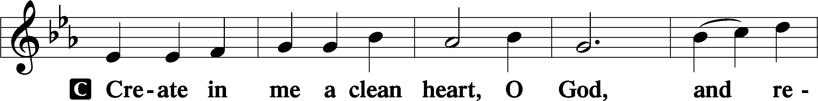
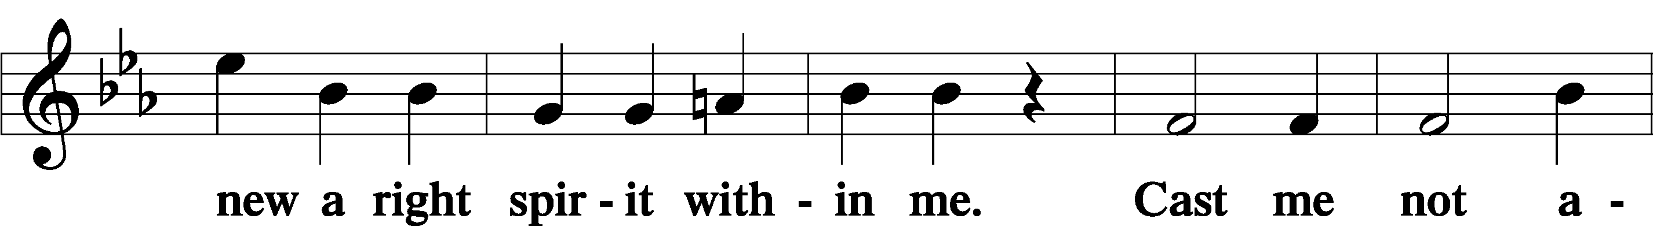
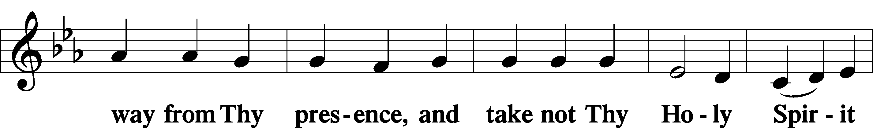
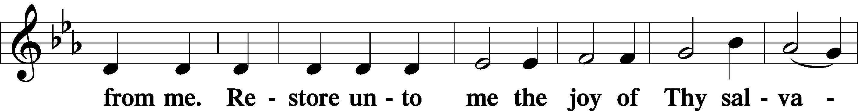
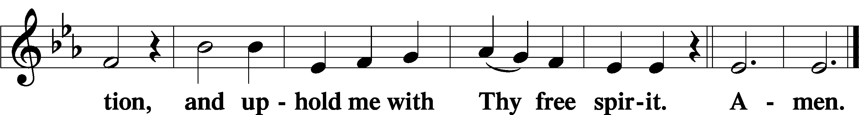

Sit

Offering

Stand

Prayer of the Church

Lord’s Prayer LSB 196
Our Father who art in heaven, hallowed be Thy name, Thy kingdom come, Thy will be done on earth as it is in heaven; give us this day our daily bread; and forgive us our trespasses as we forgive those who trespass against us; and lead us not into temptation, but deliver us from evil. For Thine is the kingdom and the power and the glory forever and ever. Amen.

Sit

Hymn
TLH 235 O Holy Spirit, Enter In (v. 5-8)

5. Thy heavenly strength sustain our heart
That we may act the valiant part
With Thee as our Reliance,
Be Thou our Refuge and our Shield
That we may never quit the field,
But bid all foes defiance.
Descend, Defend
From all errors and earth's terrors;
Thy salvation
Be our constant consolation.
6. O mighty Rock, O Source of Life,
Let Thy dear Word, mid doubt and strife,
Be strong within us burning
That we be faithful unto death,
In Thy pure love and holy faith,
From Thee true wisdom learning.
Thy grace And peace
On us shower; By Thy power
Christ confessing,
Let us win our Savior's blessing.
7. O gentle Dew, from heaven now fall
With power upon the hearts of all,
Thy tender love instilling,
That heart to heart more closely bound,
In kindly deeds be fruitful found,
The law of love fulfilling;
Dwell thus In us.
Envy banish; Strife will vanish
Where Thou livest.
Peace and love and joy Thou givest.
8. Grant that our days, while life shall last,
In purest holiness be passed,
Be Thou our Strength and Tower.
From sinful lust and vanity
And from dead works set Thou us free
In every evil hour.
Keep Thou Pure now
From offenses Heart and senses;
Blessed Spirit!
Let us heavenly life inherit.

Stand

Concluding Collect
A Let us pray.
Almighty God, grant to Your Church Your Holy Spirit and the wisdom that comes down from above, that Your Word may not be bound but have free course and be preached to the joy and edifying of Christ’s holy people, so that in steadfast faith we may serve You and, in the confession of Your name, abide unto the end; through Jesus Christ, Your Son, our Lord, who lives and reigns with You and the Holy Spirit, one God, now and forever.

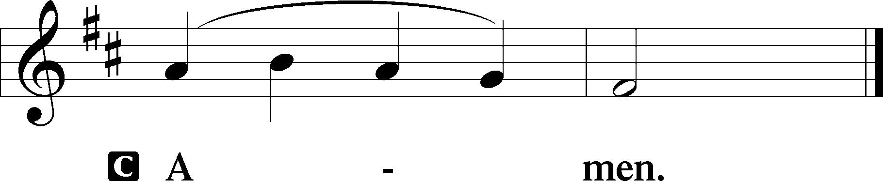

Benediction LSB 202
P The Lord bless you and keep you.
The Lord make His face shine upon you and be gracious unto you.
The Lord lift up His countenance upon you and give you peace.
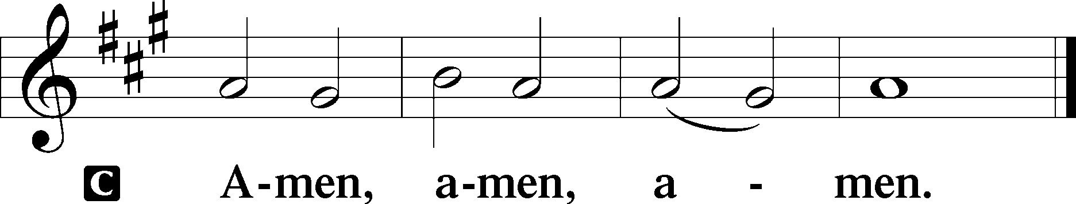

Closing Hymn
496 Holy Spirit, Light Divine
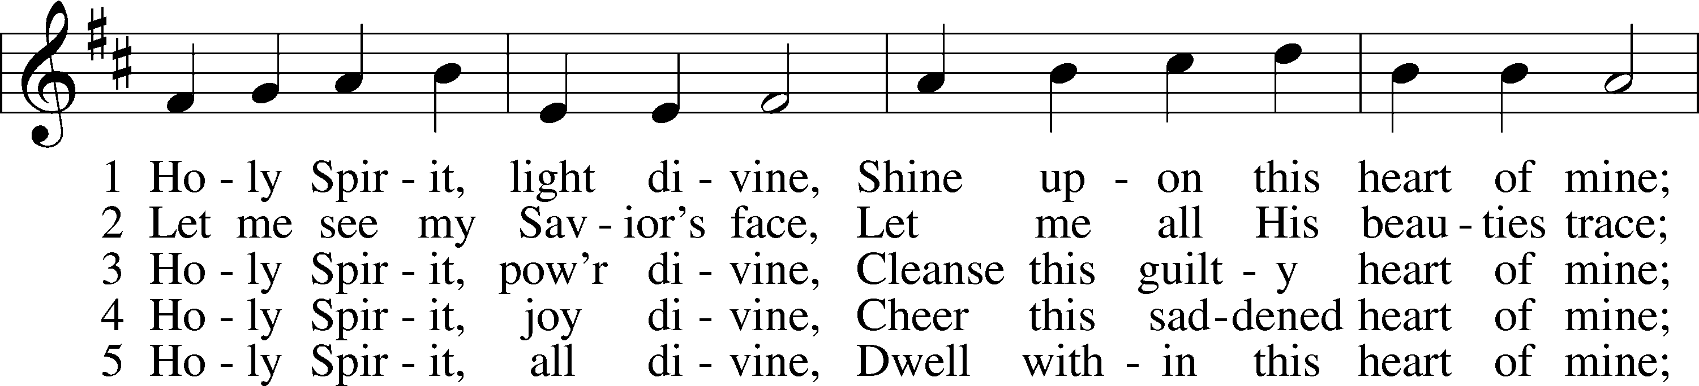
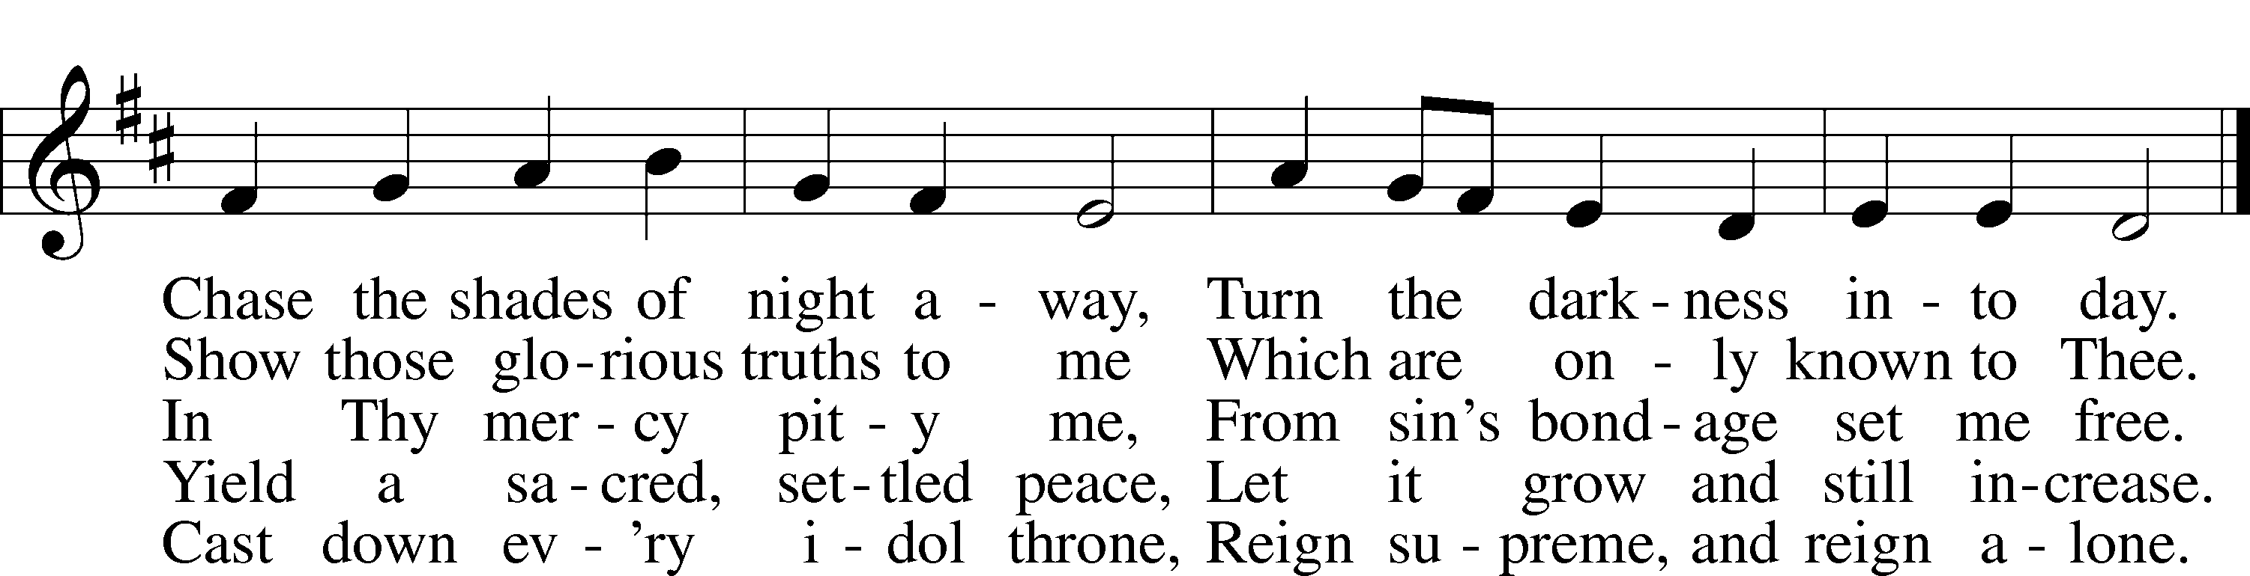
Text: Andrew Reed, 1787–1862, alt.
Tune: Orlando Gibbons, 1583–1625
Text and tune: Public domain

Acknowledgments
Divine Service, Setting Three from Lutheran Service Book
Unless otherwise indicated, Scripture quotations are from the ESV® Bible (The Holy Bible, English Standard Version®), copyright © 2001 by Crossway, a publishing ministry of Good News Publishers. Used by permission. All rights reserved.
Created by Lutheran Service Builder © 2023 Concordia Publishing House.

