Order of Service — April 14, 2024
(3rd Sunday of Easter)

Welcome/Announcements

Opening Hymn
464 The Strife Is O’er, the Battle Done
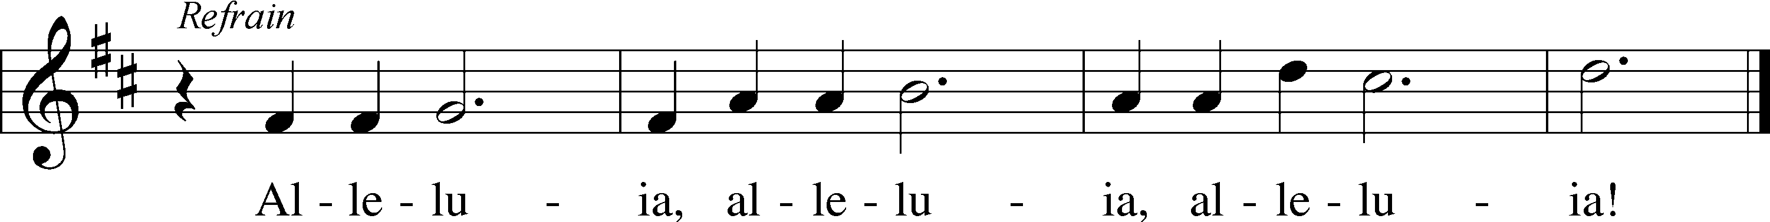
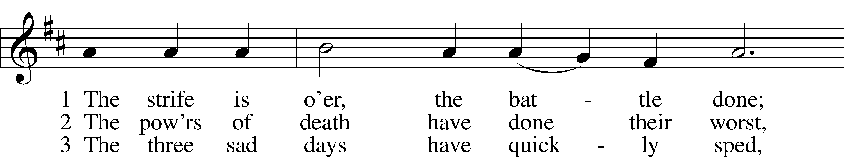
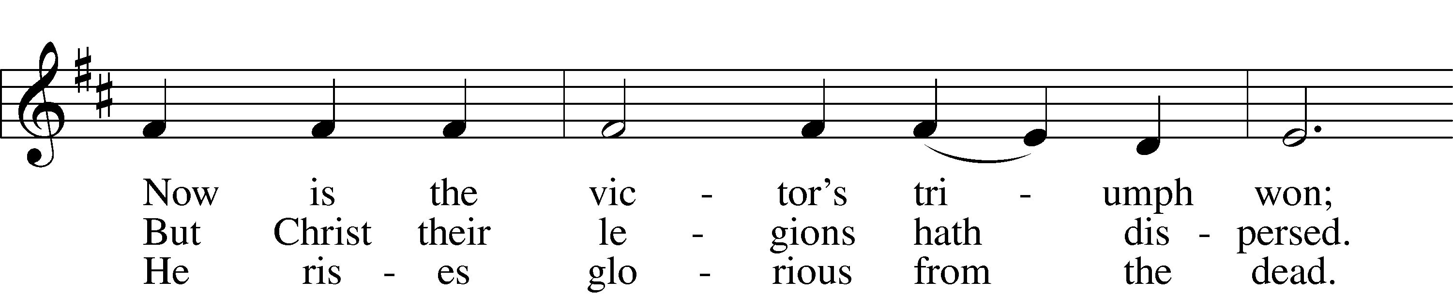
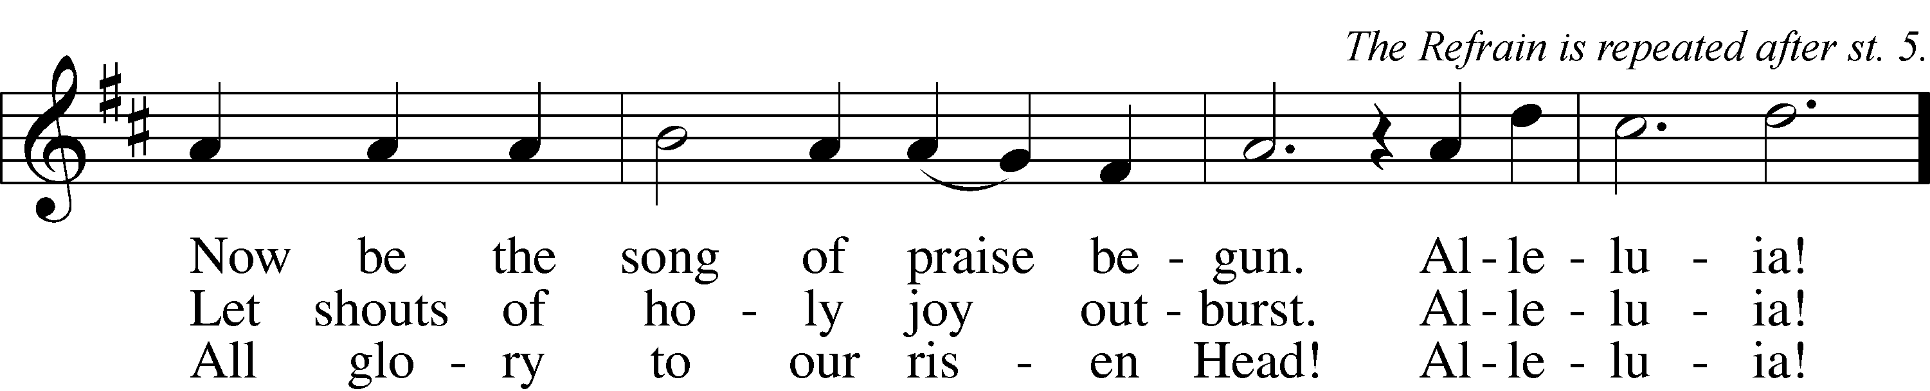

4 He broke the age-bound chains of hell;
The bars from heav’n’s high portals fell.
Let hymns of praise His triumph tell.
Alleluia!

5 Lord, by the stripes which wounded Thee,
From death’s dread sting Thy servants free
That we may live and sing to Thee.
Alleluia! Refrain
Text: Symphonia Sirenum Selectarum, 1695, Köln; tr. Francis Pott, 1832–1909, alt.
Tune: Giovanni P. da Palestrina, c. 1525–1594, adapt.
Text and tune: Public domain

Stand

Invocation/Confession & Absolution
P In the name of the Father and of the Son and of the Holy Spirit.
C Amen.

P Beloved in the Lord! Let us draw near with a true heart and confess our sins unto God our Father, beseeching Him in the name of our Lord Jesus Christ to grant us forgiveness.

P Our help is in the name of the Lord,
C who made heaven and earth.
P I said, I will confess my transgressions unto the Lord,
C and You forgave the iniquity of my sin.

Silence for reflection on God’s Word and for self-examination.

P O almighty God, merciful Father,
C I, a poor, miserable sinner, confess unto You all my sins and iniquities with which I have ever offended You and justly deserved Your temporal and eternal punishment. But I am heartily sorry for them and sincerely repent of them, and I pray You of Your boundless mercy and for the sake of the holy, innocent, bitter sufferings and death of Your beloved Son, Jesus Christ, to be gracious and merciful to me, a poor, sinful being.

P Upon this your confession, I, by virtue of my office, as a called and ordained servant of the Word, announce the grace of God unto all of you, and in the stead and by the command of my Lord Jesus Christ I forgive you all your sins in the name of the Father and of the Son and of the Holy Spirit.
C Amen.

Introit Psalm 30:1–5; antiphon: Psalm 16:11b
In Your presence there is fullness of joy;
at Your right hand are pleasures forevermore.
I will extol You, O Lord, for You have drawn me up
and have not let my foes rejoice over me.
O Lord my God, I cried to You for help,
and You have healed me.
O Lord, You have brought up my soul from Sheol;
You restored me to life from among those who go down to the pit.
Sing praises to the Lord, O you His saints,
and give thanks to His holy name.
For His anger is but for a moment, and His favor is for a lifetime.
Weeping may tarry for the night, but joy comes with the morning.
Glory be to the Father and to the Son
and to the Holy Spirit;
as it was in the beginning,
is now, and will be forever. Amen.
In Your presence there is fullness of joy;
at Your right hand are pleasures forevermore.

Kyrie LSB 186
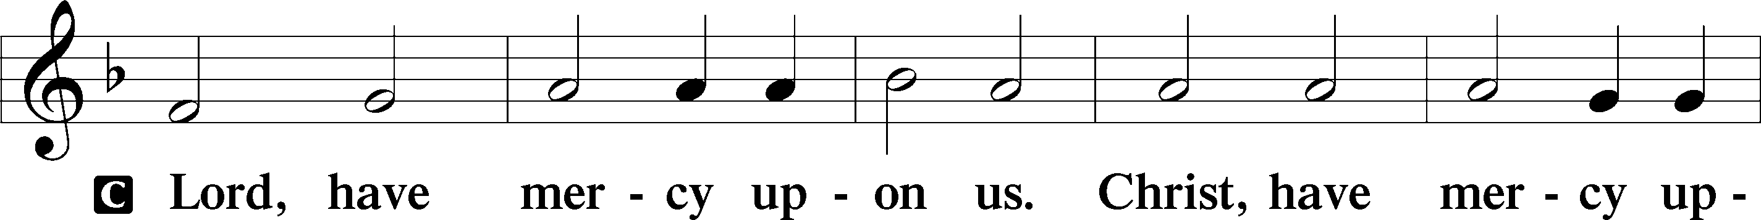
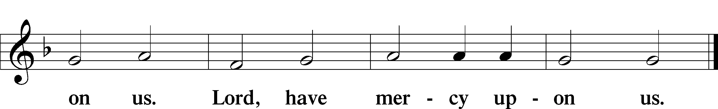

Gloria in Excelsis LSB 187
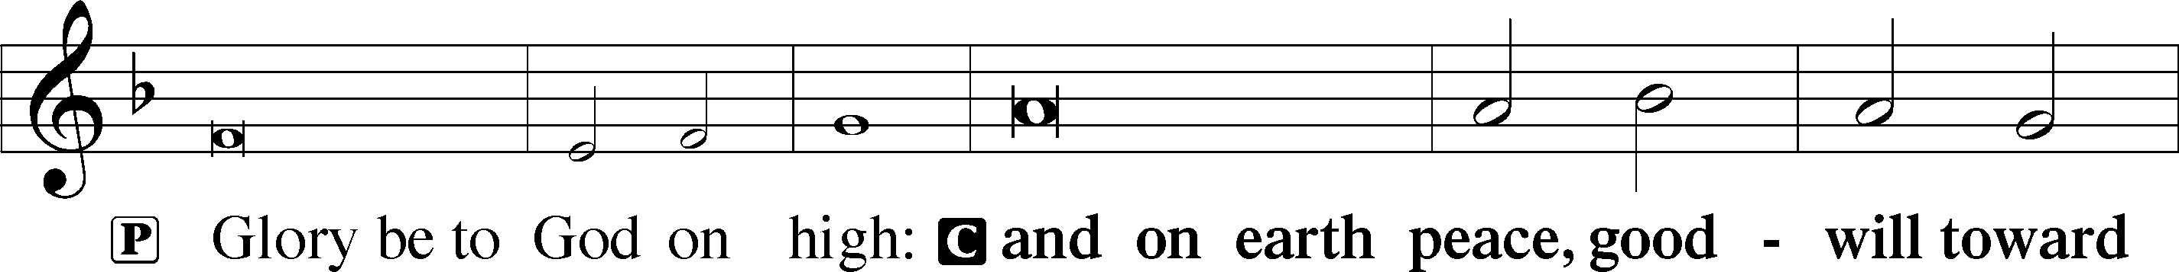
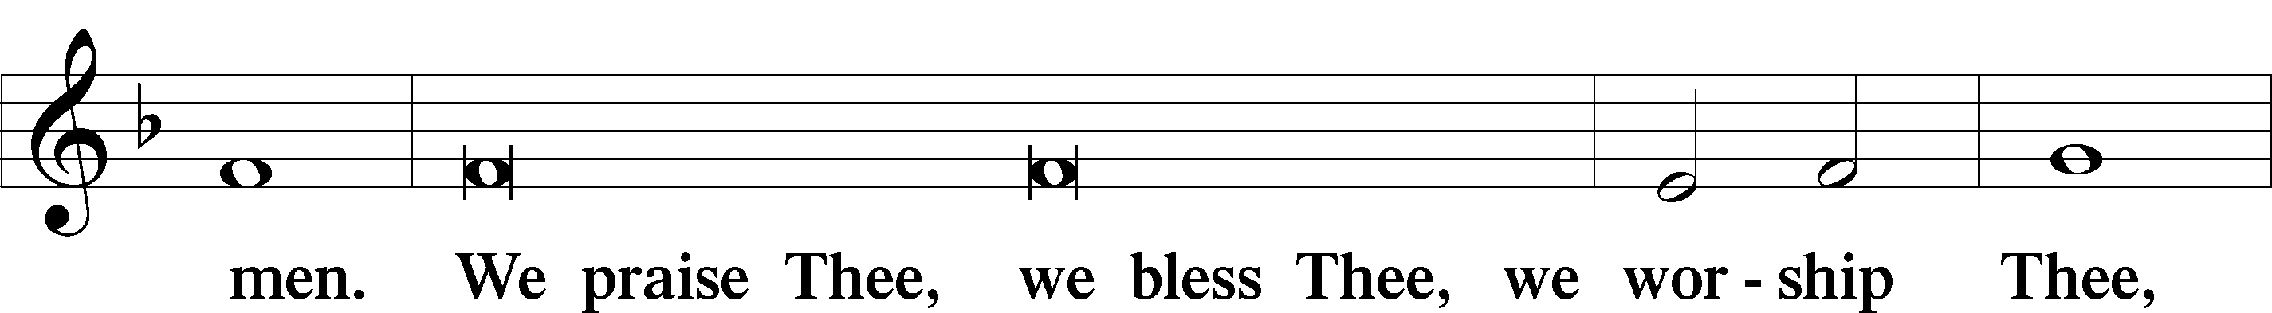
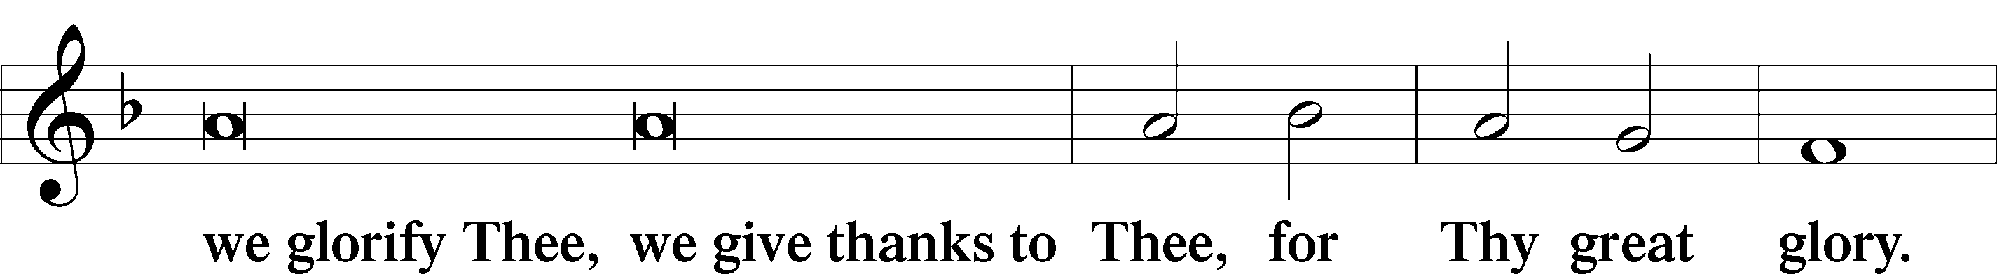
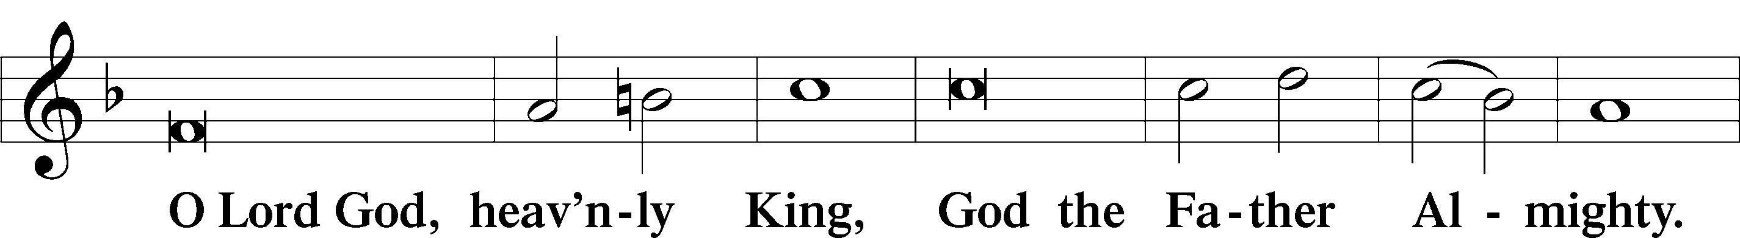
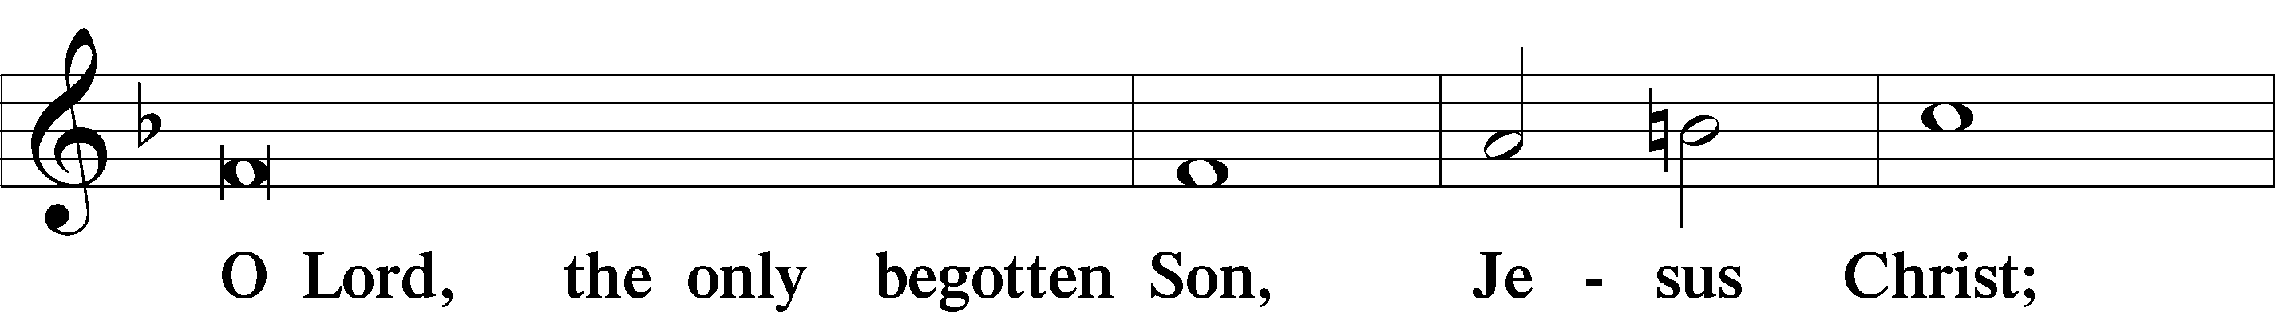
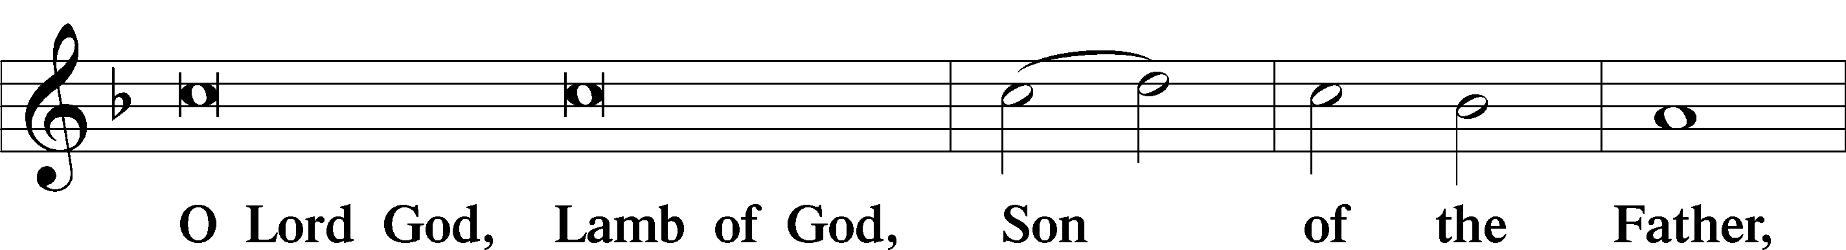
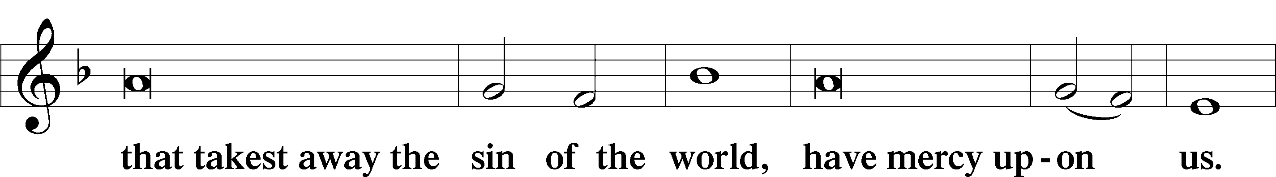
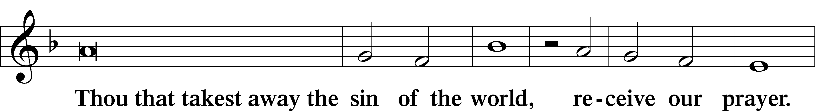
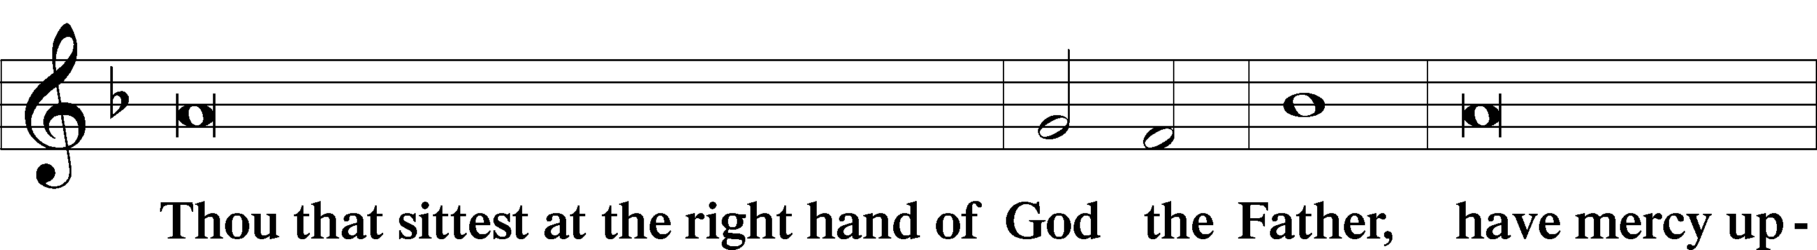
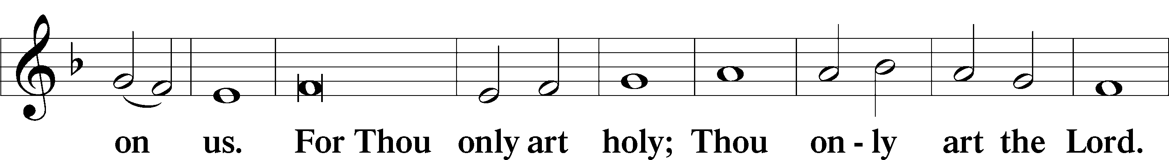
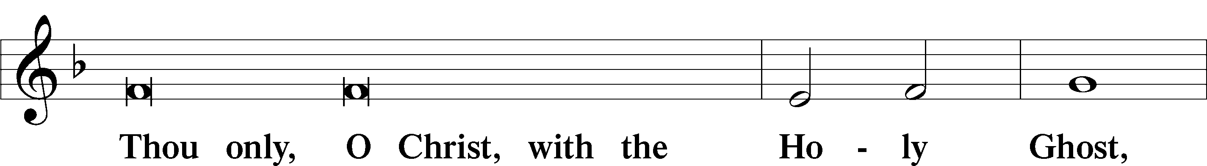
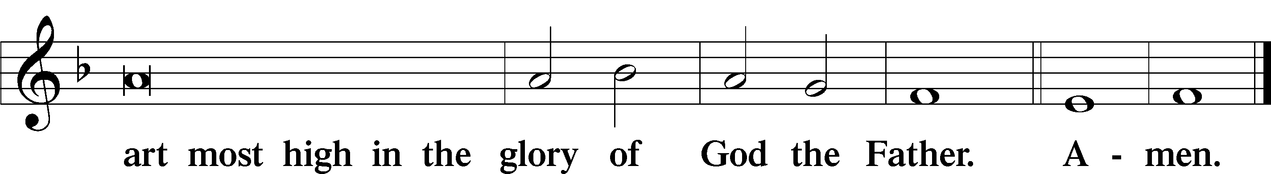

Salutation and Collect of the Day
P The Lord be with you.
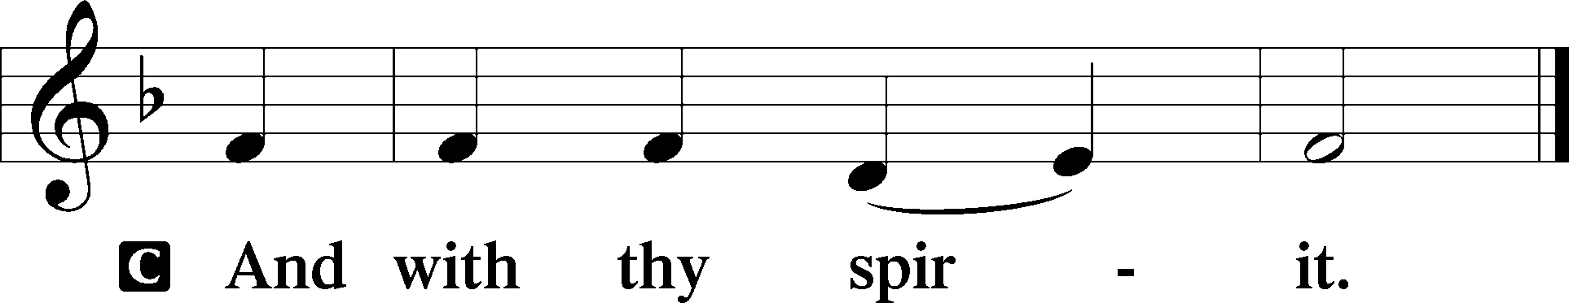

P Let us pray.
O God, through the humiliation of Your Son You raised up the fallen world. Grant to Your faithful people, rescued from the peril of everlasting death, perpetual gladness and eternal joys; through Jesus Christ, our Lord, who lives and reigns with You and the Holy Spirit, one God, now and forever.

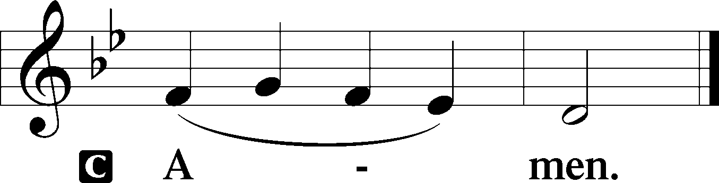

Sit

First Reading Acts 3:11–21
¹¹While [the lame man who was now healed] clung to Peter and John, all the people ran together to them in the portico called Solomon’s, astounded. ¹²And when Peter saw it he addressed the people: “Men of Israel, why do you wonder at this, or why do you stare at us, as though by our own power or piety we have made him walk? ¹³The God of Abraham, the God of Isaac, and the God of Jacob, the God of our fathers, glorified His servant Jesus —whom you delivered over and denied in the presence of Pilate, when he had decided to release him. ¹⁴But you denied the Holy and Righteous One, and asked for a murderer to be granted to you, ¹⁵and you killed the Author of Life, whom God raised from the dead. To this we are witnesses. ¹⁶And His name—by faith in His name—has made this man strong whom you see and know, and the faith that is through Jesus has given the man this perfect health in the presence of you all. ¹⁷And now, brothers, I know that you acted in ignorance, as did also your rulers. ¹⁸But what God foretold by the mouth of all the prophets — that His Christ would suffer — He thus fulfilled. ¹⁹Repent therefore, and turn again, that your sins may be blotted out, ²⁰that times of refreshing may come from the presence of the Lord, and that He may send the Christ appointed for you — Jesus, ²¹whom heaven must receive until the time for restoring all the things about which God spoke by the mouth of His holy prophets long ago.”

A This is the Word of the Lord.
C Thanks be to God.

Epistle 1 John 3:1–7
¹See what kind of love the Father has given to us, that we should be called children of God; and so we are. The reason why the world does not know us is that it did not know Him. ²Beloved, we are God’s children now, and what we will be has not yet appeared; but we know that when He appears we shall be like Him, because we shall see Him as He is. ³And everyone who thus hopes in Him purifies himself even as He is pure. ⁴Everyone who makes a practice of sinning also practices lawlessness; sin is lawlessness. ⁵You know that He appeared in order to take away sins, and in Him there is no sin. ⁶No one who abides in Him keeps on sinning; no one who keeps on sinning has either seen Him or known Him. ⁷Little children, let no one deceive you. Whoever practices righteousness is righteous, just as He is righteous.

A This is the Word of the Lord.
C Thanks be to God.

Stand

Alleluia LSB 190
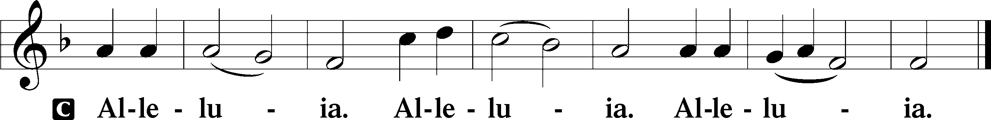

Holy Gospel Luke 24:36–49
P The Holy Gospel according to St. Luke, the twenty-fourth chapter.

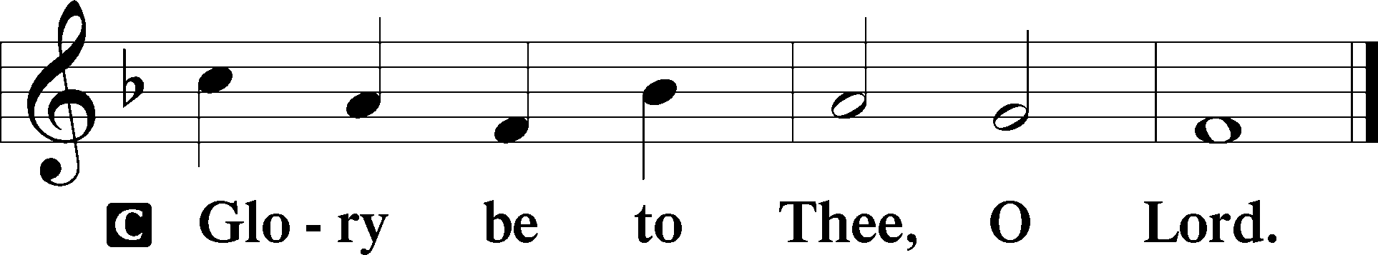

³⁶As they were talking about these things, Jesus Himself stood among them, and said to them, “Peace to you!” ³⁷But they were startled and frightened and thought they saw a spirit. ³⁸And He said to them, “Why are you troubled, and why do doubts arise in your hearts? ³⁹See My hands and My feet, that it is I Myself. Touch Me, and see. For a spirit does not have flesh and bones as you see that I have.” ⁴⁰And when He had said this, He showed them His hands and His feet. ⁴¹And while they still disbelieved for joy and were marveling, He said to them, “Have you anything here to eat?” ⁴²They gave Him a piece of broiled fish, ⁴³and He took it and ate before them. ⁴⁴Then He said to them, “These are My words that I spoke to you while I was still with you, that everything written about Me in the Law of Moses and the Prophets and the Psalms must be fulfilled.” ⁴⁵Then He opened their minds to understand the Scriptures, ⁴⁶and said to them, “Thus it is written, that the Christ should suffer and on the third day rise from the dead, ⁴⁷and that repentance and forgiveness of sins should be proclaimed in His name to all nations, beginning from Jerusalem. ⁴⁸You are witnesses of these things. ⁴⁹And behold, I am sending the Promise of my Father upon you. But stay in the city until you are clothed with power from on high.”

P This is the Gospel of the Lord.

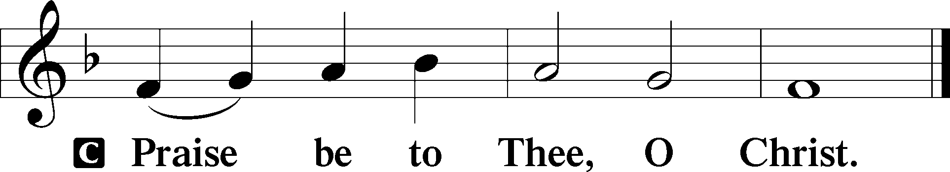
Nicene Creed
C I believe in one God,
the Father Almighty,
Maker of heaven and earth
and of all things visible and invisible.

And in one Lord Jesus Christ,
the Only-Begotten Son of God,
begotten of His Father before all worlds,
God of God, Light of Light,
Very God of Very God,
begotten, not made,
being of one substance with the Father,
by whom all things were made;
who for us men and for our salvation came down from heaven
and was incarnate by the Holy Spirit of the virgin Mary
and was made man;
and was crucified also for us under Pontius Pilate.
He suffered and was buried.
And the third day He rose again according to the Scriptures
and ascended into heaven
and sits at the right hand of the Father.
And He will come again with glory to judge both the living and the dead,
whose kingdom will have no end.

And I believe in the Holy Spirit,
the Lord and Giver of life,
who proceeds from the Father and the Son,
who with the Father and the Son together is worshiped and glorified,
who spoke by the prophets.
And I believe in one holy Christian and apostolic Church,
I acknowledge one Baptism for the remission of sins,
and I look for the resurrection of the dead
and the life of the world to come. Amen.

Sit

Children’s Message

Sermon Hymn
480 He’s Risen, He’s Risen
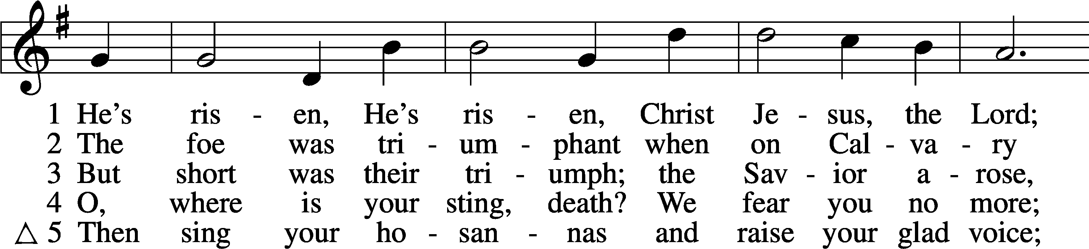
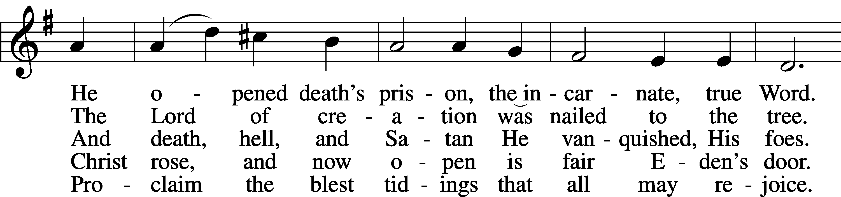
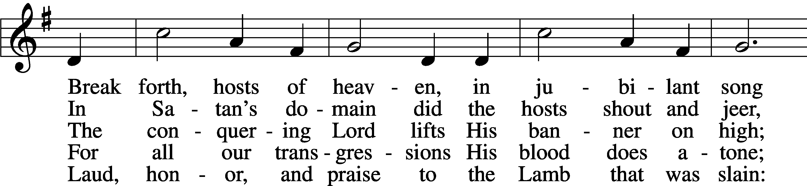
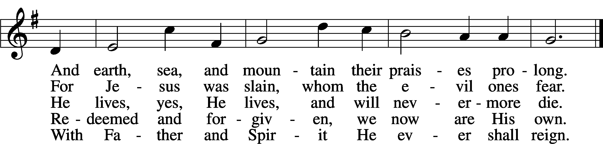
Text: C. F. W. Walther, 1811–87, abr.; tr. Anna M. Meyer, 1867–1941, alt.
Tune: C. F. W. Walther, 1811–87
Text: © 1941 Concordia Publishing House. Used by permission: LSB Hymn License no. 110002874
Tune: Public domain

Sermon

Stand

Offertory LSB 192
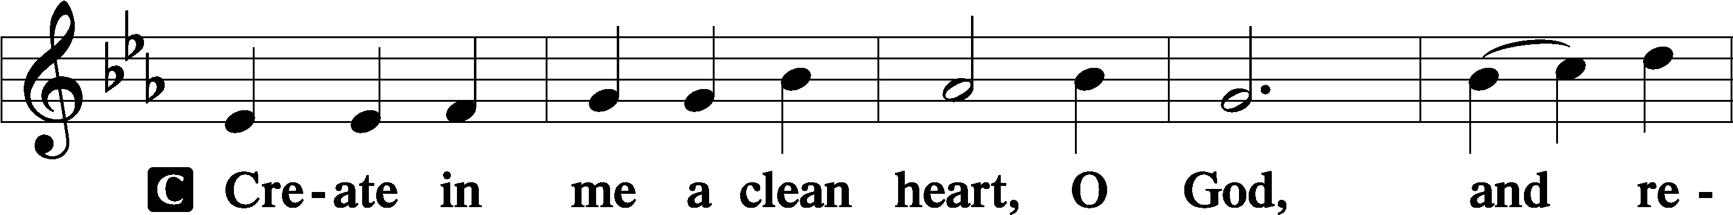
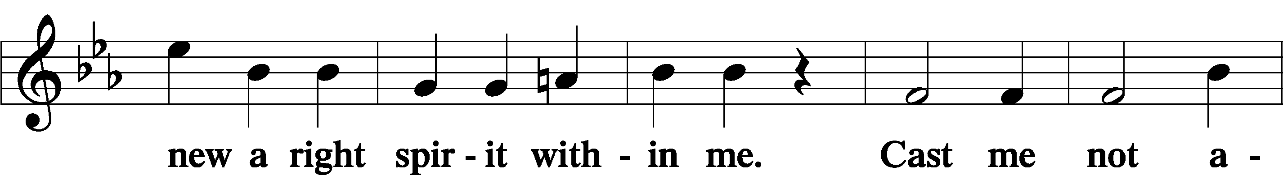
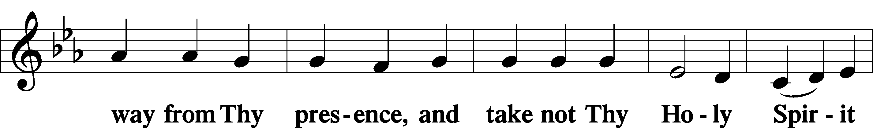
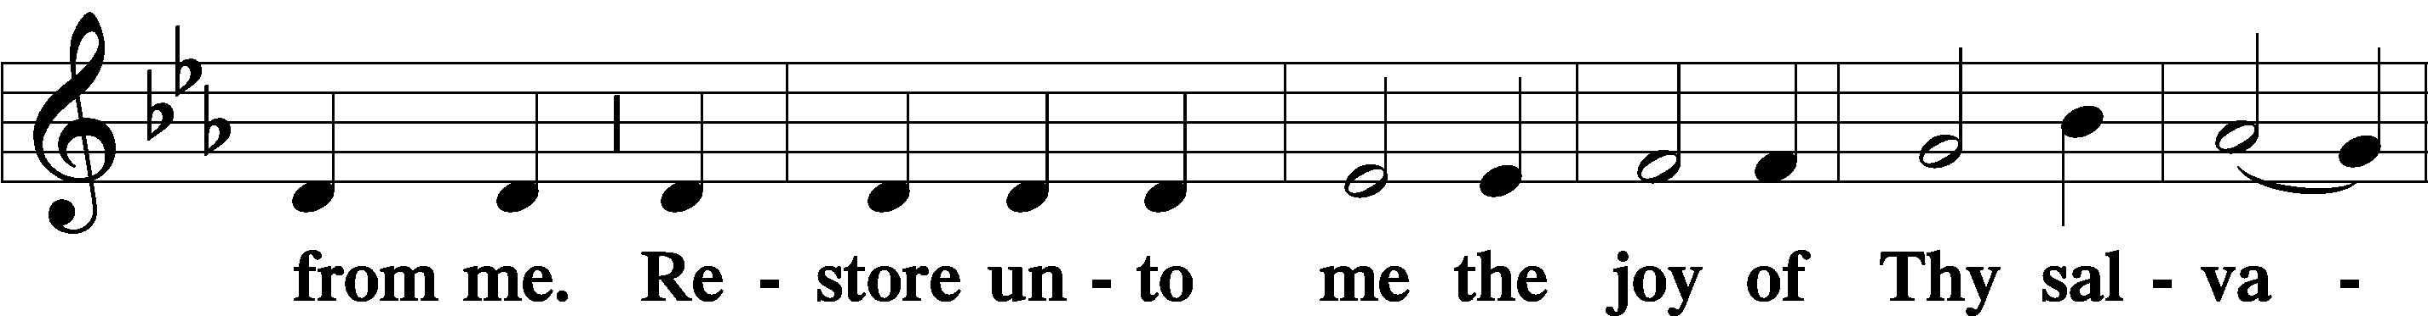
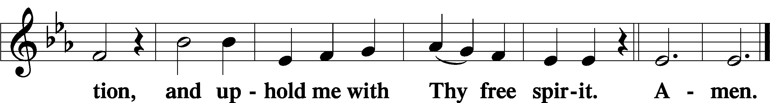

Sit

Offering

Stand

Prayer of the Church

Preface LSB 194
P The Lord be with you.
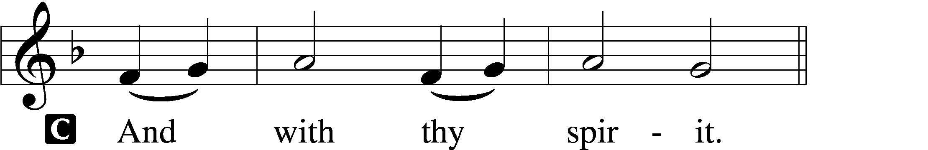

P Lift up your hearts.
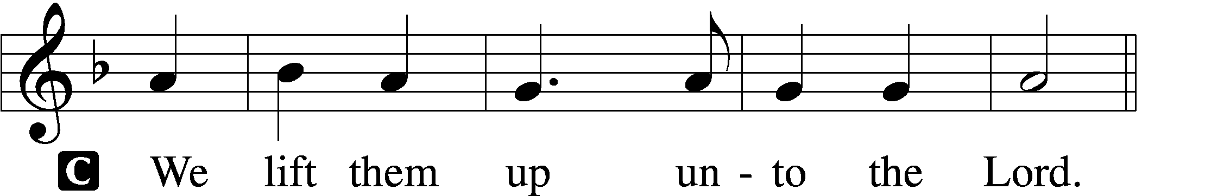

P Let us give thanks unto the Lord, our God.
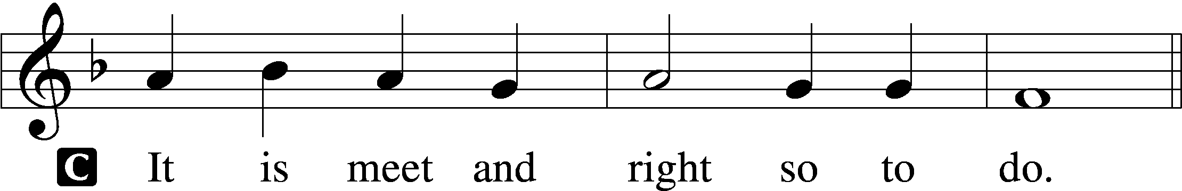

P It is truly meet, right, and salutary that we should at all times and in all places give thanks to You, holy Lord, almighty Father, everlasting God. And most especially are we bound to praise You on this day for the glorious resurrection of Your Son, Jesus Christ, the very Paschal Lamb, who was sacrificed for us and bore the sins of the world. By His dying He has destroyed death, and by His rising again He has restored to us everlasting life. Therefore with Mary Magdalene, Peter and John, and with all the witnesses of the resurrection, with angels and archangels, and with all the company of heaven we laud and magnify Your glorious name, evermore praising You and saying:

Sanctus LSB 195
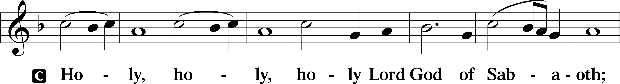
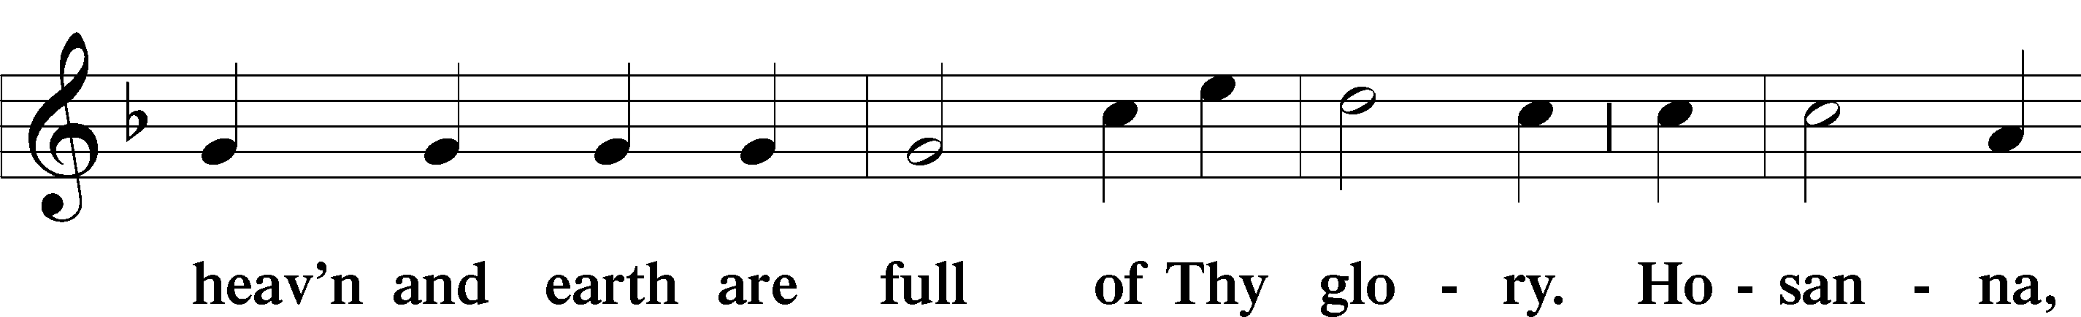
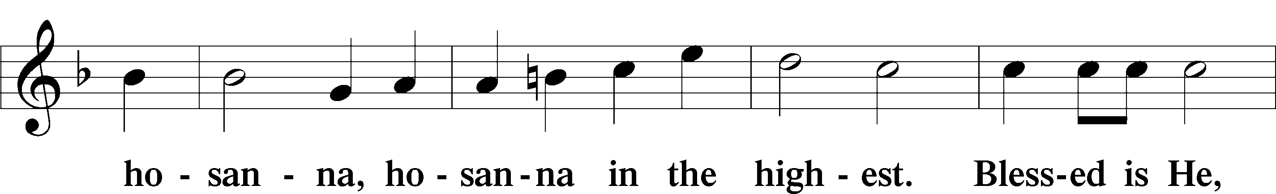
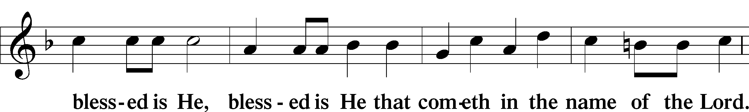
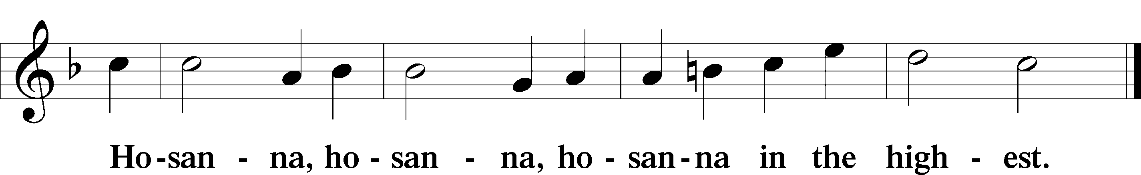

Lord’s Prayer LSB 196
P Our Father who art in heaven,
hallowed be Thy name,
Thy kingdom come,
Thy will be done on earth as it is in heaven;
give us this day our daily bread;
and forgive us our trespasses as we forgive those who trespass against us;
and lead us not into temptation,
but deliver us from evil.
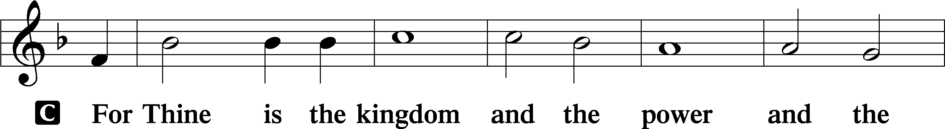
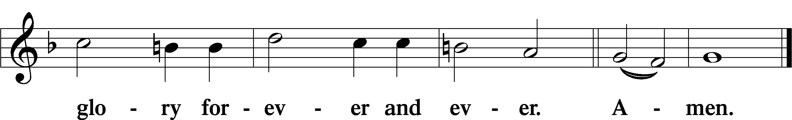

The Words of Our Lord LSB 197
P Our Lord Jesus Christ, on the night when He was betrayed, took bread, and when He had given thanks, He broke it and gave it to the disciples and said: “Take, eat; this is My body, which is given for you. This do in remembrance of Me.”

In the same way also He took the cup after supper, and when He had given thanks, He gave it to them, saying: “Drink of it, all of you; this cup is the new testament in My blood, which is shed for you for the forgiveness of sins. This do, as often as you drink it, in remembrance of Me.”

Pax Domini LSB 197
P The peace of the Lord be with you always.

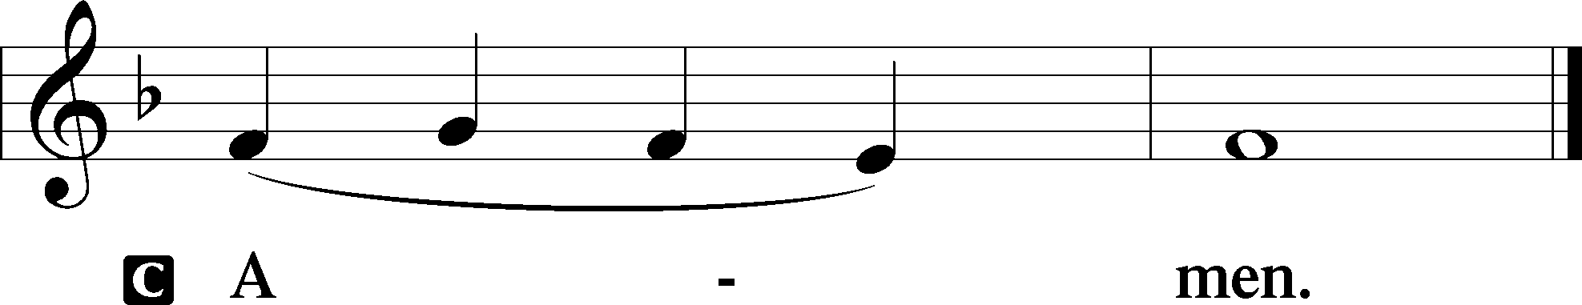

Agnus Dei LSB 198
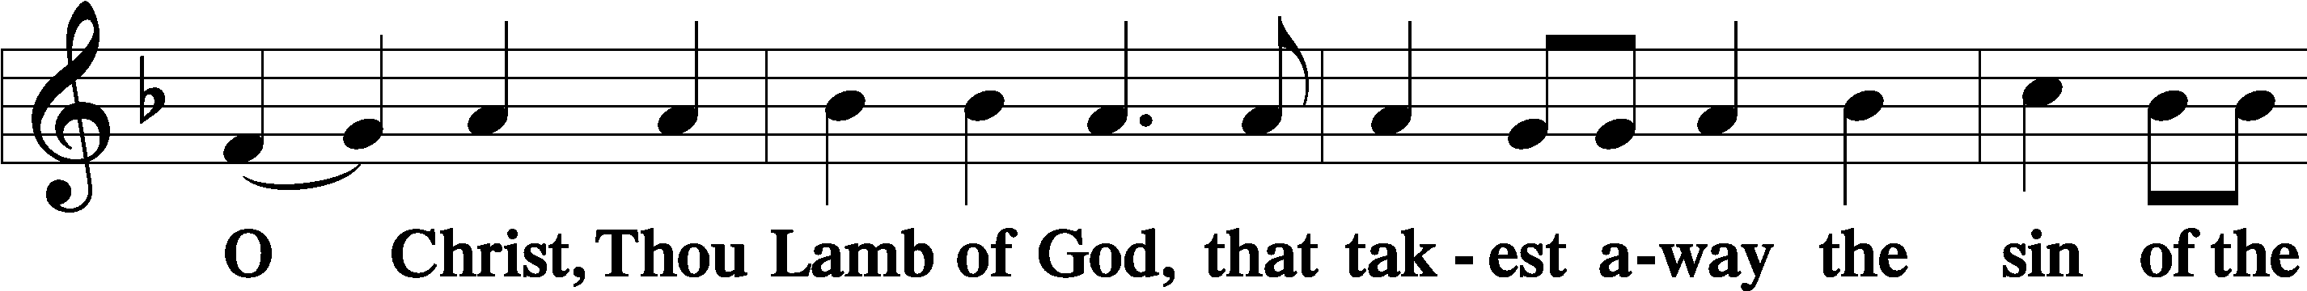
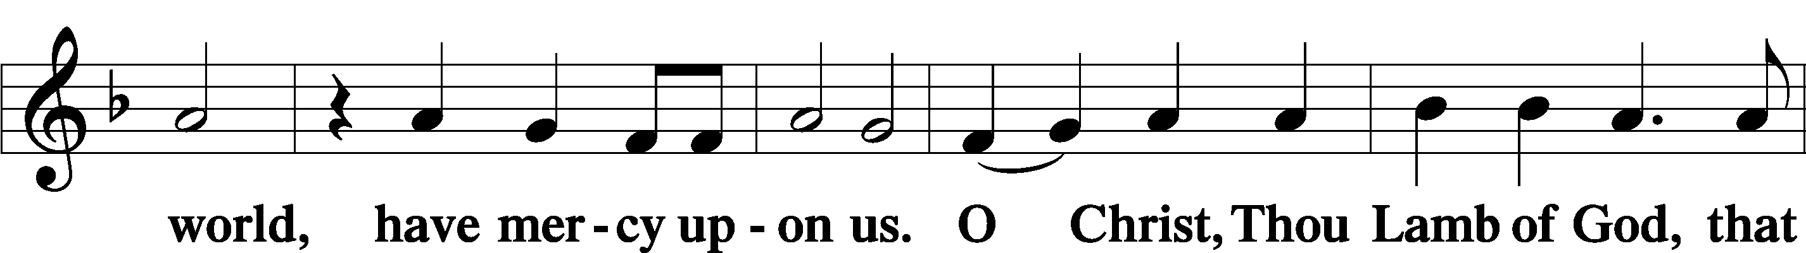
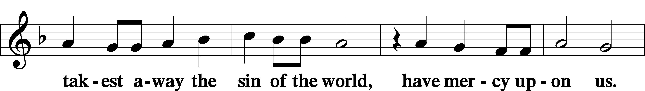
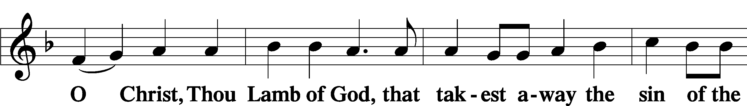
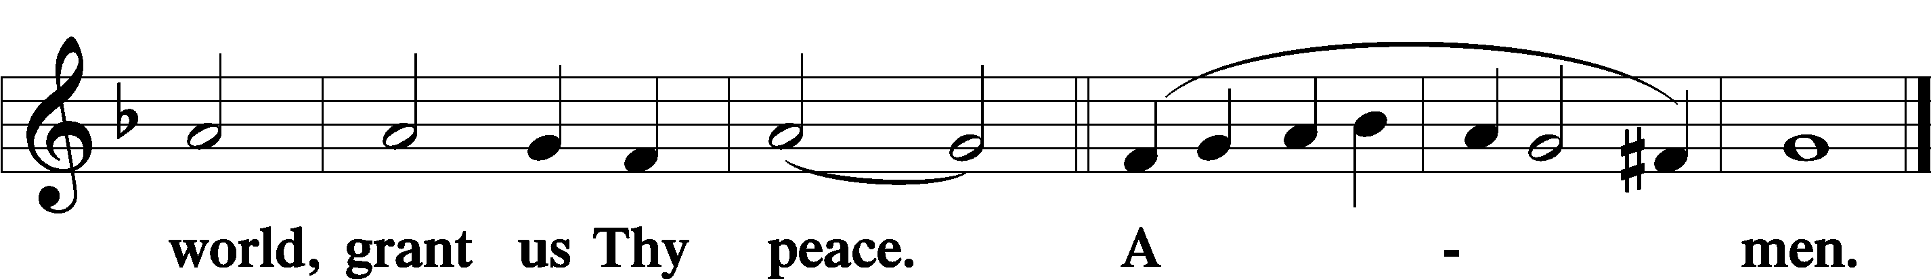

Sit

— The Distribution —

Distribution Hymn
470 O Sons and Daughters of the King
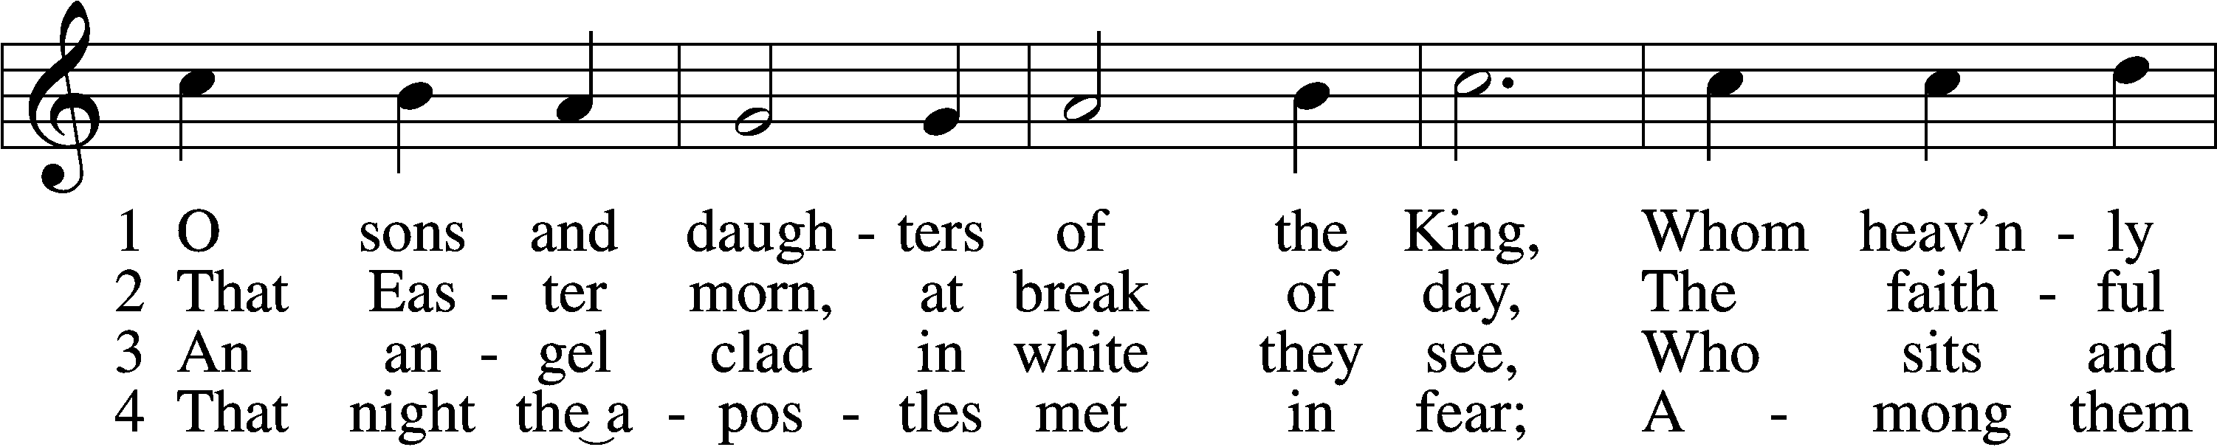
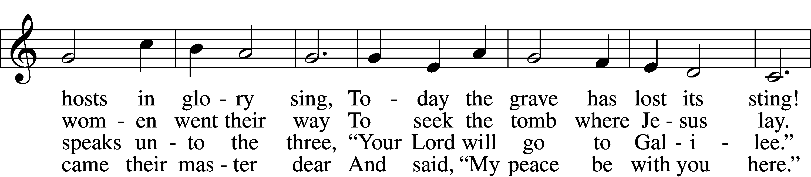
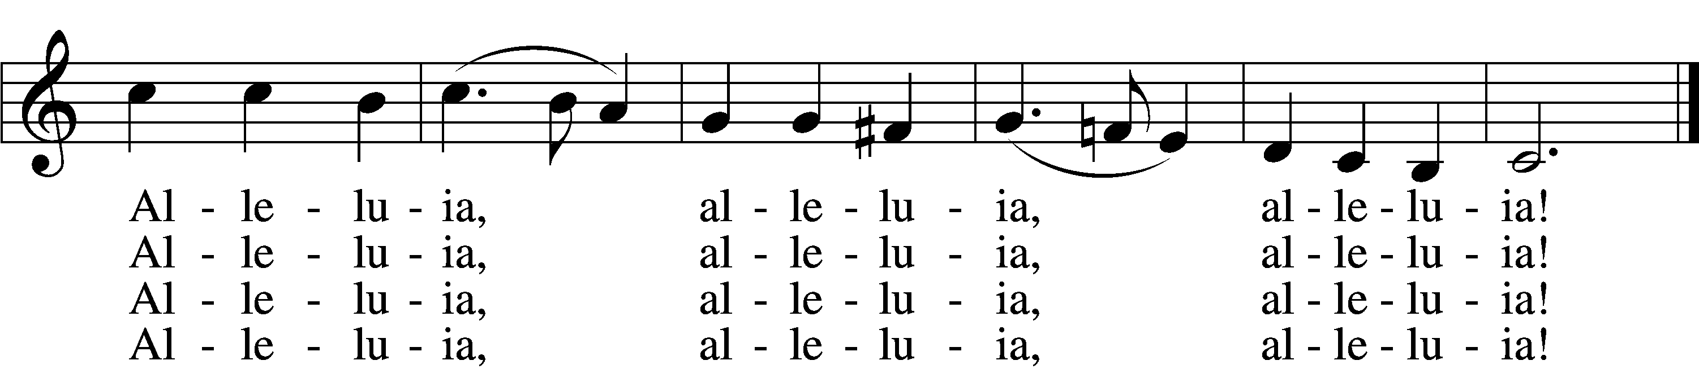

5 When Thomas first the tidings heard
That they had seen the risen Lord,
He doubted the disciples’ word.
Alleluia, alleluia, alleluia!

6 “My piercèd side, O Thomas, see,
And look upon My hands, My feet;
Not faithless but believing be.”
Alleluia, alleluia, alleluia!

7 No longer Thomas then denied;
He saw the feet, the hands, the side;
“You are my Lord and God!” he cried.
Alleluia, alleluia, alleluia!

8 How blest are they who have not seen
And yet whose faith has constant been,
For they eternal life shall win.
Alleluia, alleluia, alleluia!

9 On this most holy day of days
Be laud and jubilee and praise:
To God your hearts and voices raise.
Alleluia, alleluia, alleluia!
Text: attr. Jean Tisserand, d. 1494; tr. John Mason Neale, 1818–66, alt.
Tune: Melchior Vulpius, c. 1570–1615
Text and tune: Public domain

Stand

Nunc Dimittis LSB 199
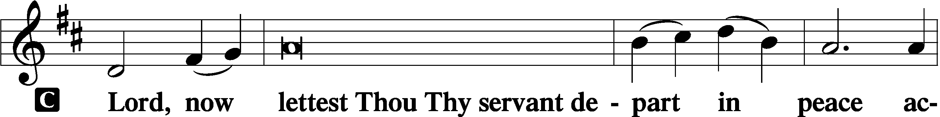

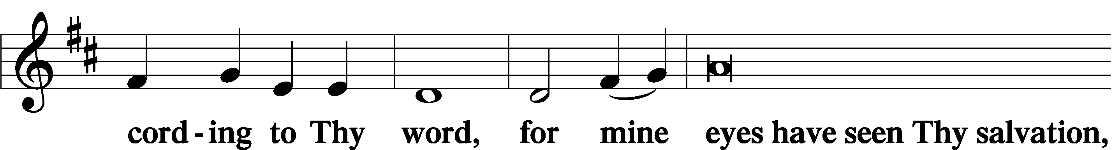

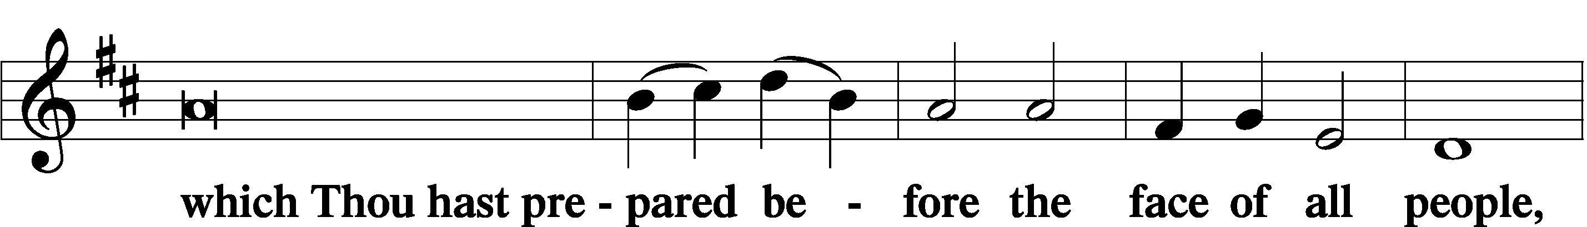

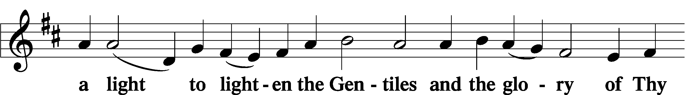

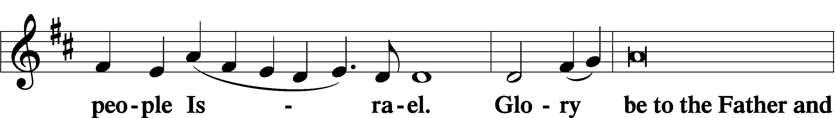

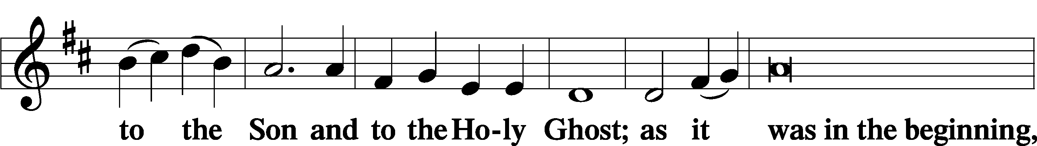

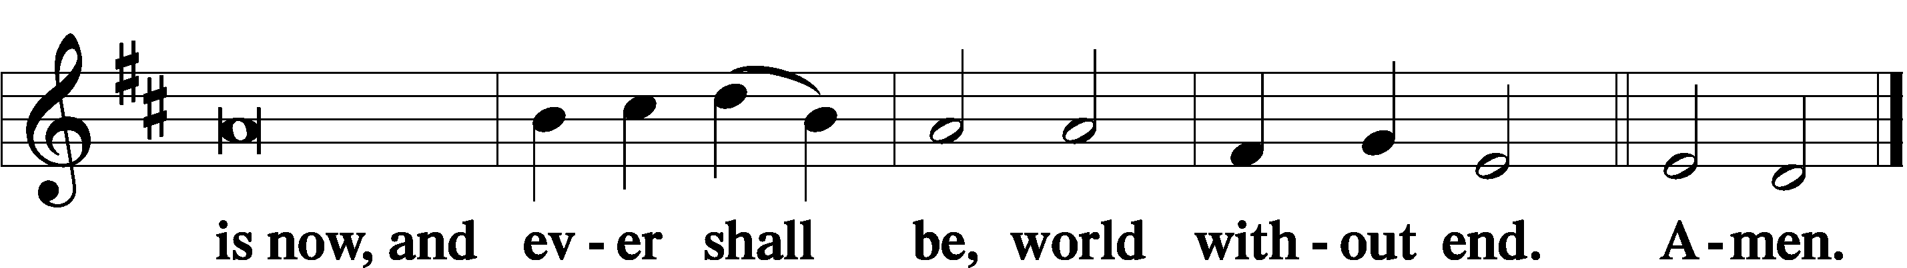

Thanksgiving LSB 200
A O give thanks unto the Lord, for He is good,

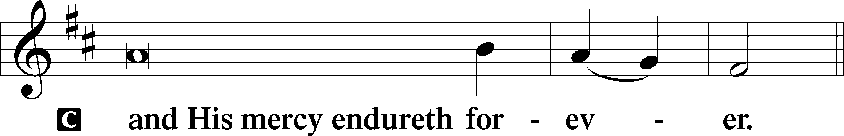

A Let us pray.
We give thanks to You, almighty God, that You have refreshed us through this salutary gift, and we implore You that of Your mercy You would strengthen us through the same in faith toward You and in fervent love toward one another; through Jesus Christ, Your Son, our Lord, who lives and reigns with You and the Holy Spirit, one God, now and forever.

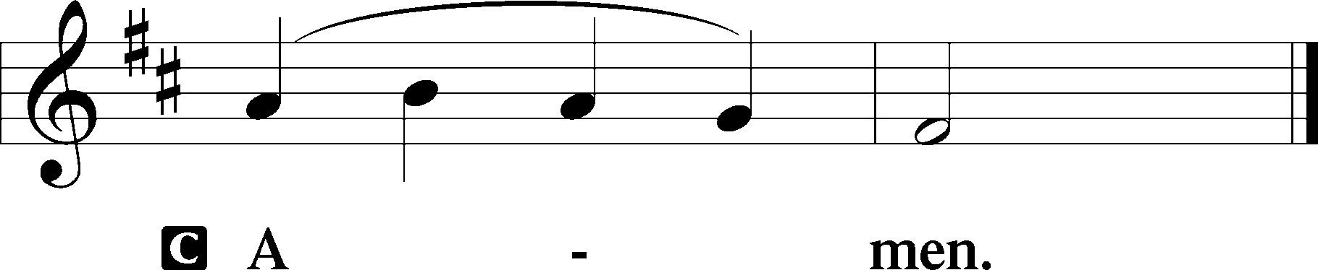

P The Lord be with you.

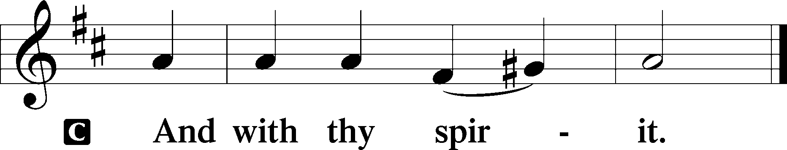

Benedicamus LSB 202
A Bless we the Lord.

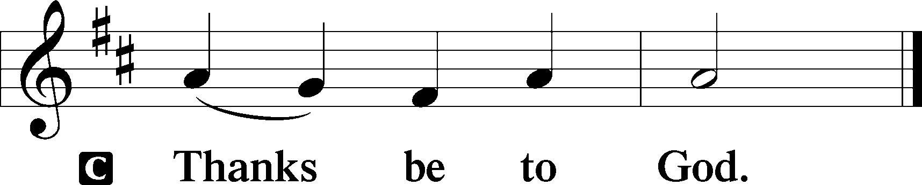

Benediction LSB 202
P The Lord bless you and keep you.
The Lord make His face shine upon you and be gracious unto you.
The Lord lift up His countenance upon you and give you peace.
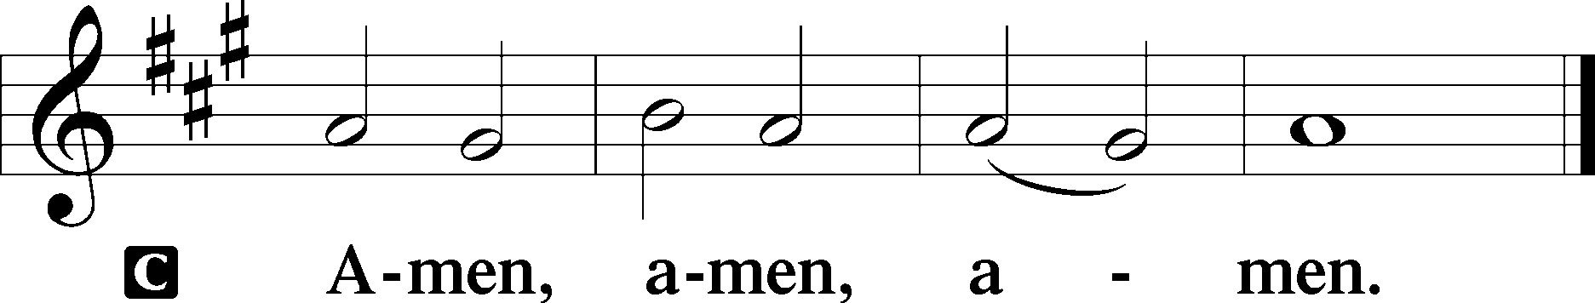

Closing Hymn
475 Good Christian Friends, Rejoice and Sing
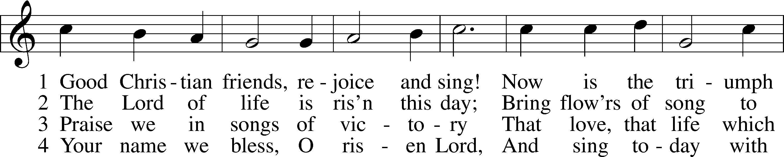
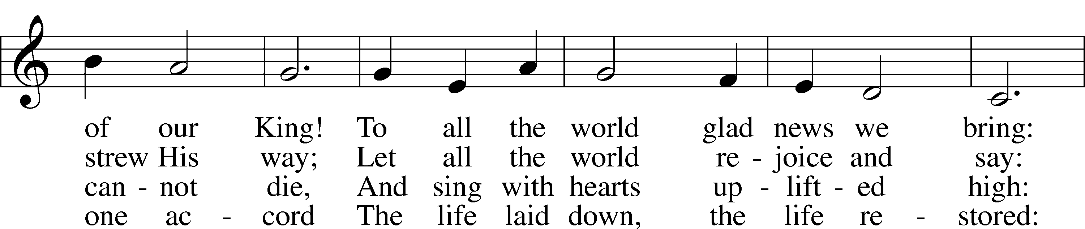
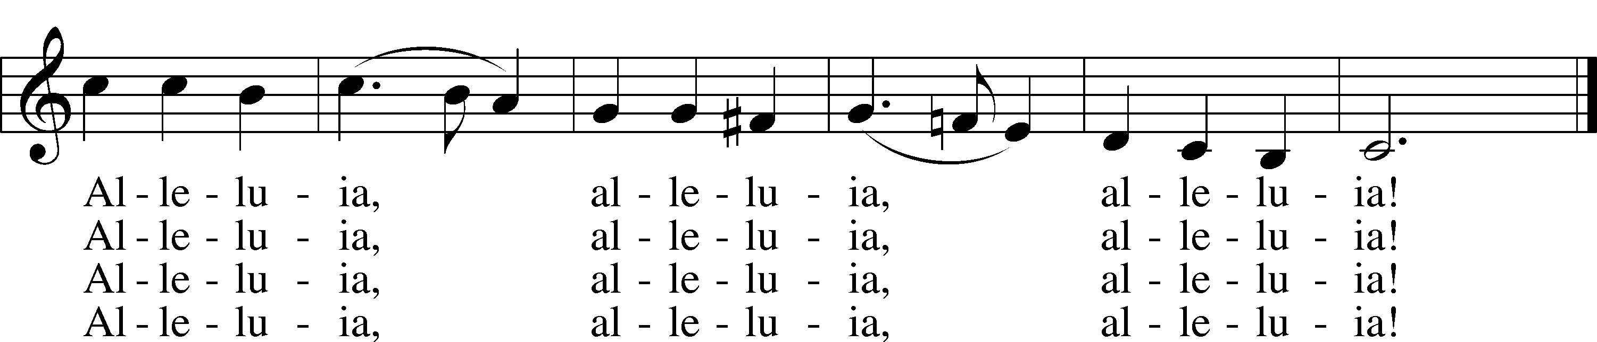
Text: Cyril A. Alington, 1872–1955, alt.
Tune: Melchior Vulpius, c. 1570–1615
Text: © 1958, renewed 1986 Hymns Ancient and Modern Ltd., admin. Hope Publishing Co. Used by permission: LSB Hymn License no. 110002874
Tune: Public domain

Acknowledgments
Divine Service, Setting Three from Lutheran Service Book
Unless otherwise indicated, Scripture quotations are from the ESV® Bible (The Holy Bible, English Standard Version®), copyright © 2001 by Crossway, a publishing ministry of Good News Publishers. Used by permission. All rights reserved.
Created by Lutheran Service Builder © 2024 Concordia Publishing House.

